Problem Statement:
Deploy a three tier Architecture in AWS. Try to use custom VPC instead of default ones. Secure and apply best practices
Solution:
A step-by-step guide for AWS Three Tier Web Architecture is available at the following location. We will follow the same and implement the solution
https://catalog.us-east-1.prod.workshops.aws/workshops/85cd2bb2-7f79-4e96-bdee-8078e469752a/en-US/introduction
Architecture:
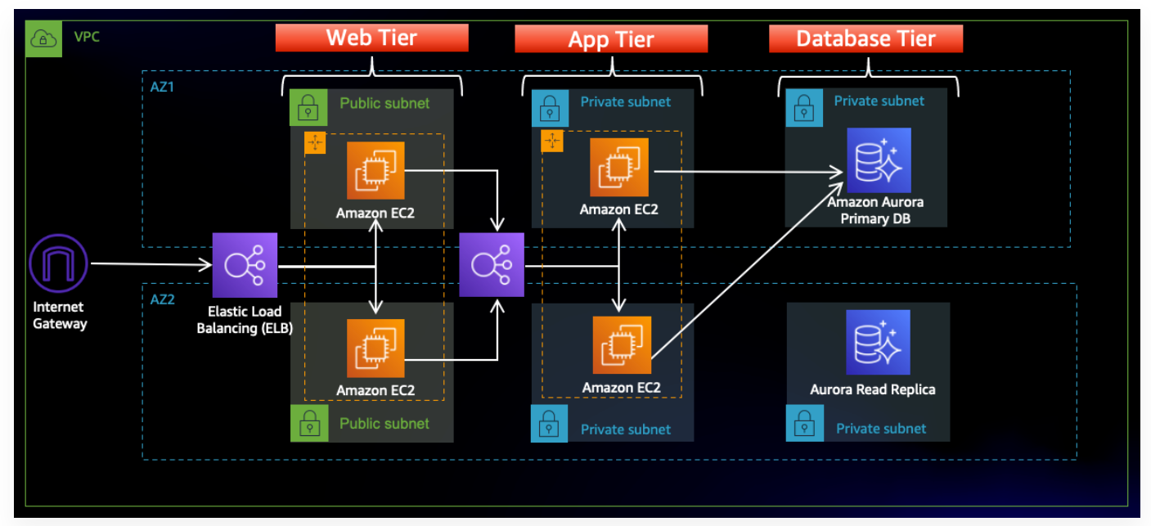
In this architecture, a public-facing Application Load Balancer forwards client traffic to our web tier EC2 instances. The web tier is running Nginx webservers that are configured to serve a React.js website and redirects our API calls to the application tier’s internal facing load balancer. The internal facing load balancer then forwards that traffic to the application tier, which is written in Node.js. The application tier manipulates data in an Aurora MySQL multi-AZ database and returns it to our web tier. Load balancing, health checks and autoscaling groups are created at each layer to maintain the availability of this architecture.

A Step-by-step guide:
- Download the code from Github by using the following command.
git clone https://github.com/aws-samples/aws-three-tier-web-architecture-workshop.git

- Open Git bash and create a directory for copying the repository
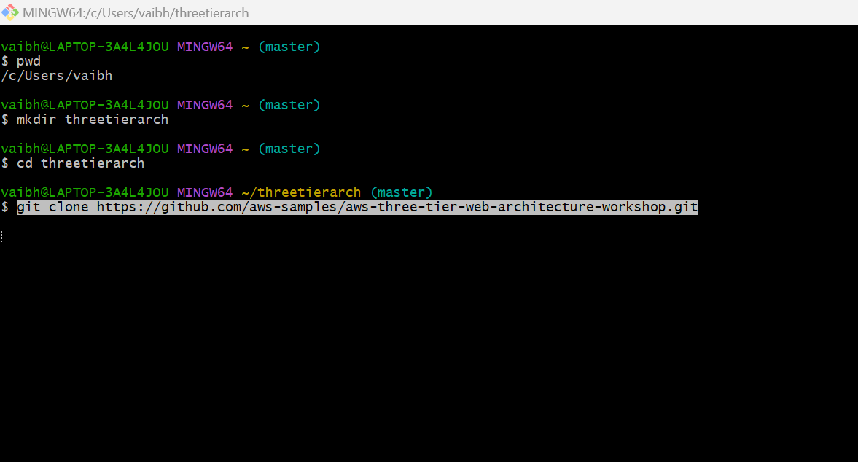
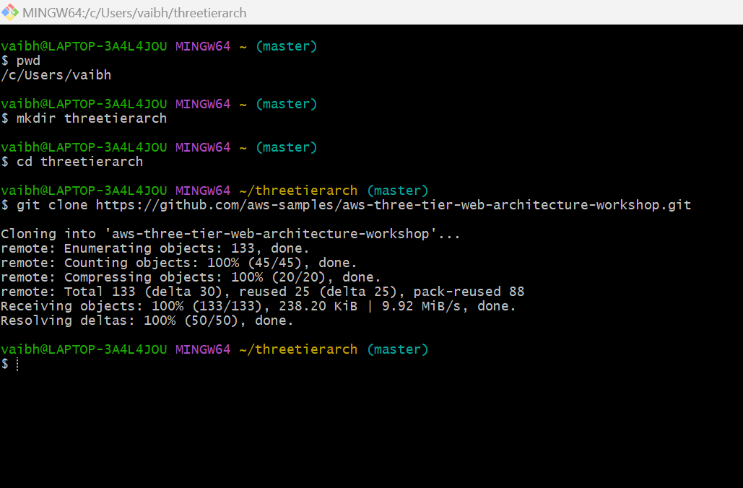
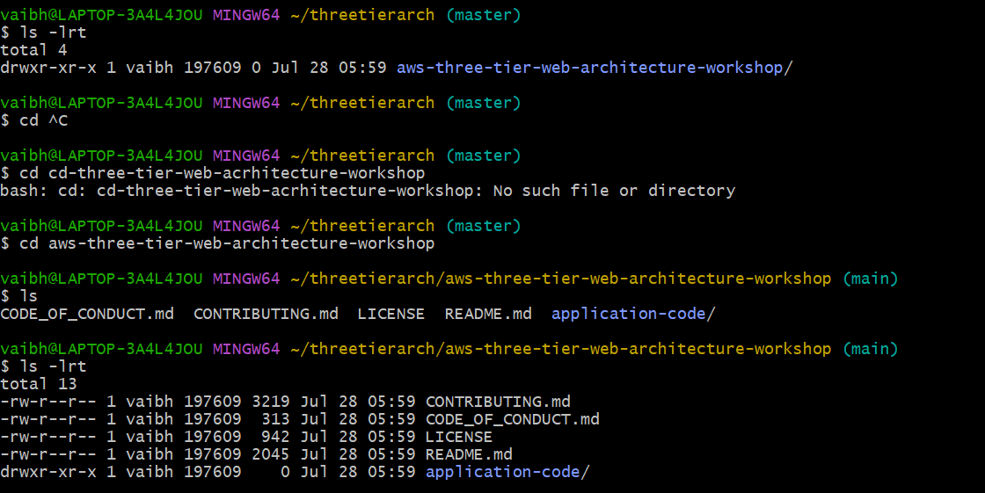

- Create a new S3 bucket in a region where you intend to deploy the entire architecture. This is the region where we will upload the code
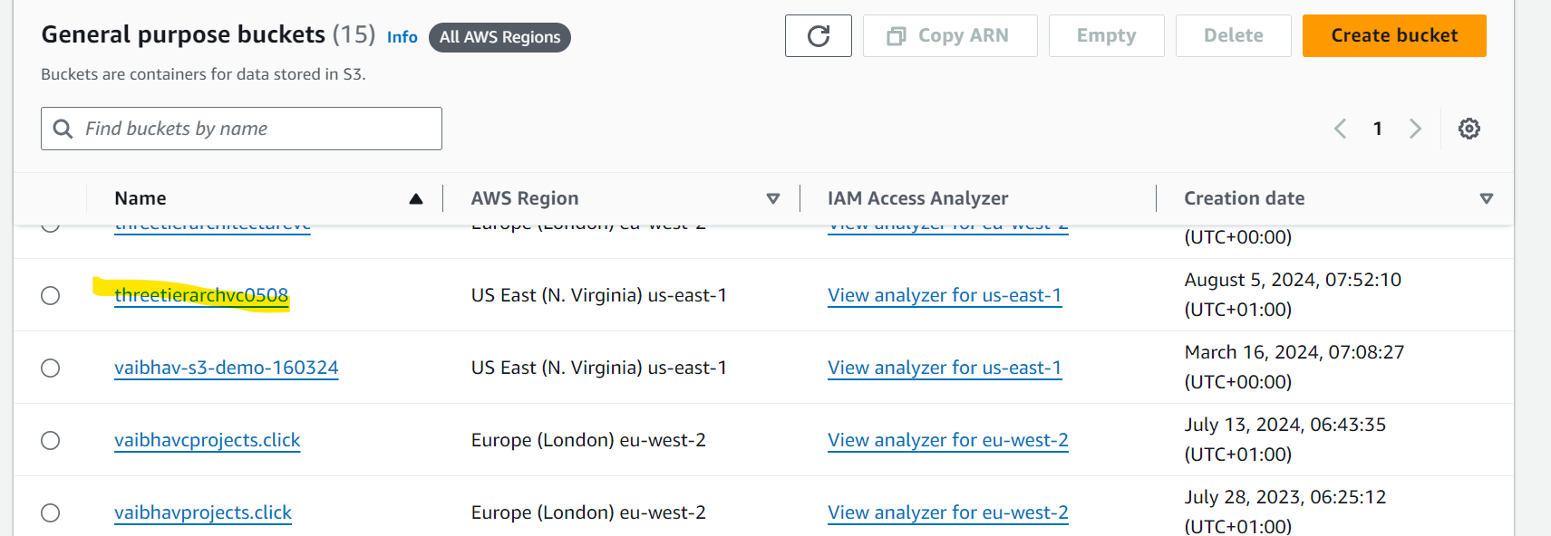

- Go to IAM dashboard and create an C2 role
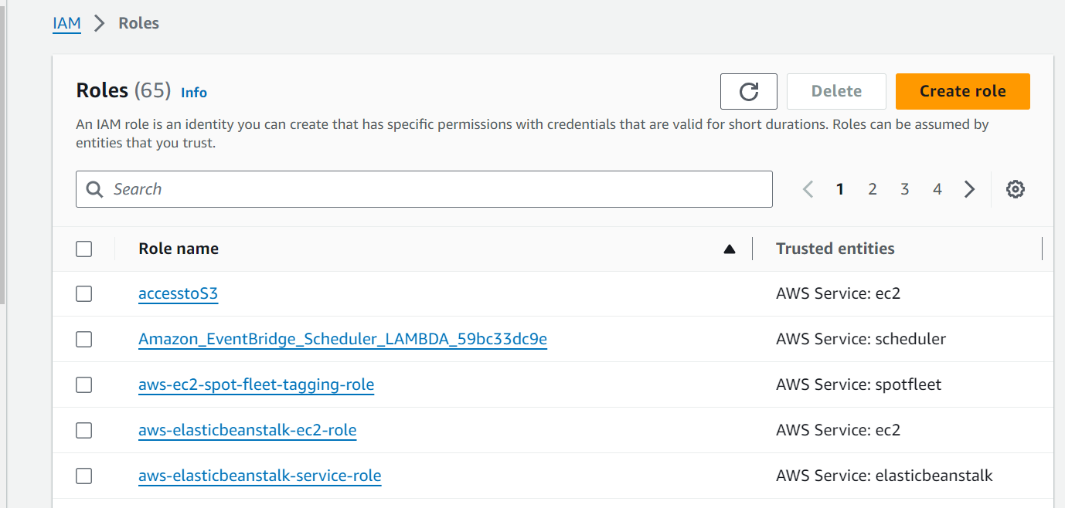
- Click on Create role and select AWS service. Select EC2 as a service and click Next
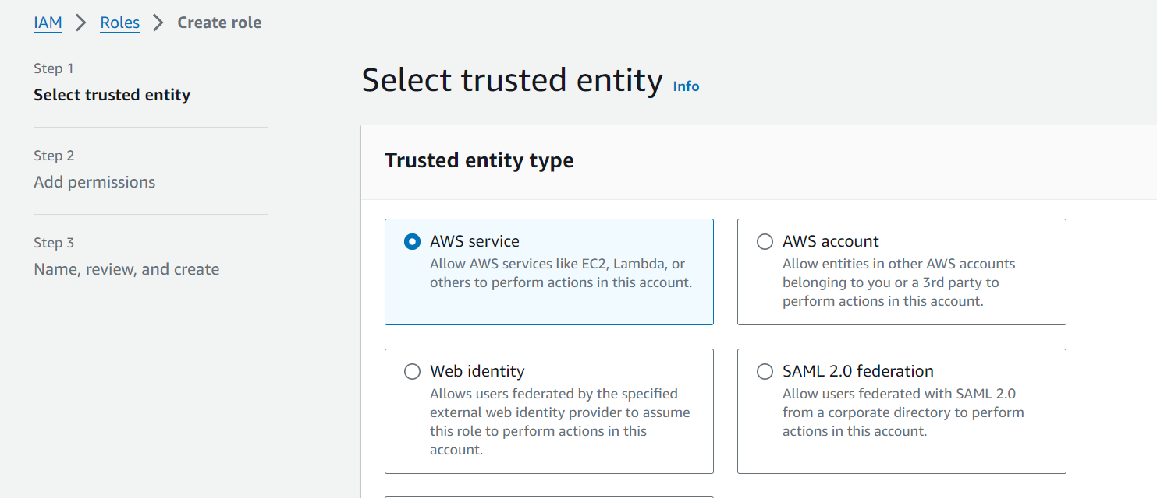
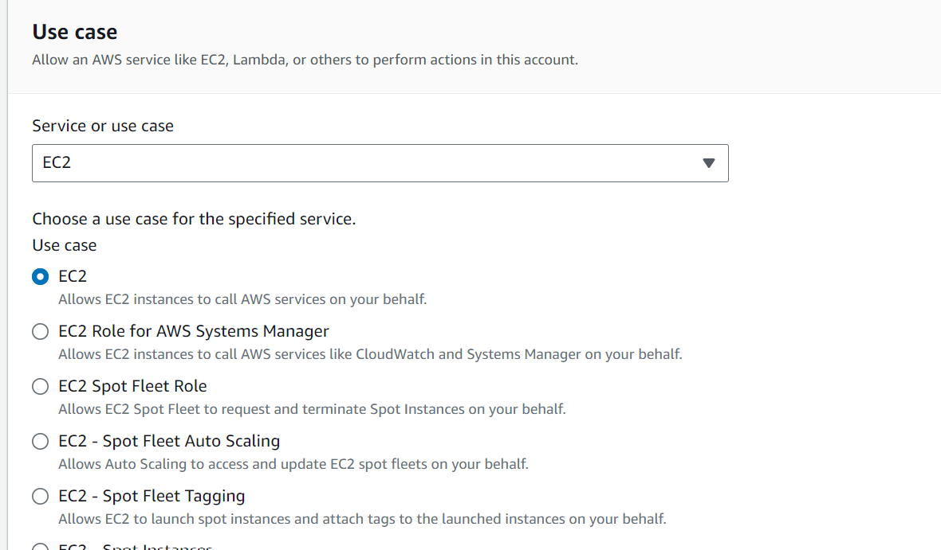

- Add following permissions. These permissions will allow our instances to download our code from S3 and use Systems Manager Session Manager to securely connect to our instances without SSH keys through the AWS console.

AmazonSSMManagedInstanceCore
AmazonS3ReadOnlyAccess

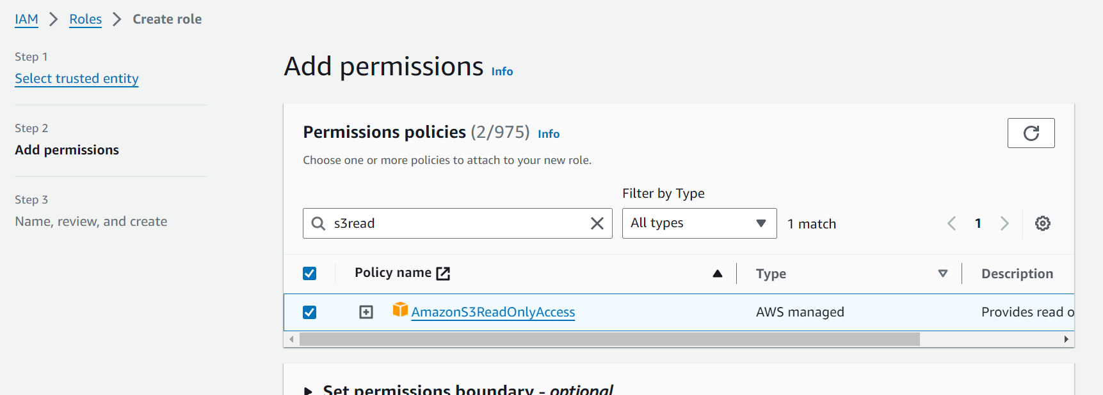
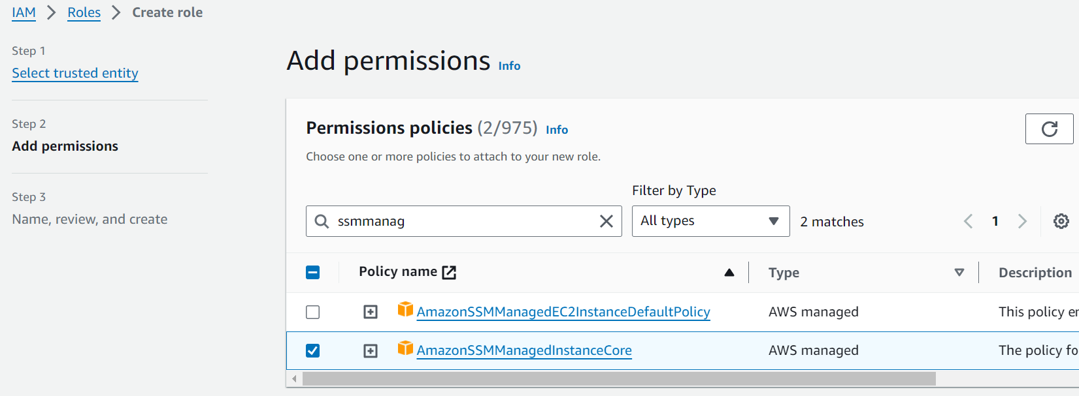

- Provide a name to the role and check if permissions have been added and click Create role
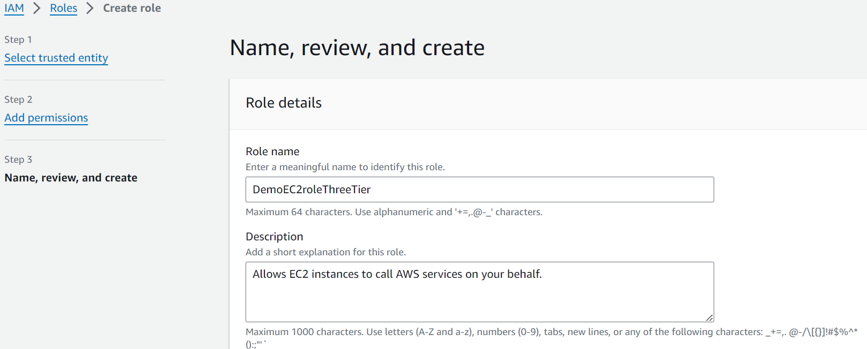
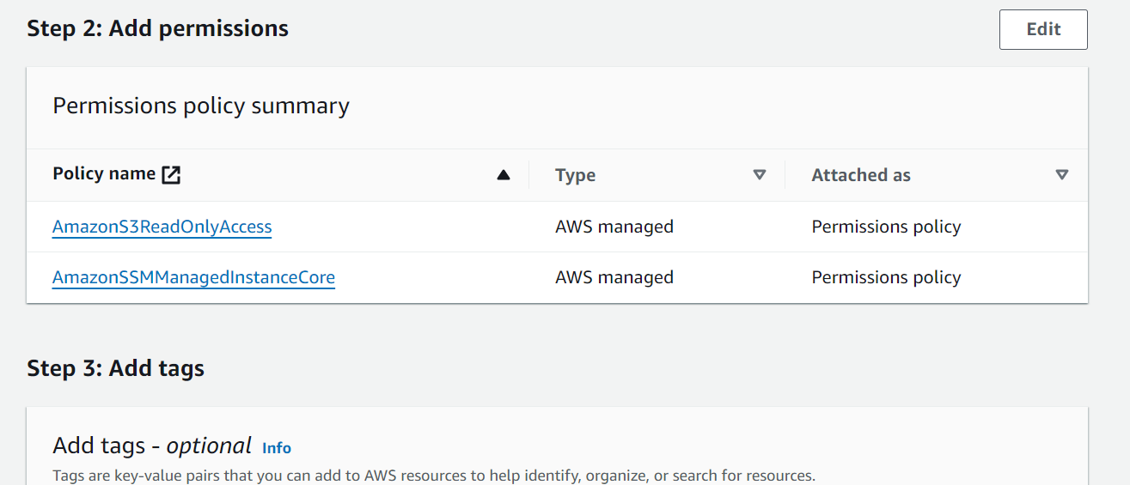

- Go to VPC dashboard and click create VPC. Follow following steps and click on create VPC
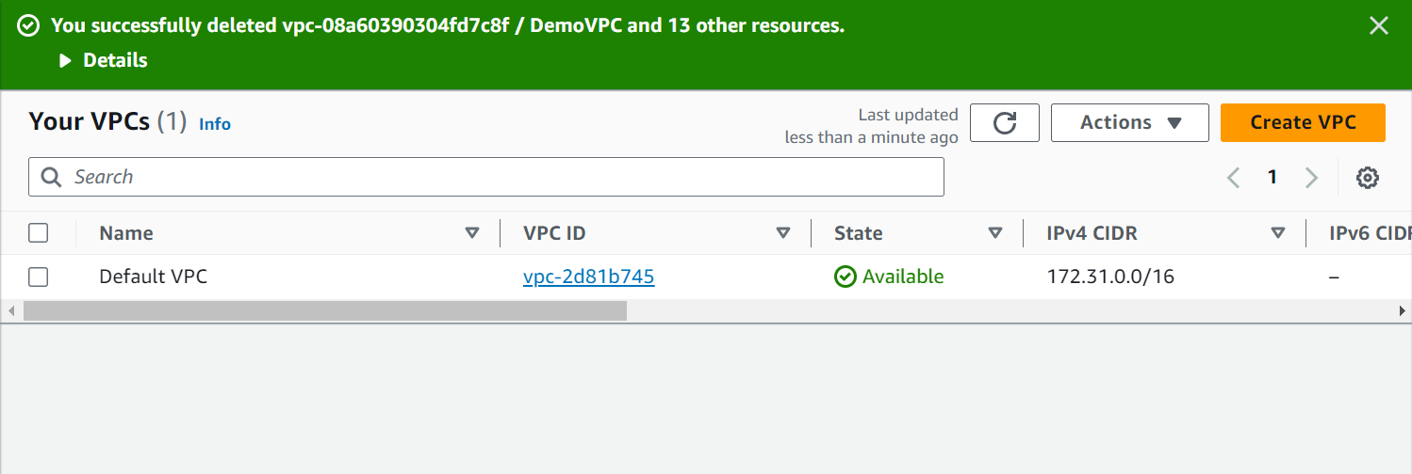

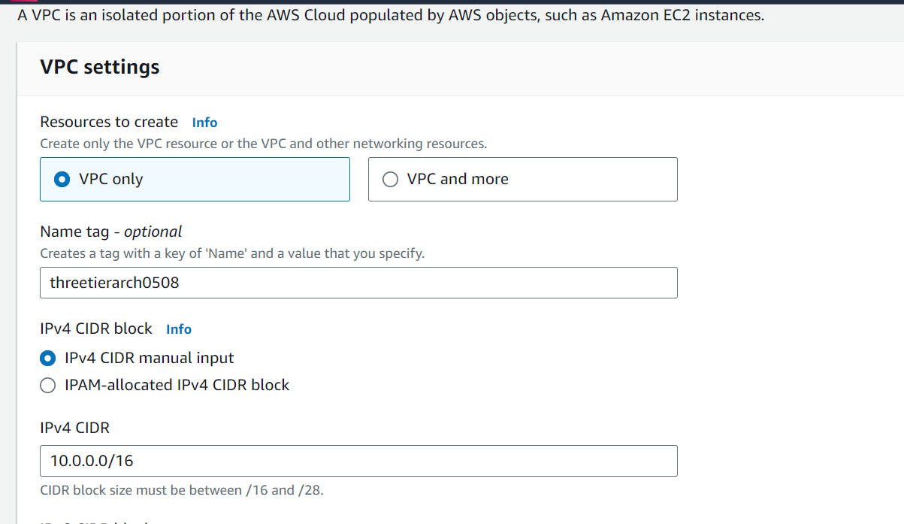
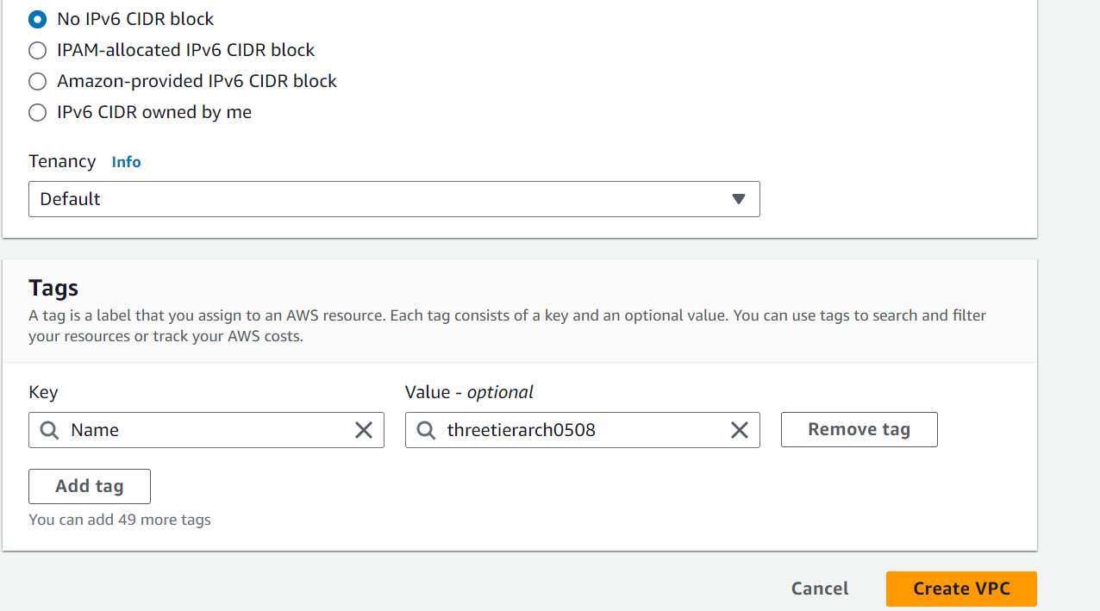
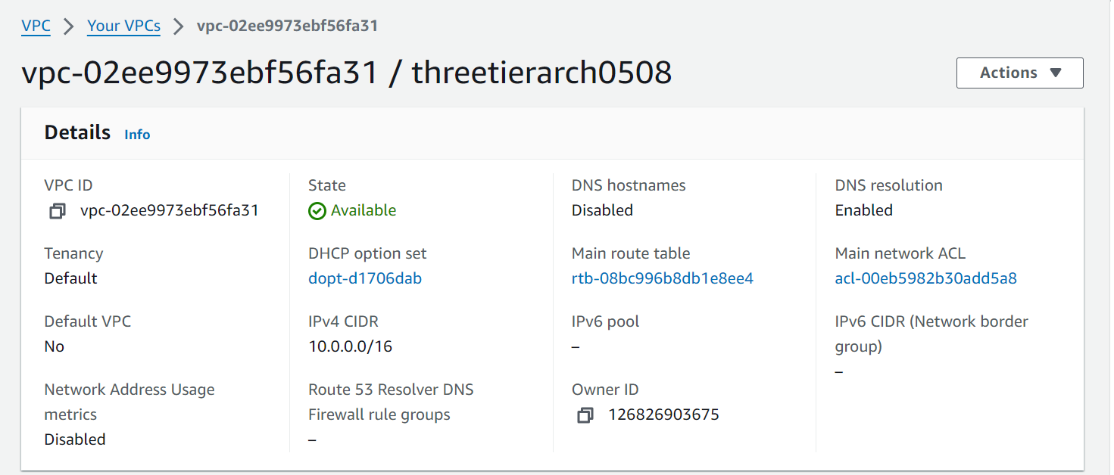

- Go to Subnets and Click on Create Subnets. We will create 6 subnets across 2 Availability Zones. There will be 2 Public subnets and 4 Private subnets as per the architecture diagram
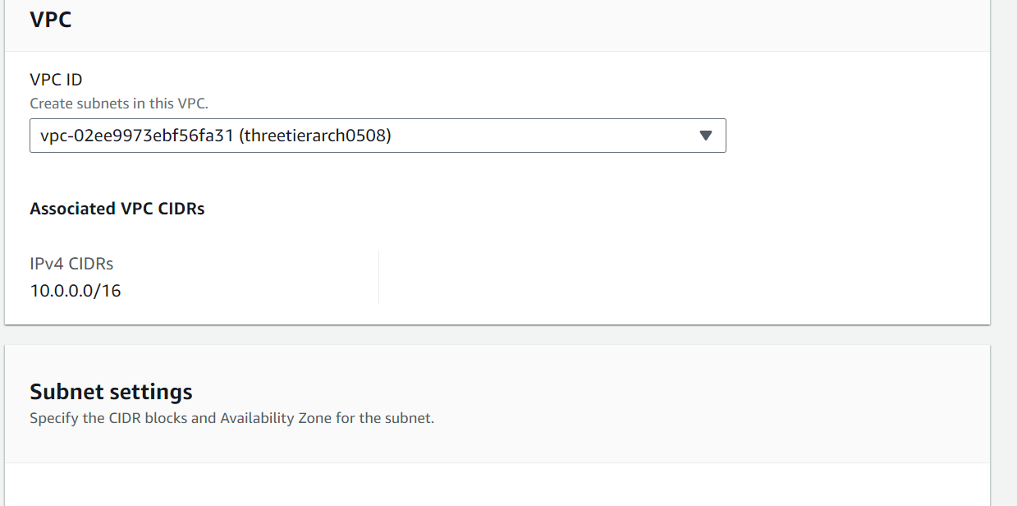

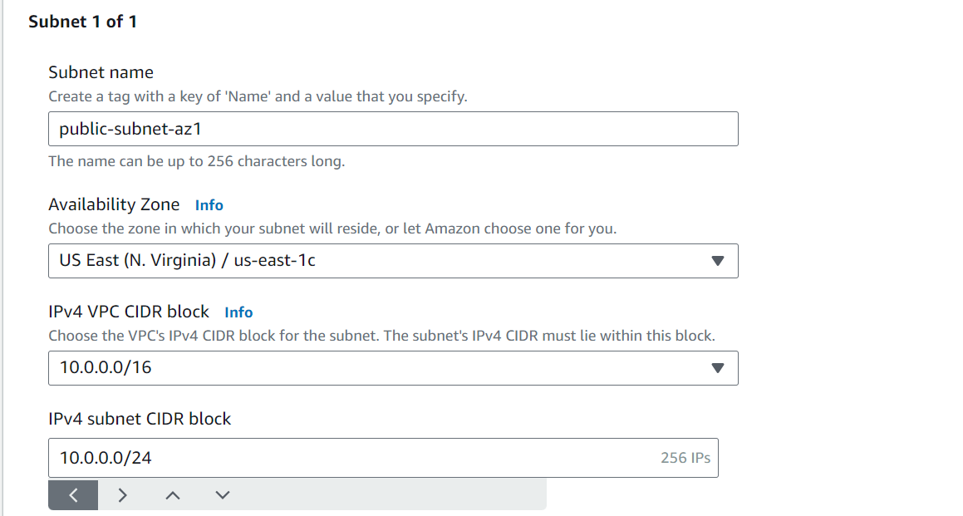
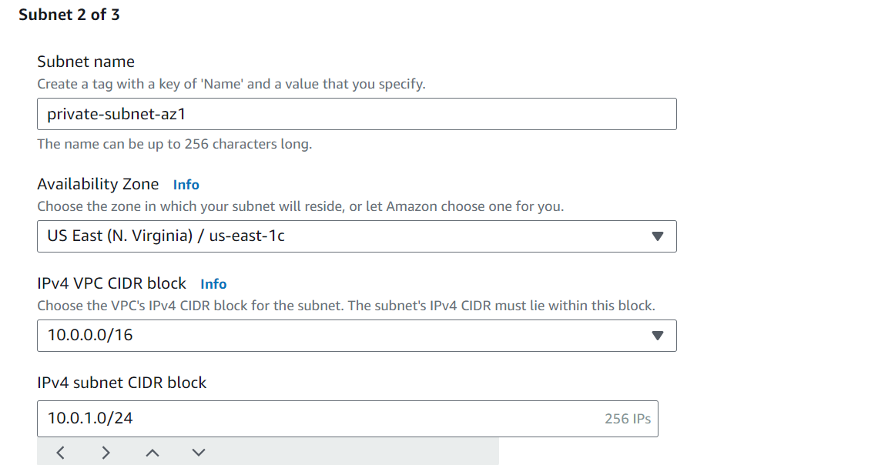
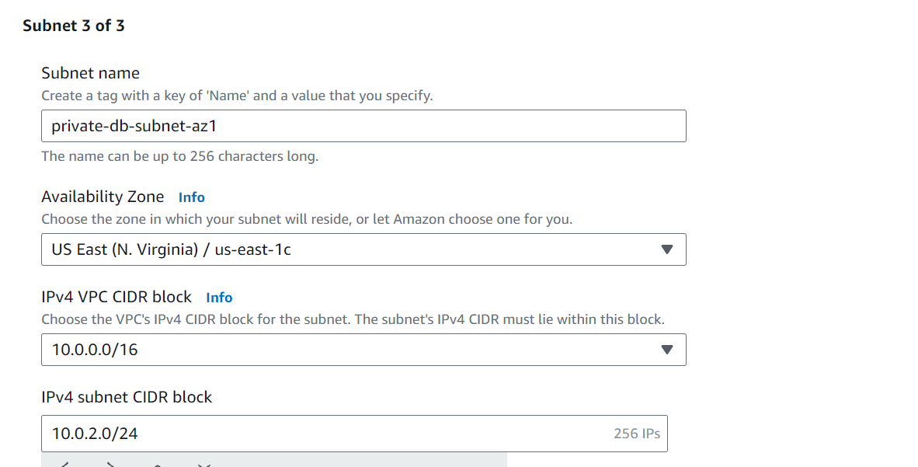
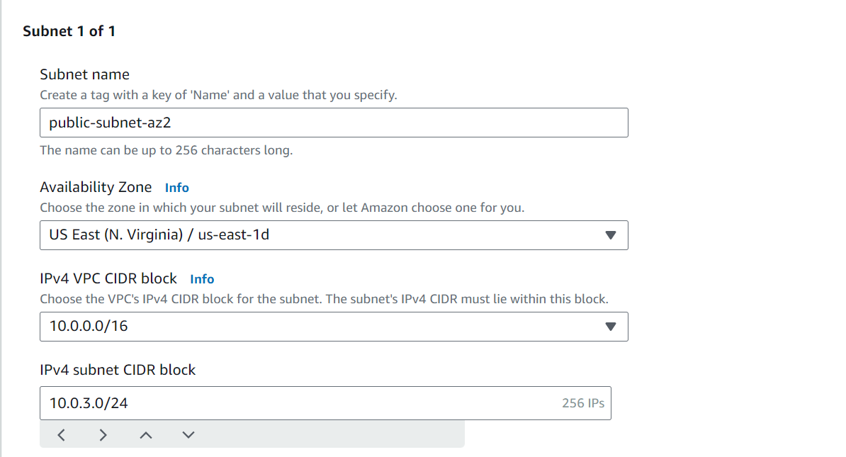
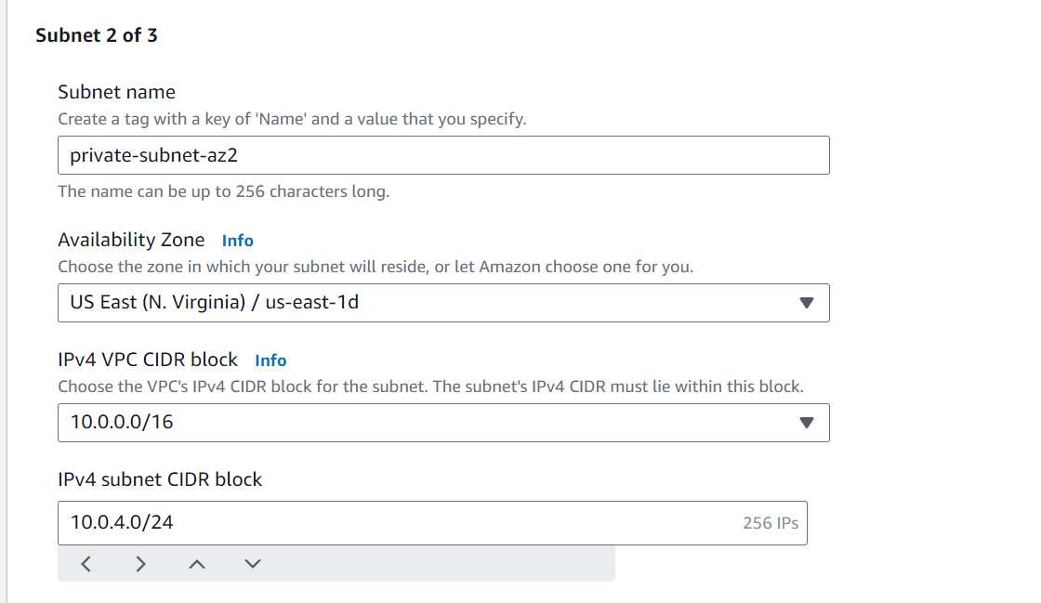
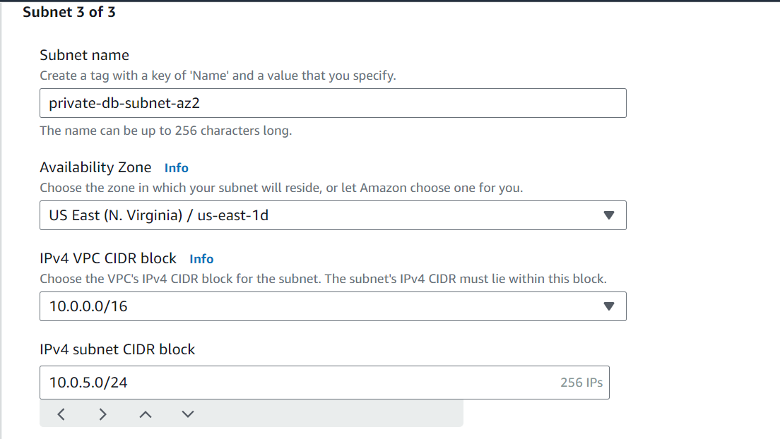
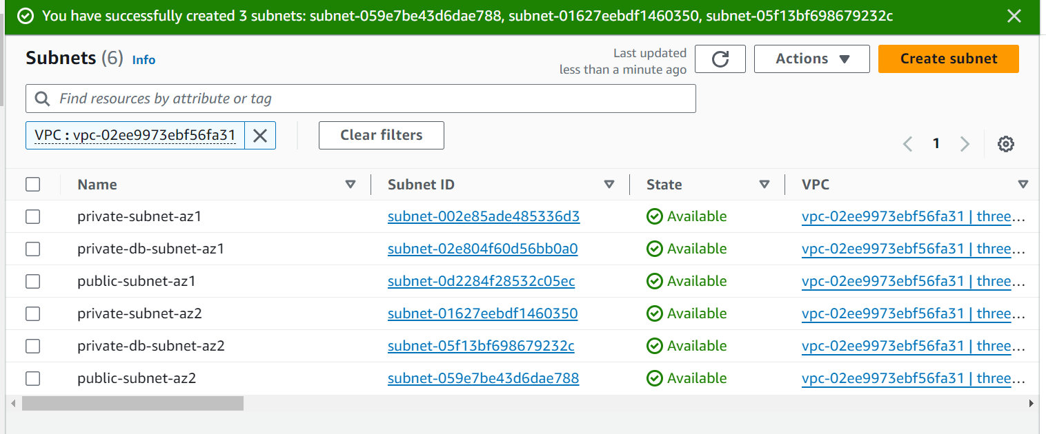

- Create an Internet Gateway and associate it with the VPC
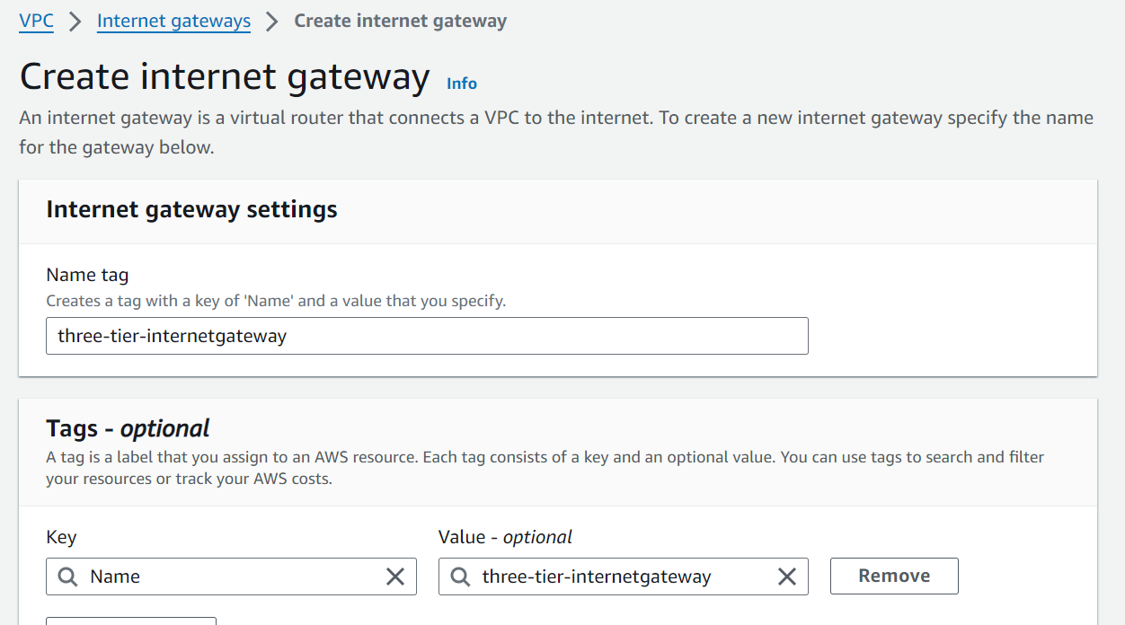

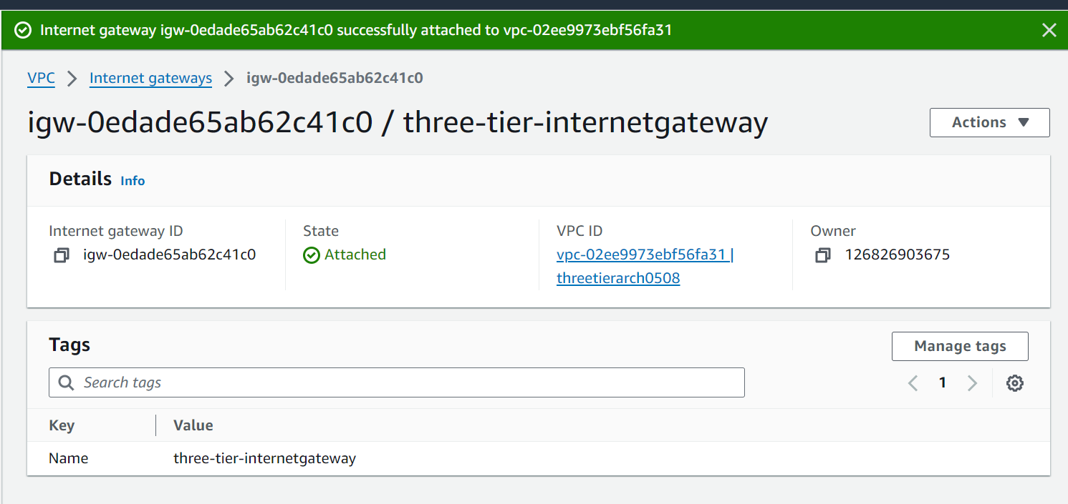

- Create a NAT gateway to allow instances in the private subnet to access Internet. We will have to create one NAT gateway per AZ so that the instances in each AZ can connect to Internet and to maintain high availability
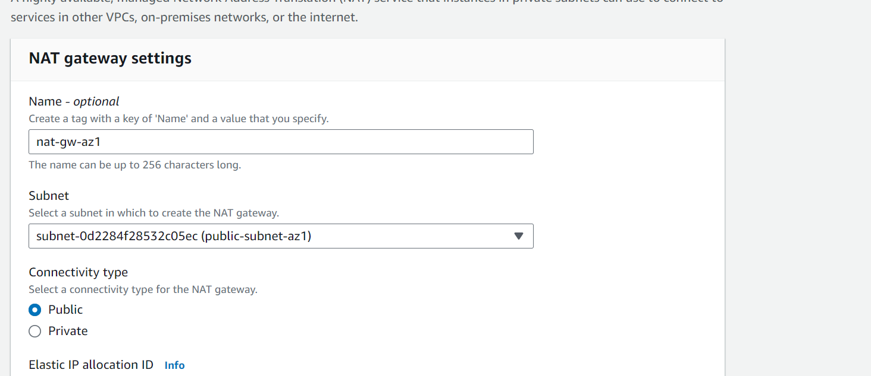
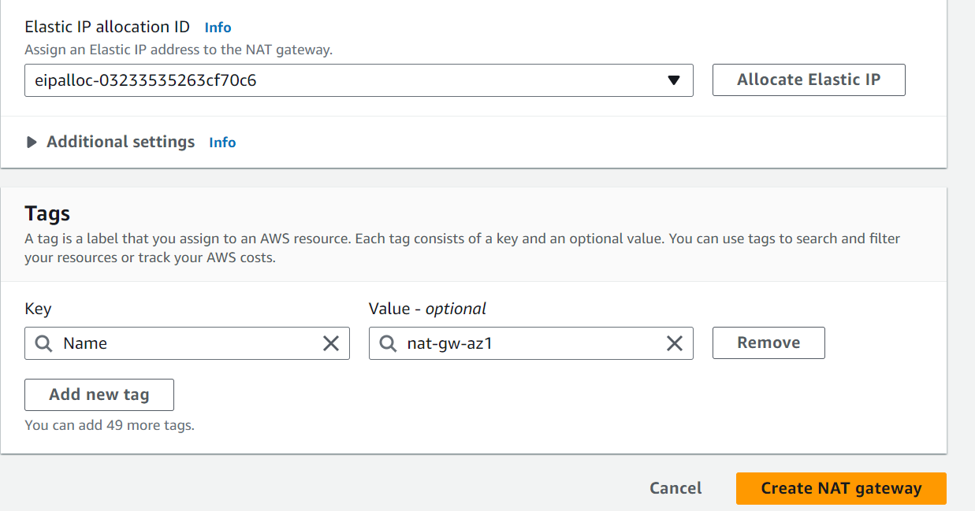
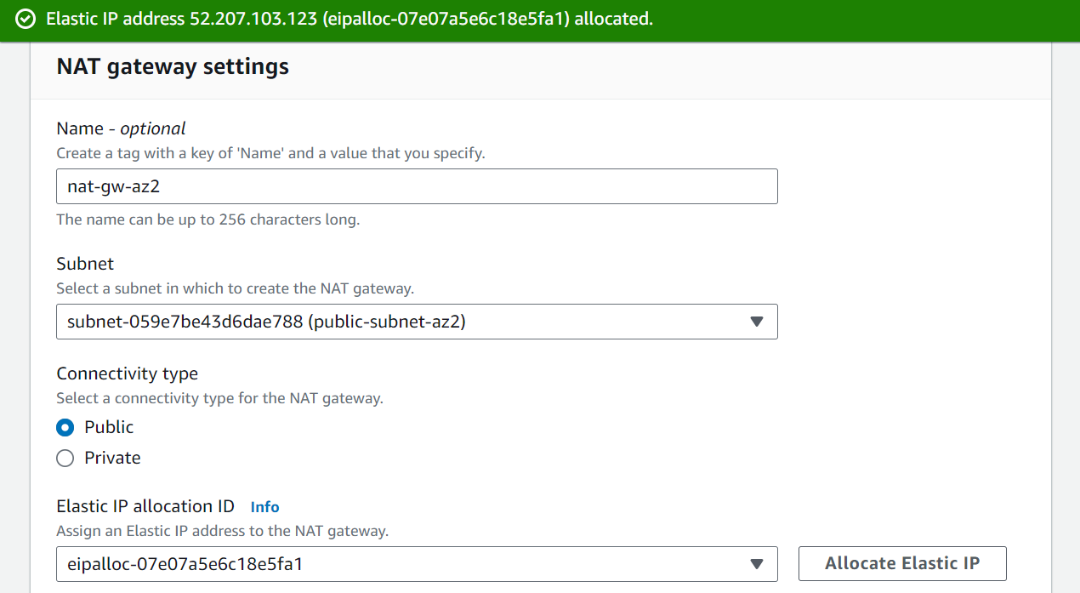

- Create a public route table and add a route to allow traffic from VPC to the internet i.e. any traffic outside VPC CIDR range will be directed to the internet gateway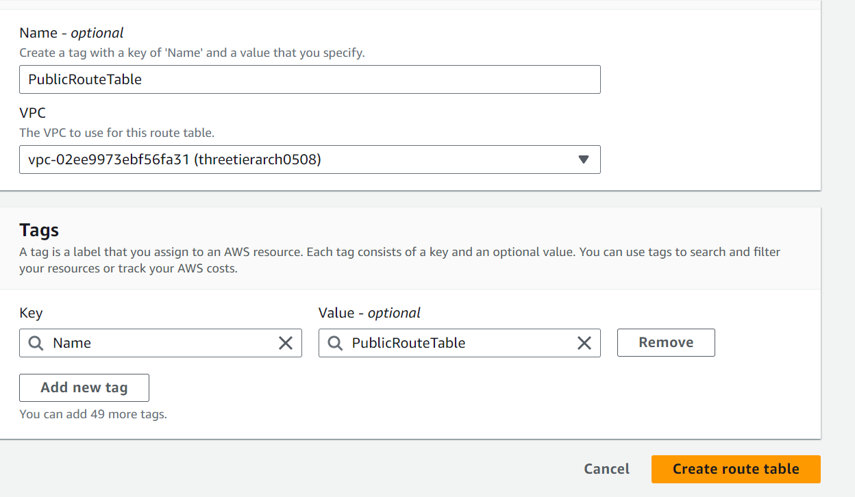
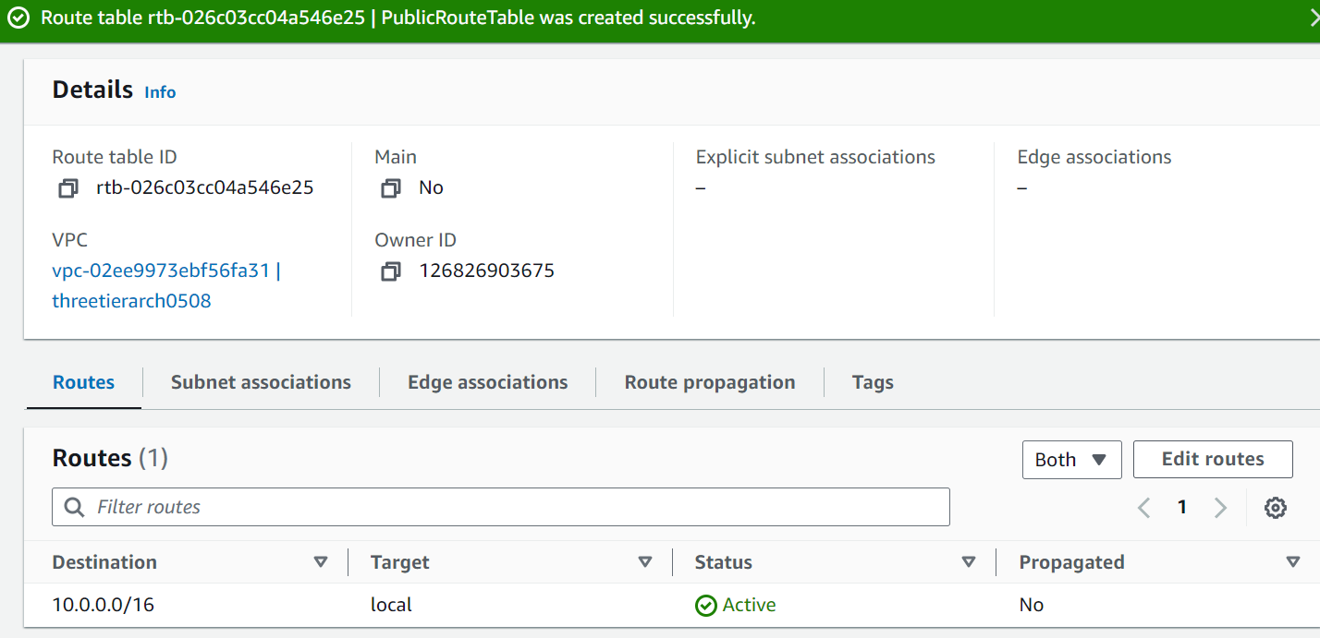
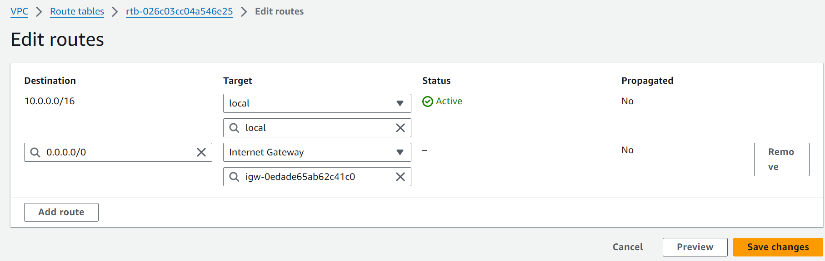

- Go to Subnet Associations and click on Edit subnet associations. Add the two public subnets

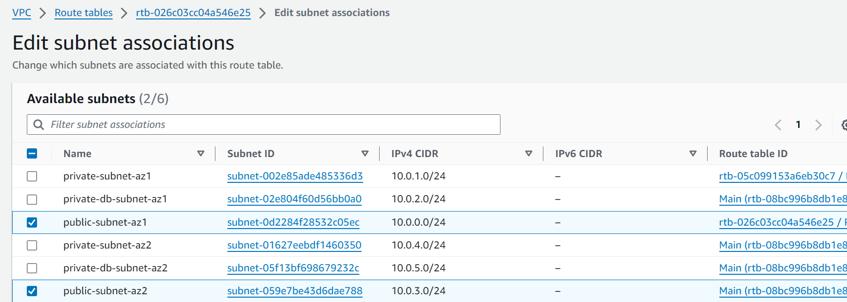
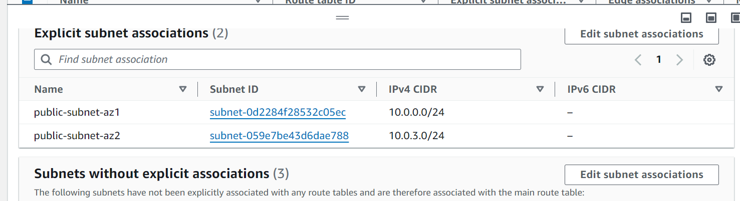

- Create a route table to redirect the traffic from private web subnet in AZ1 to the internet through the NAT gateway in AZ1. Add a route to send traffic to the internet through the NAT gateway. Similarly create another route table to redirect the traffic from private subnet in AZ2 to the internet through the corresponding NAT gateway in AZ2. Add a route to send the traffic to the internet through the NAT gateway
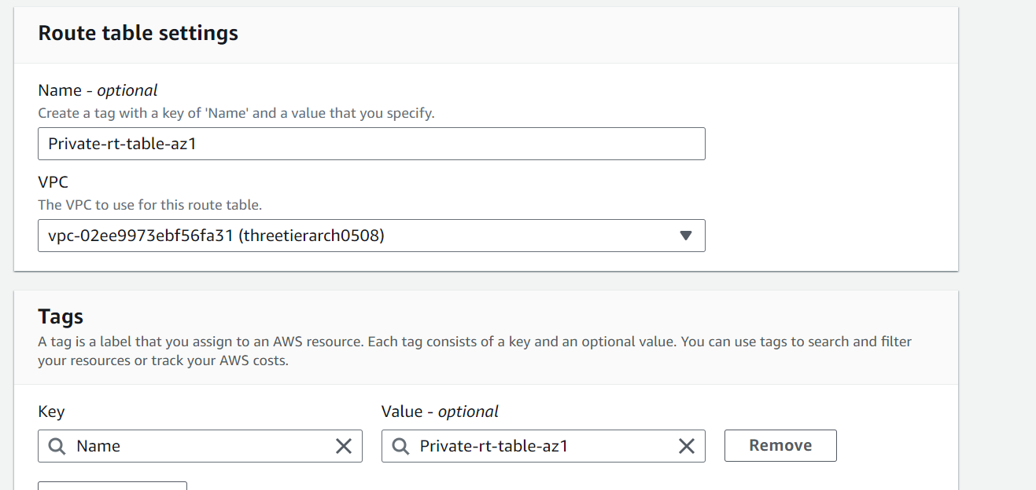
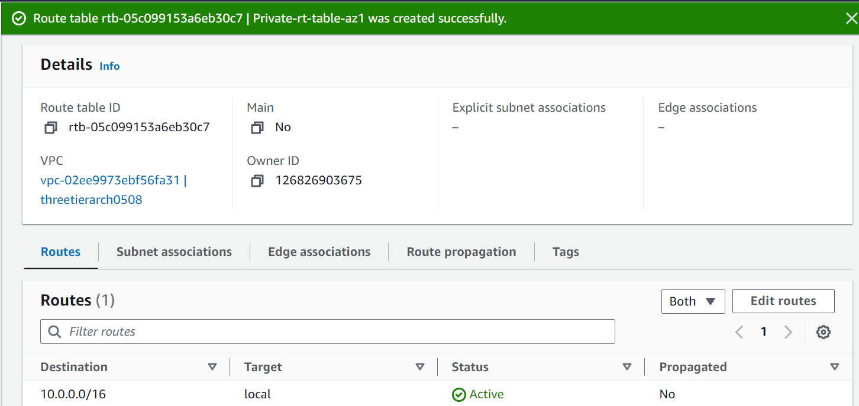
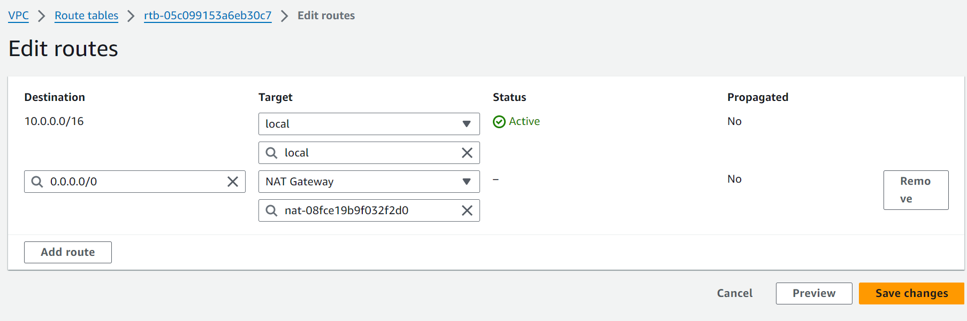
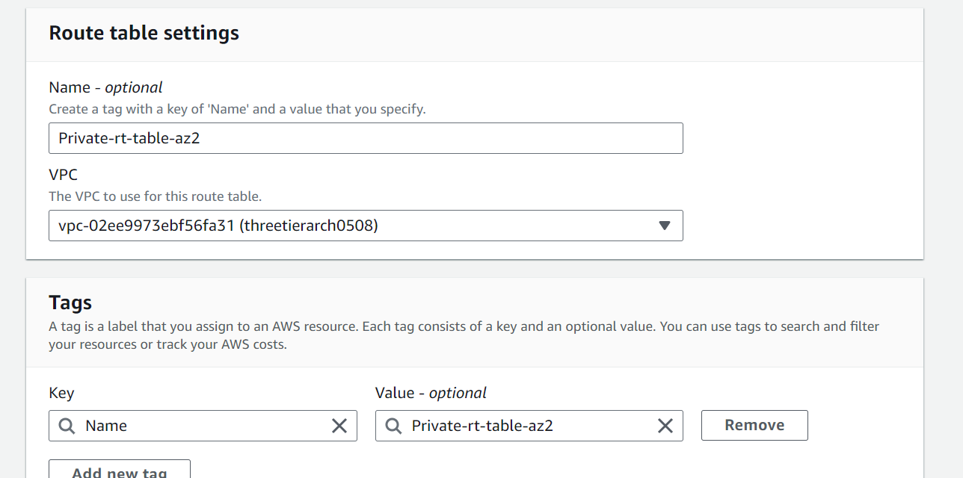
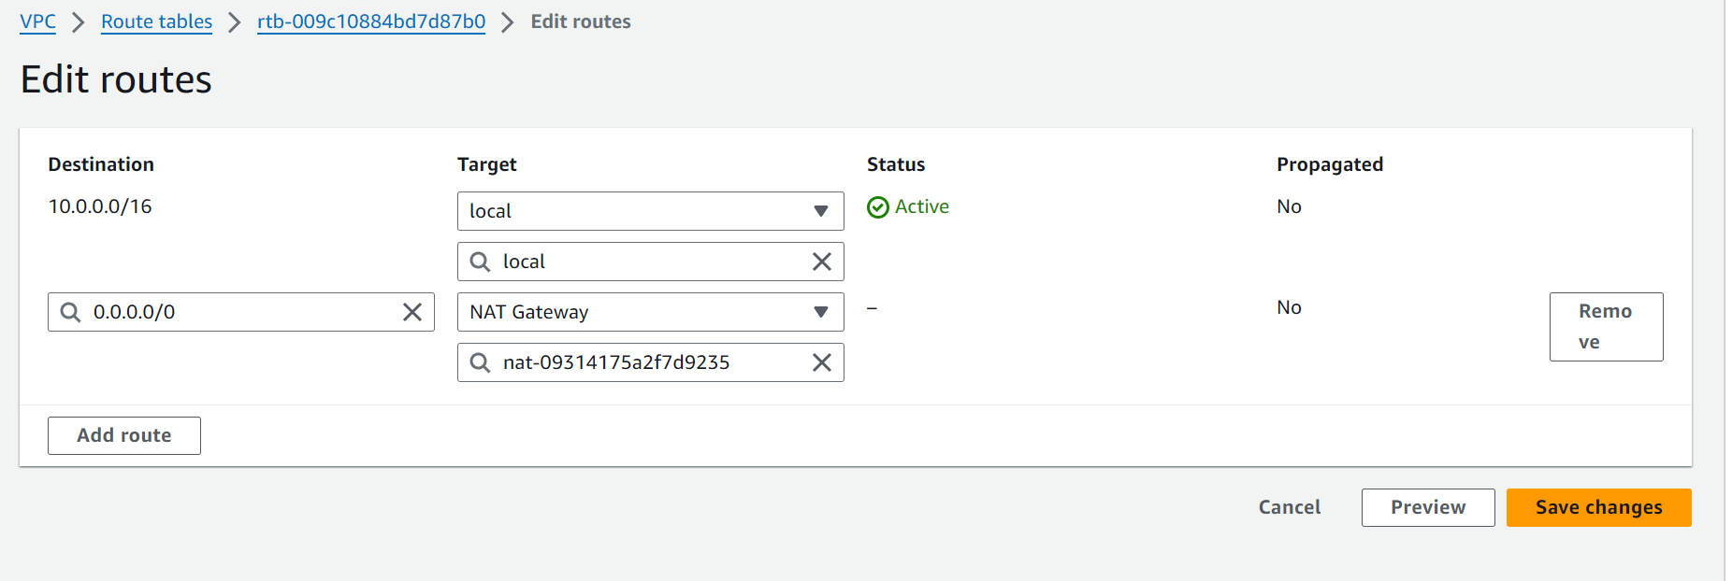

- Go to subnet association and attach the route tables in AZ1 and AZ2 to private web subnets in AZ1 and AZ2 respectively
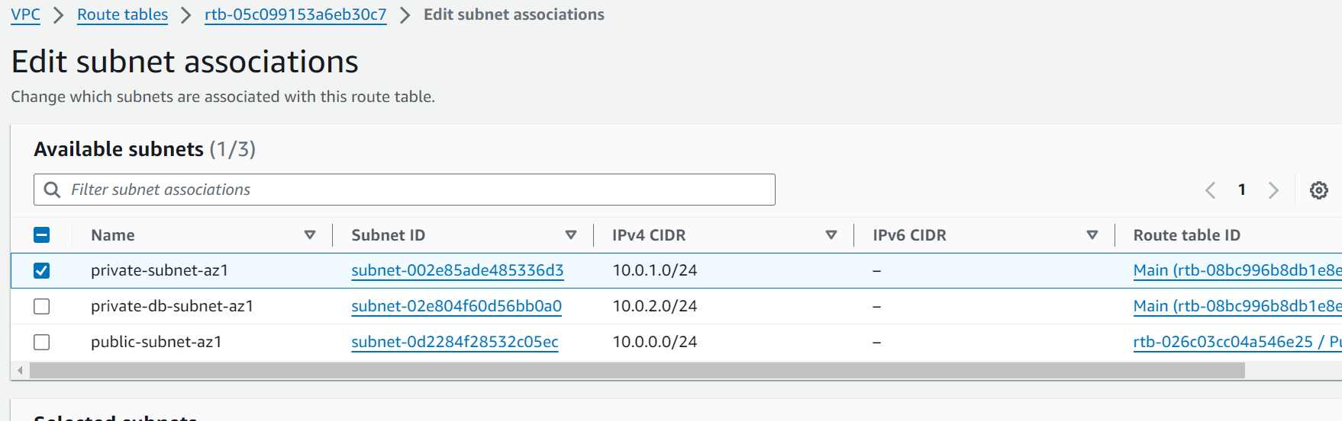
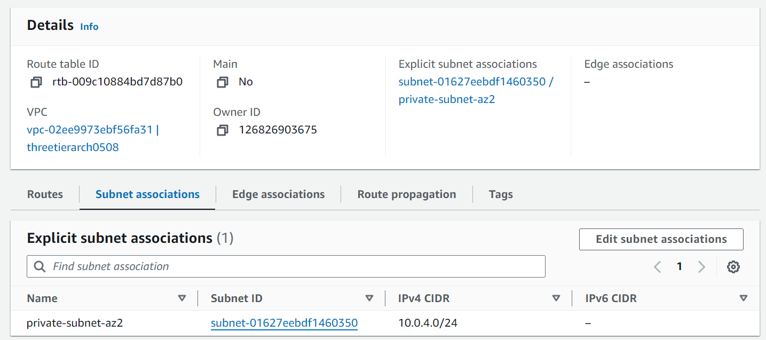

- Create security group to allow users from the internet to access public internet facing load balancer. Add inbound rule to allow HTTP traffic to your IP
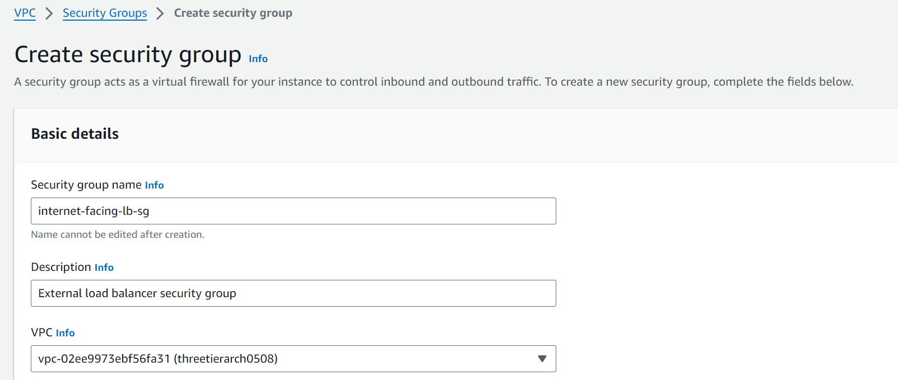
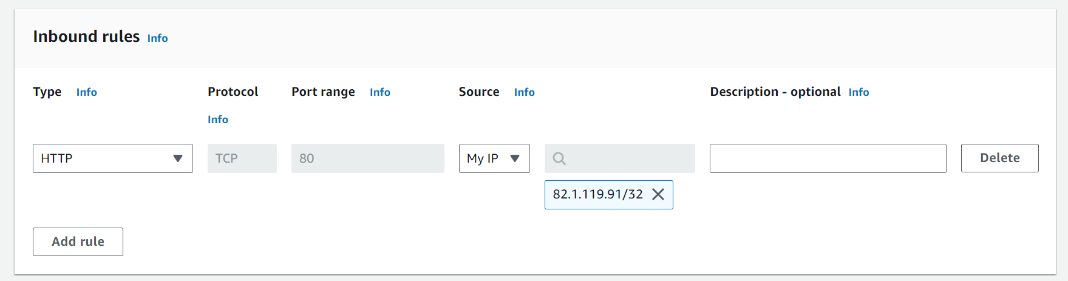

- Create a security group to manage the traffic on the web tier instances. Add an inbound rule to allow traffic from security group of public load balancer and your IP
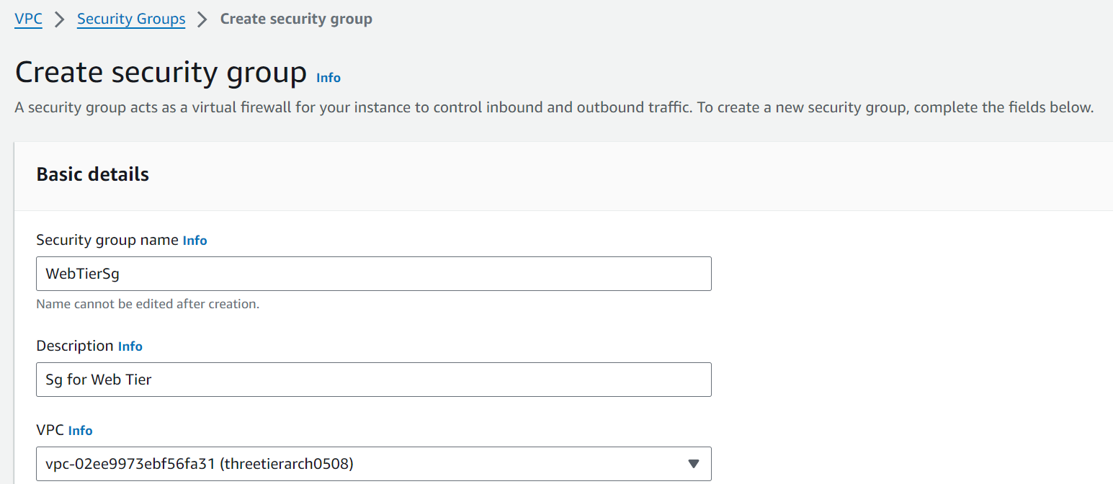
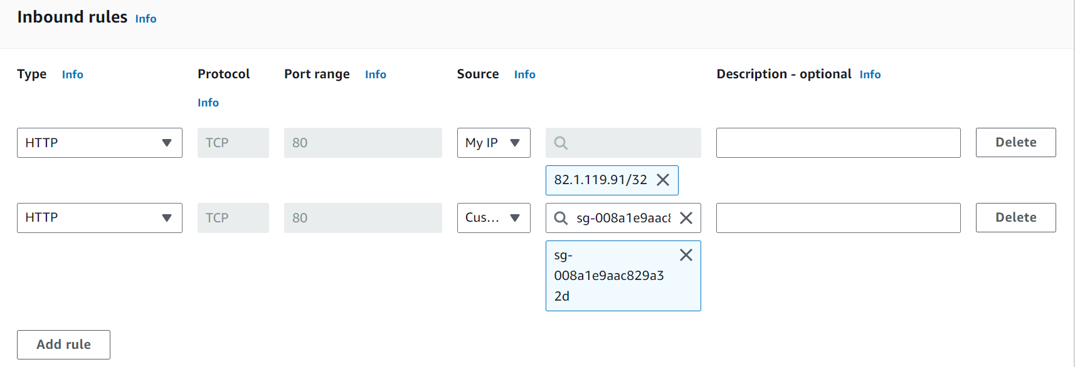
- Create third security group for the internal load balancer. Add inbound rules to allow security group of web servers to access the internal load balancer
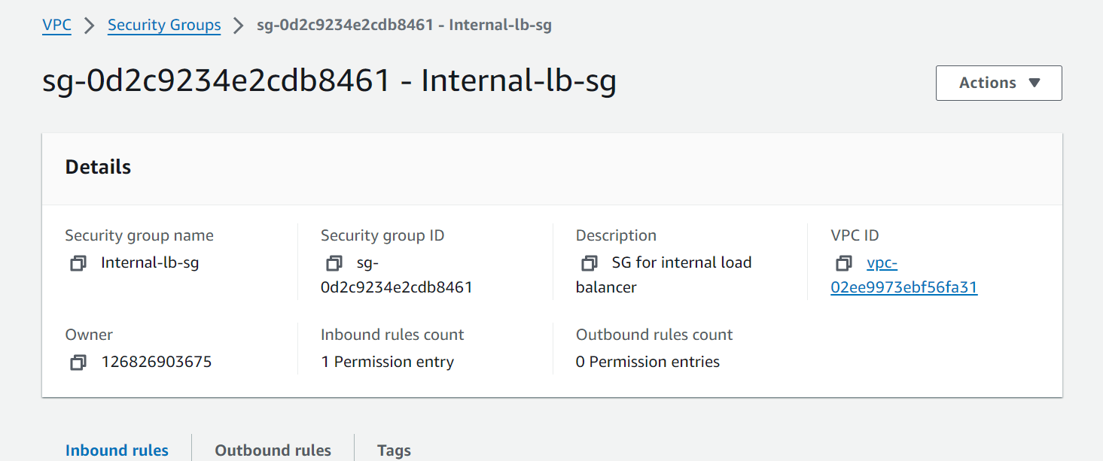

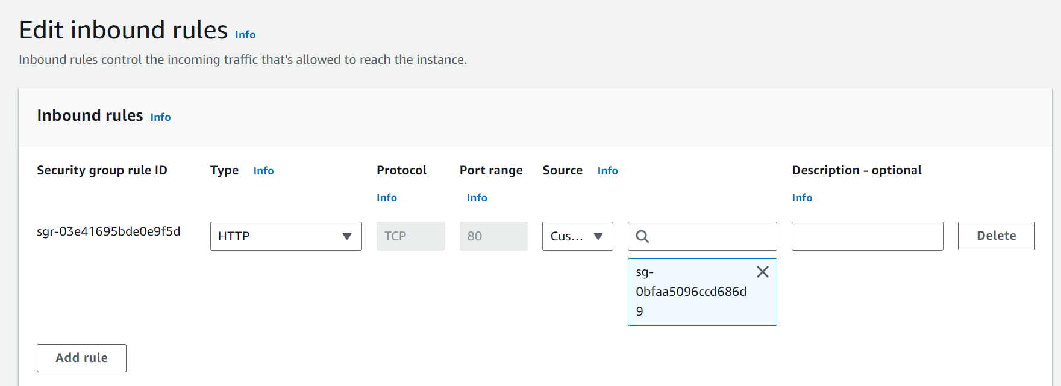

- Create fourth security group for the private instances. Add an inbound rule to allow traffic from security group of internal load balancer to the private instances. Add an inbound rule to allow traffic on port 4000
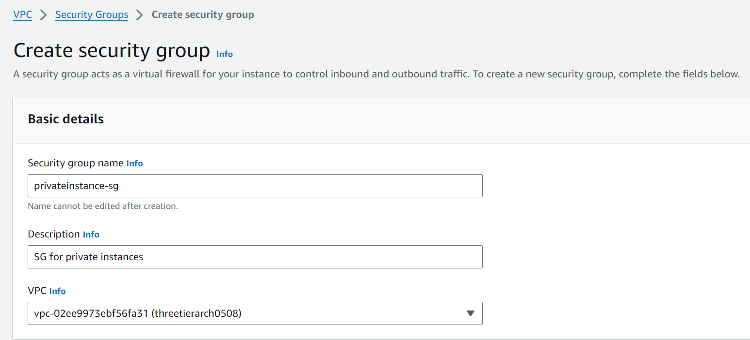
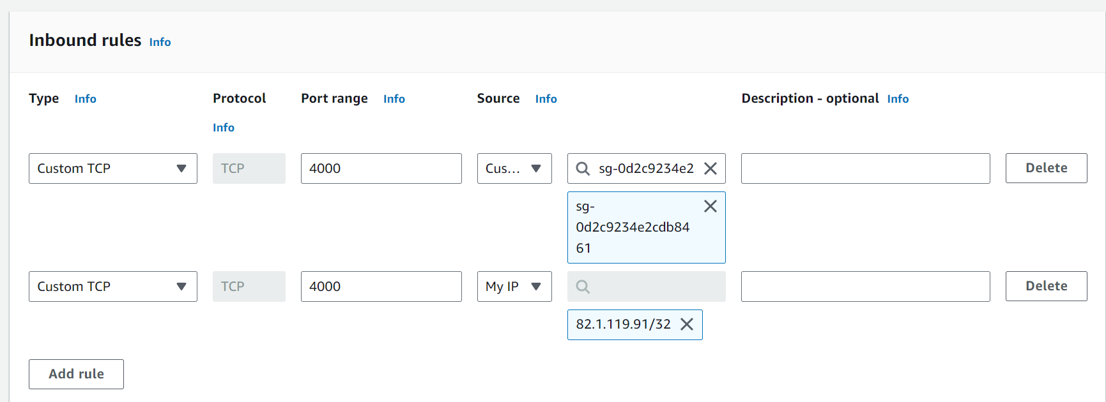

- Create a Fifth security group to allow the traffic from the private instances to our private database instances. For this security group, add an inbound rule that will allow traffic from the private instance security group to the MYSQL/Aurora port (3306).
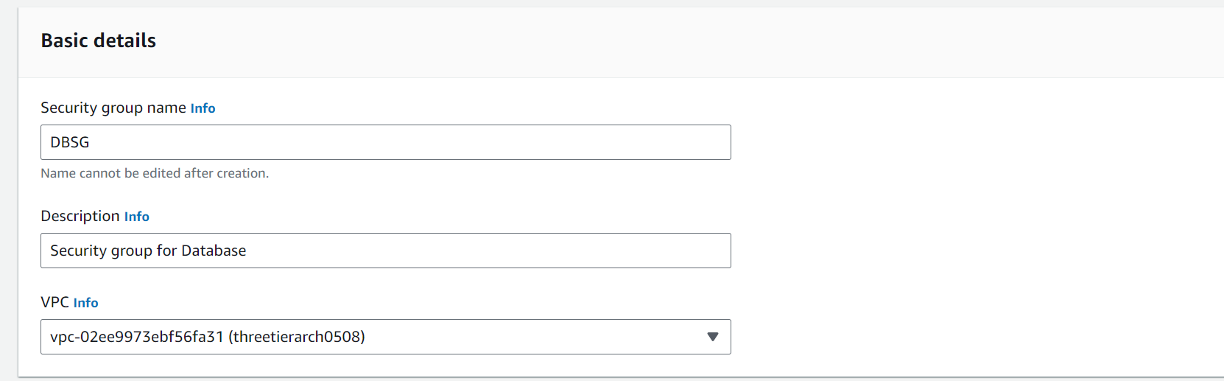
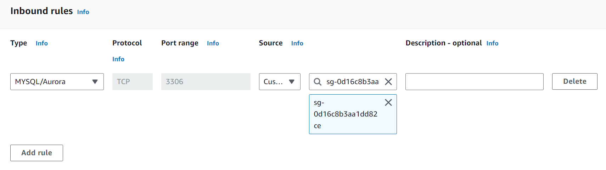

- Next step is to create RDS database. To provision RDS database we have to provision database subnet groups. Select VPC and the availability zones. Additionally select the two subnets created for DB instances. Configure the DB instance as follows and keep rest of the settings default

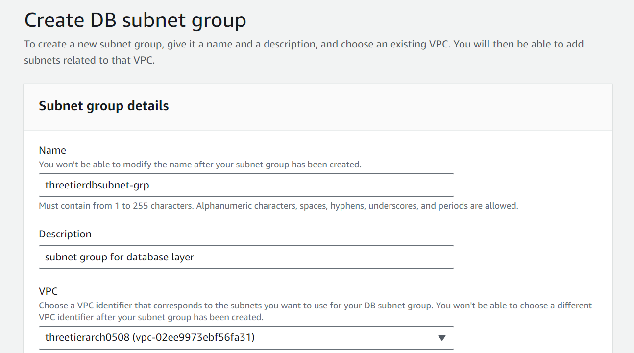

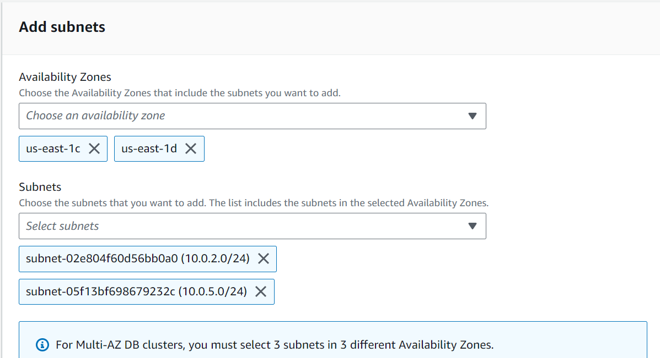

- Lets do the database deployment. Go to Create database
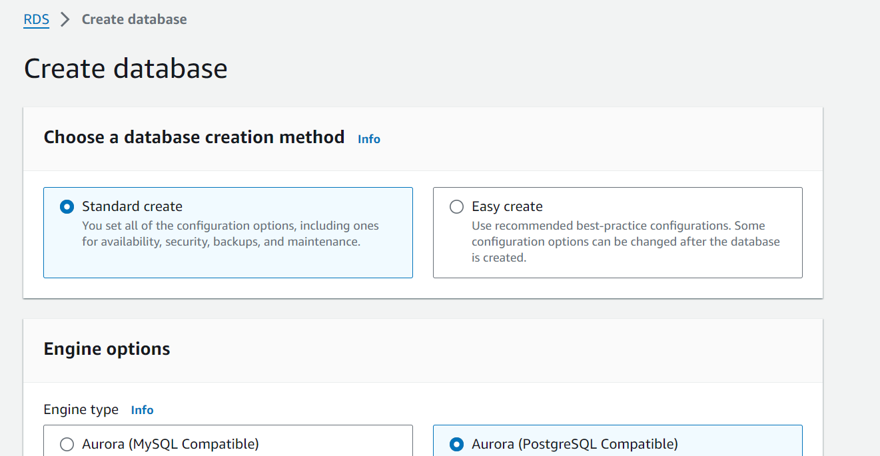
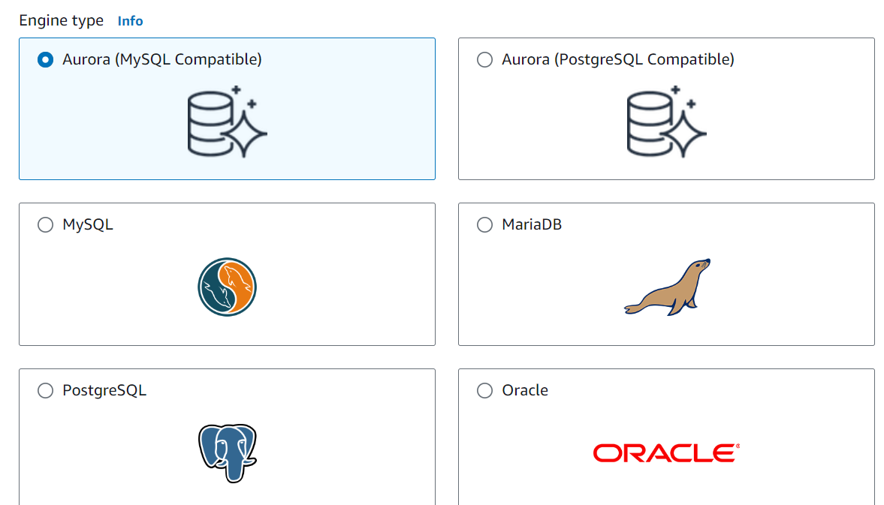
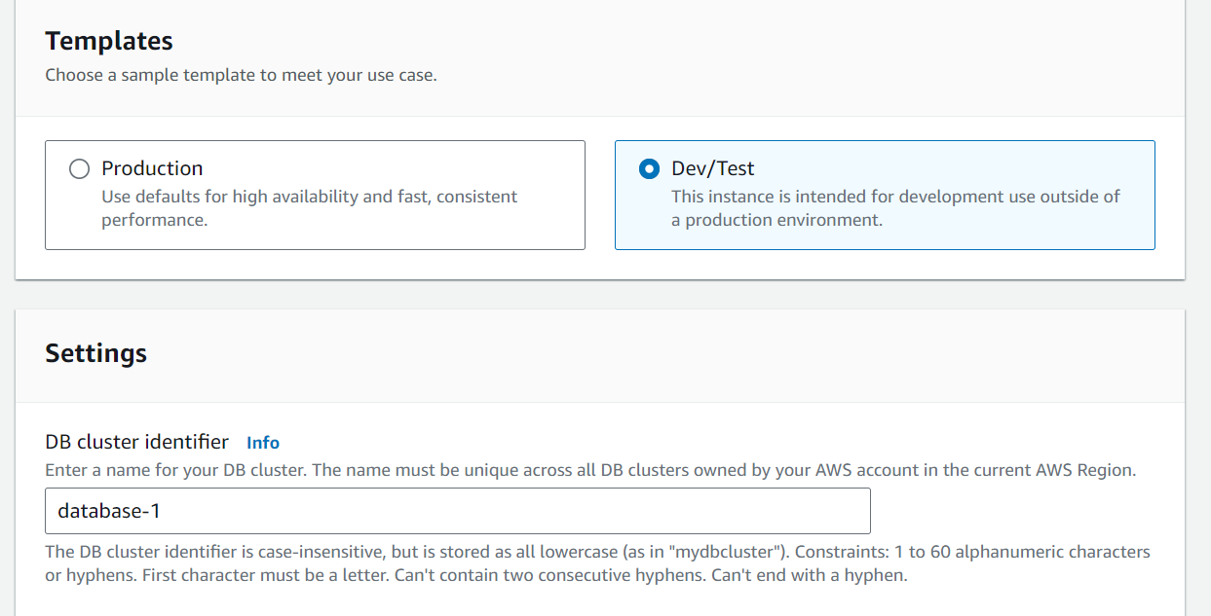
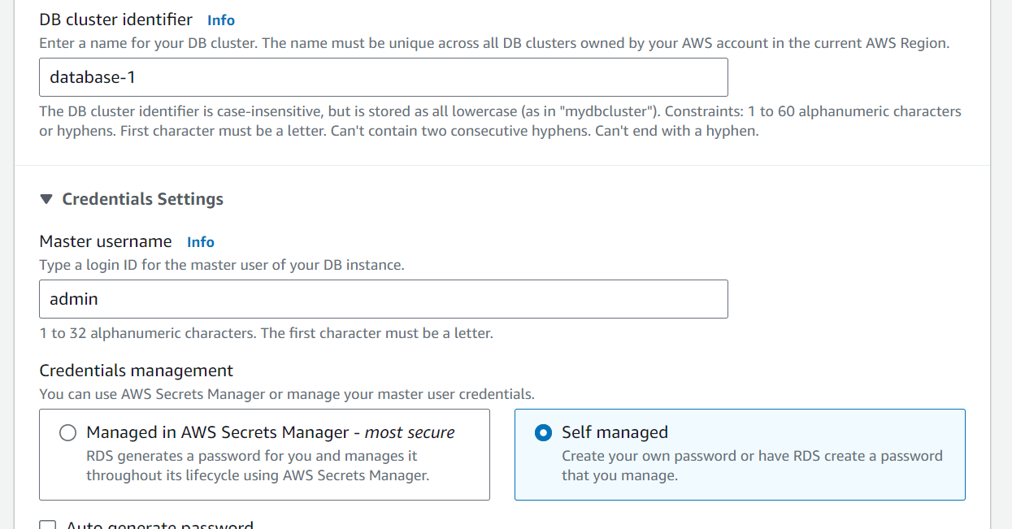
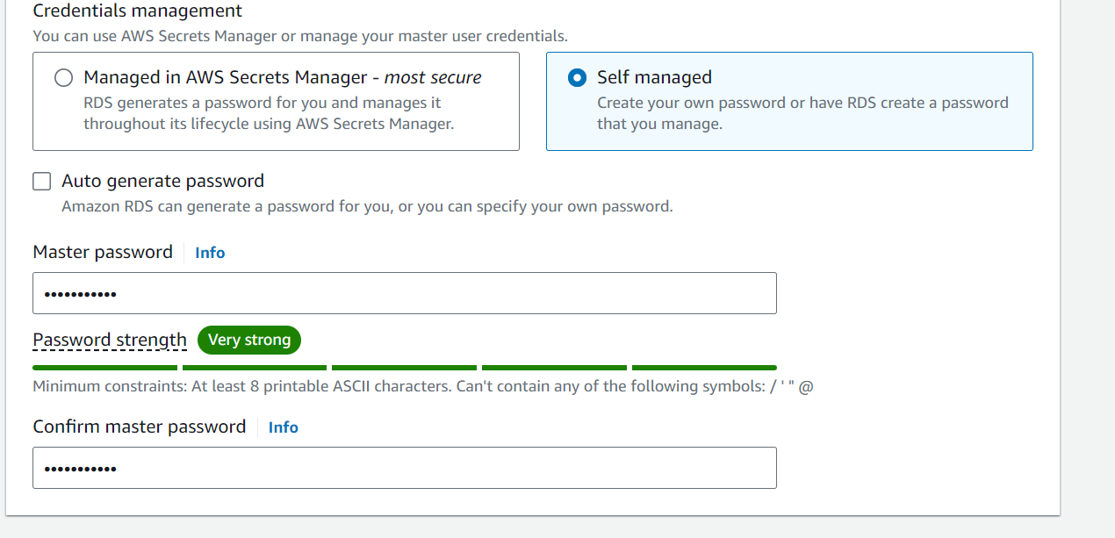

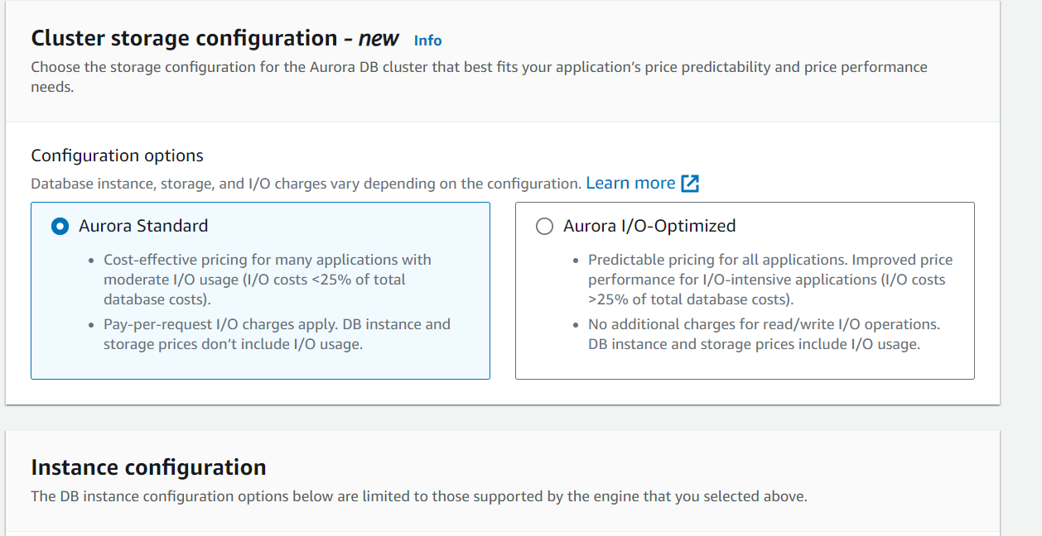
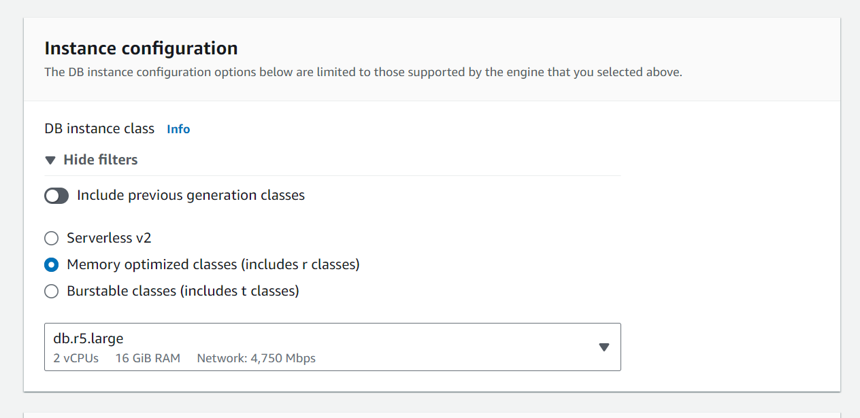
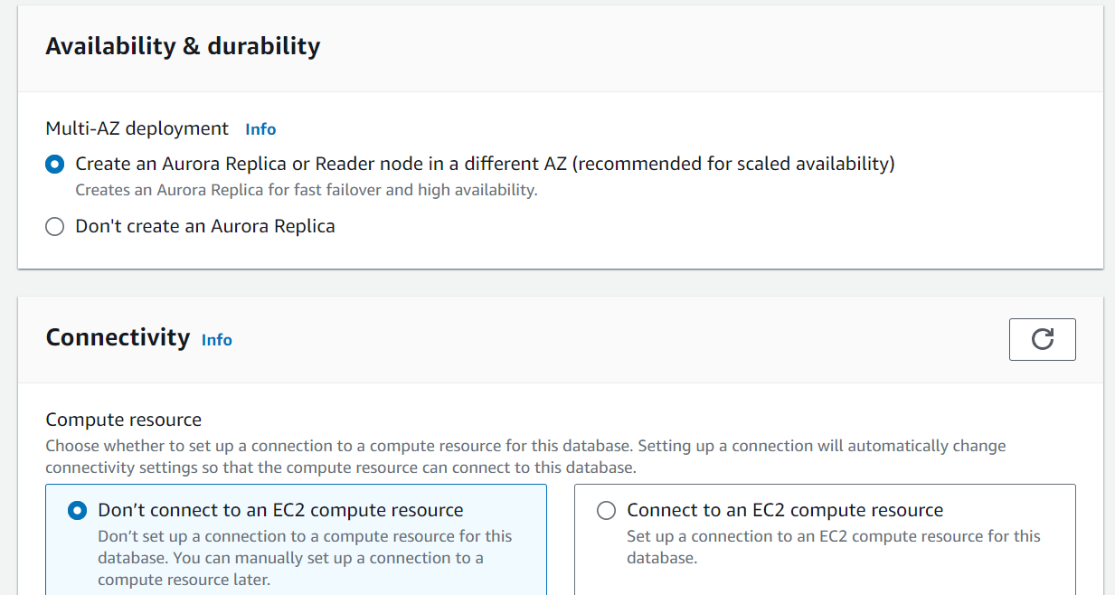
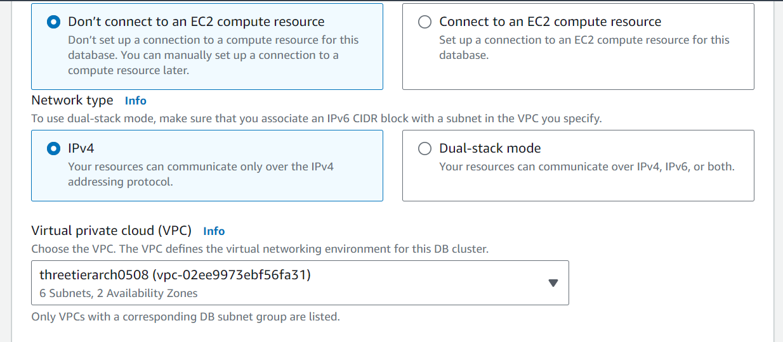
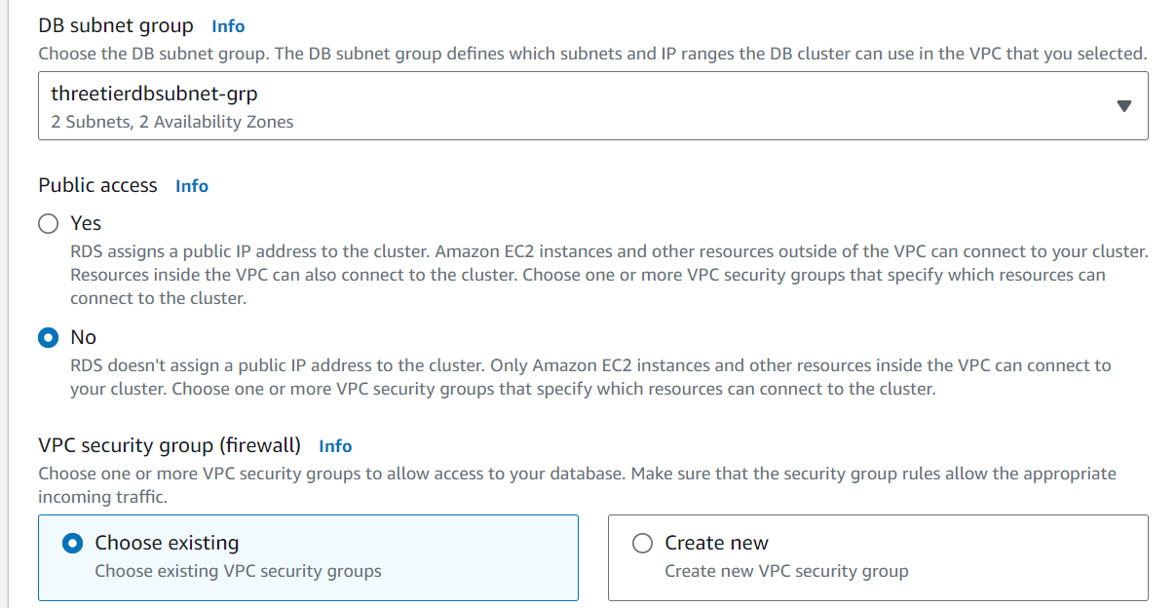
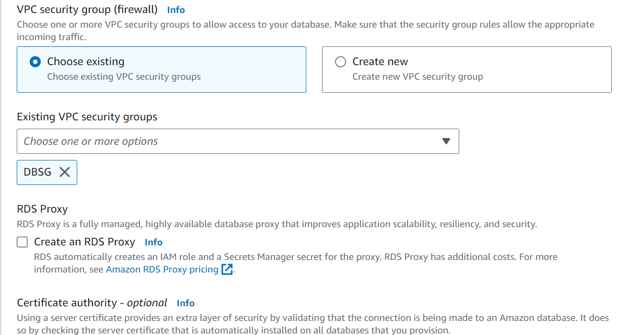
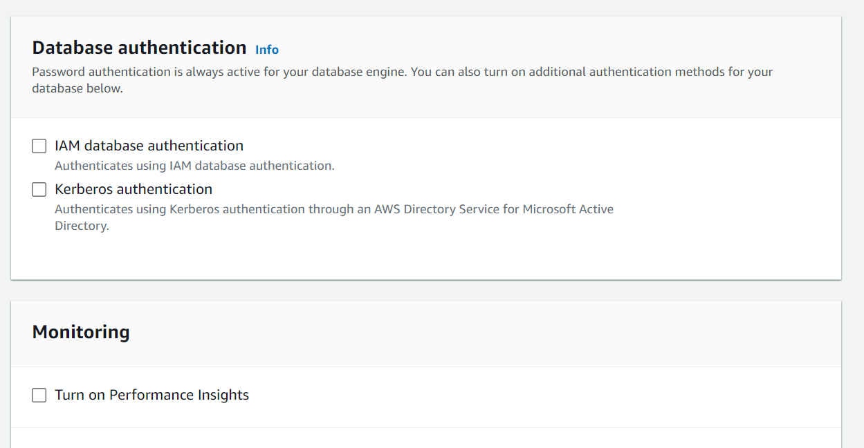
When your database is provisioned, you should see a reader and writer instance in the database subnets of each availability zone. Note down the writer endpoint for your database for later use
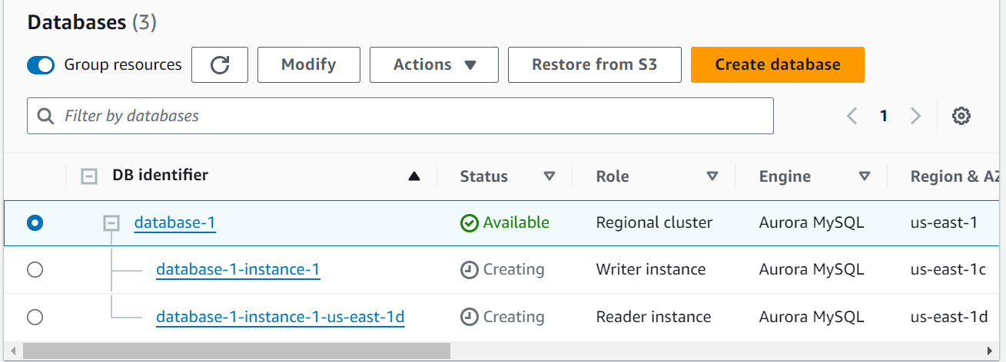

- We will create an EC2 instance for our app layer and make all necessary software configurations so that the app can run. The app layer consists of a Node.js application that will run on port 4000. We will also configure our database with some data and tables.
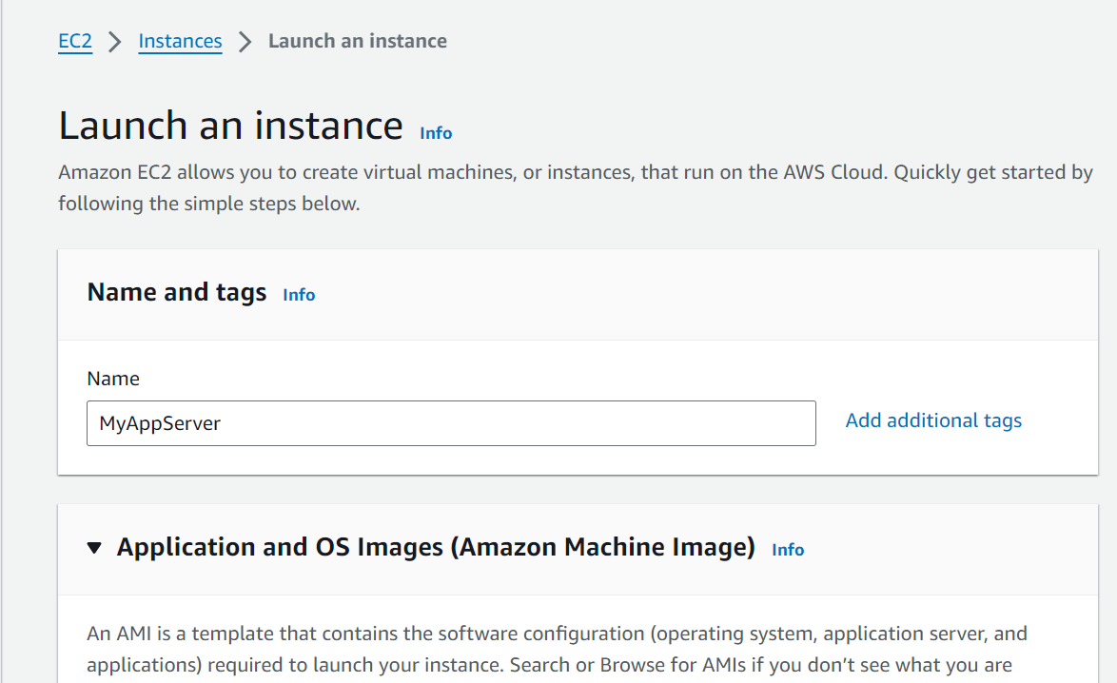
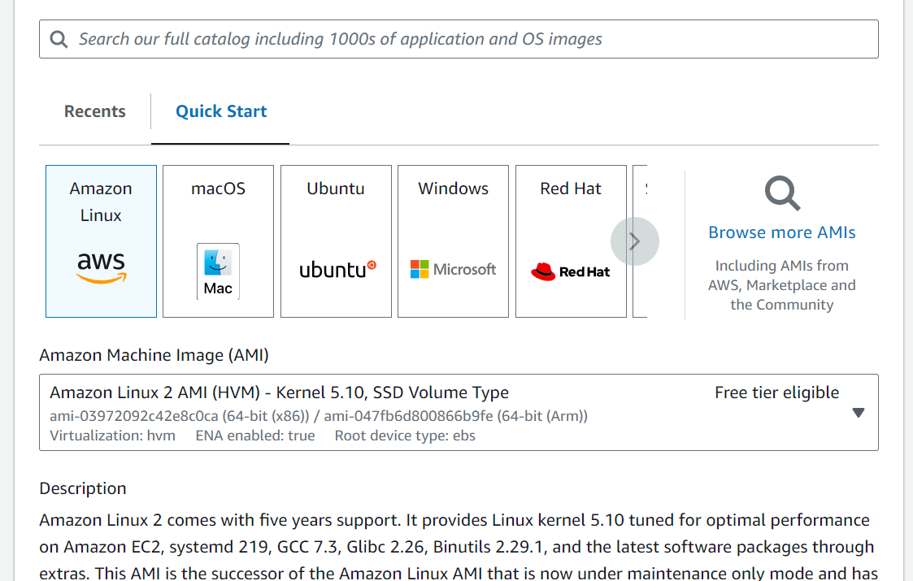
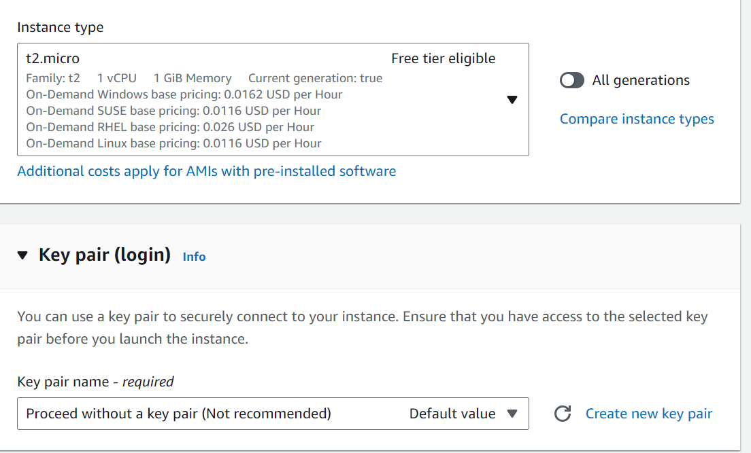
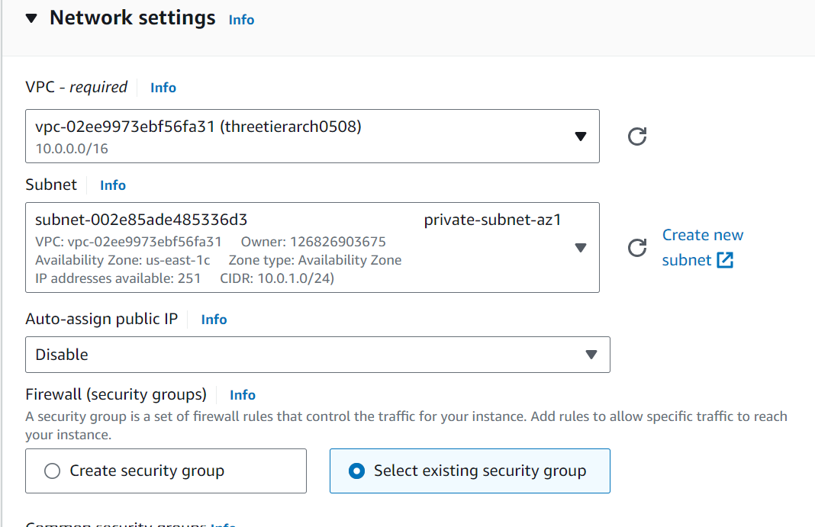
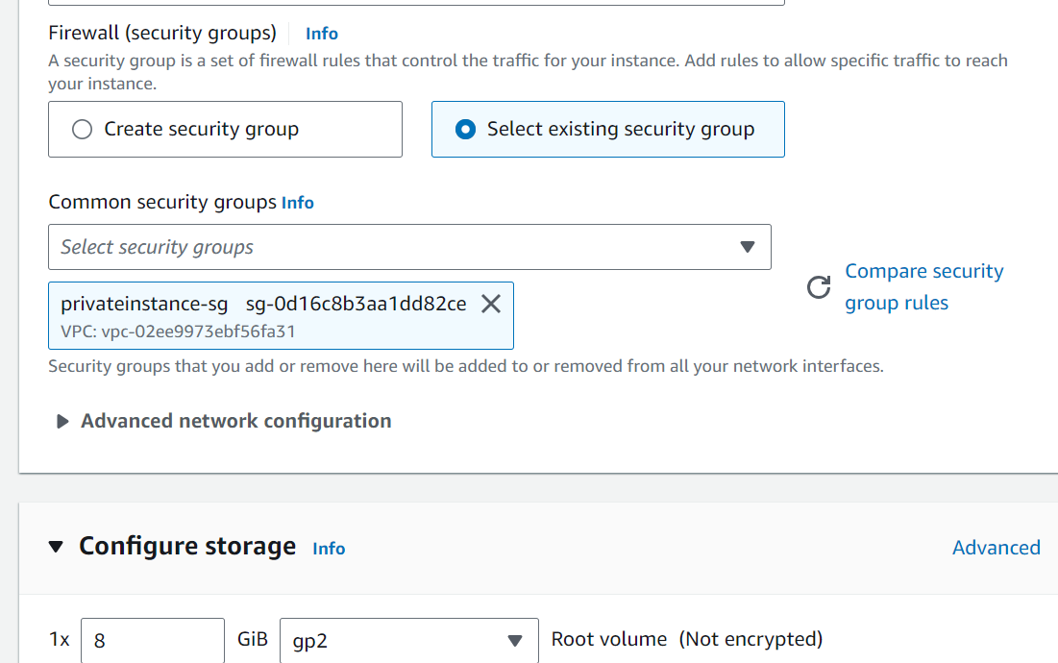

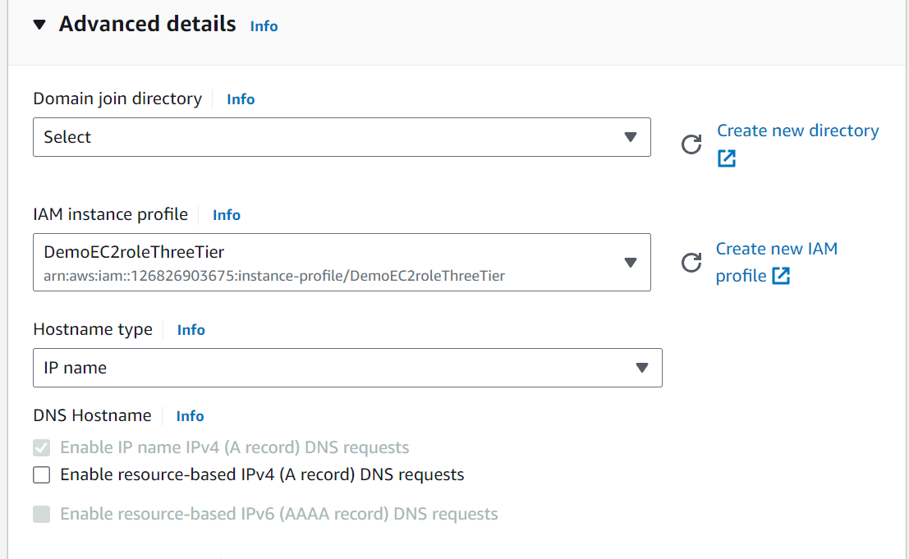
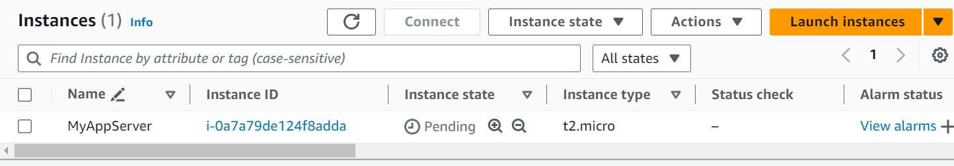

- Click the checkbox against the created instance and click on Connect.

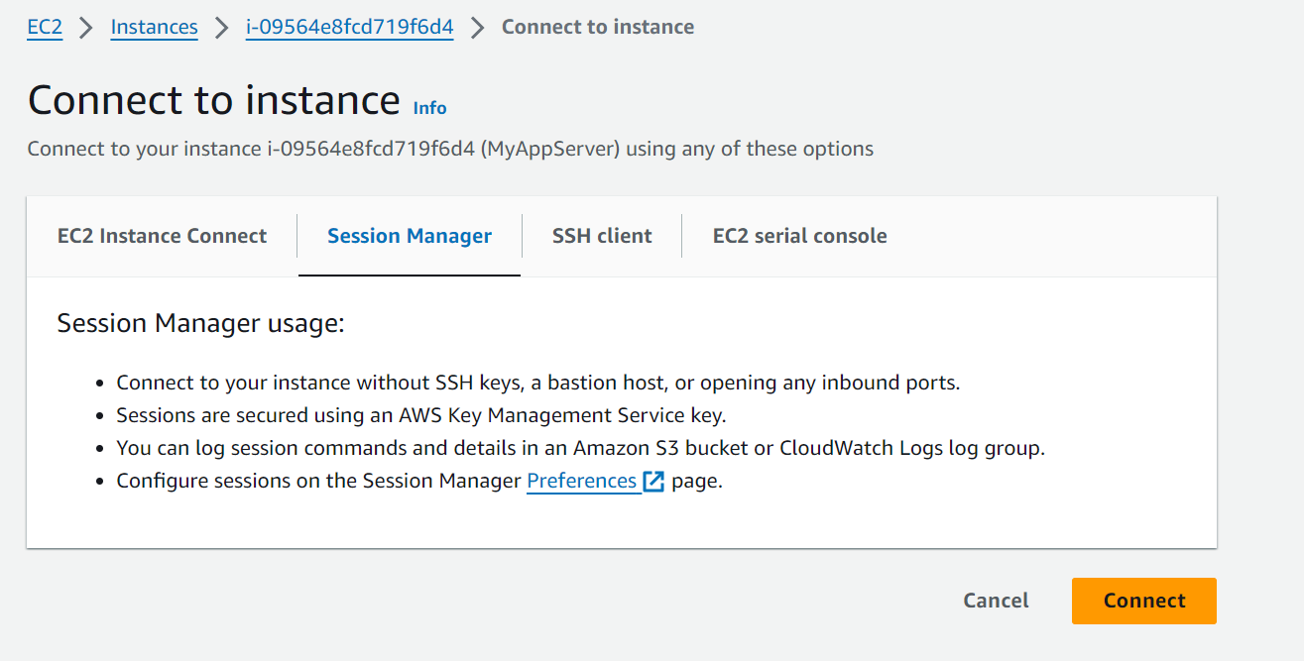

- When you first connect to your instance like this, you will be logged in as ssm-user which is the default user. Switch to ec2-user by executing command sudo -su ec2-user. Execute ping 8.8.8.8 to connect to check if the instance is able to reach to the Internet through the NAT gateway.You should see transmission of packets. Stop it by pressing ctrl+C. If you can’t reach the internet then you need to double check your route tables and subnet associations to verify if traffic is being routed to your NAT gateway!
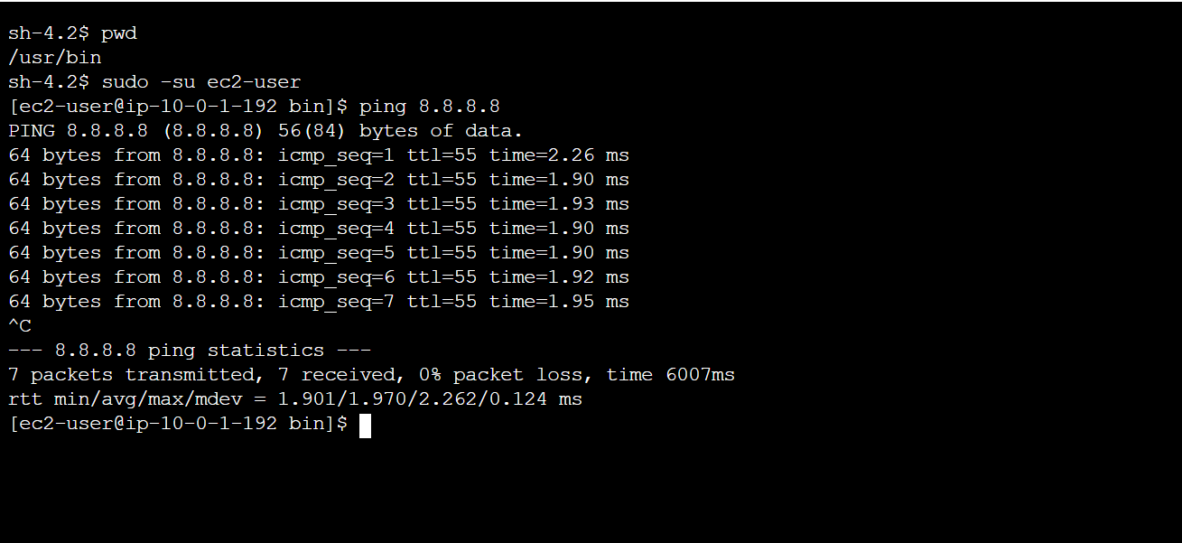

- Download MySQL CLI
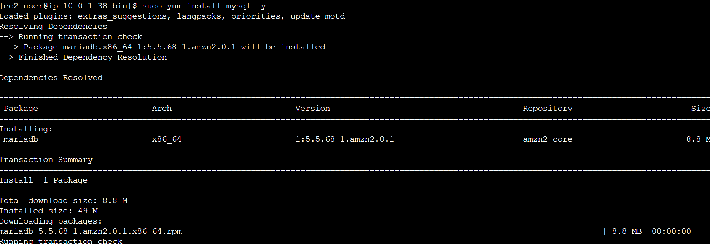
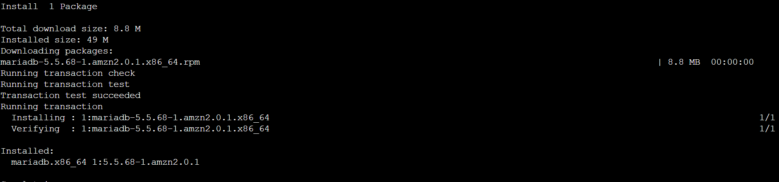

- Initiate your DB connection with your Aurora RDS writer endpoint. In the following command, replace the RDS writer endpoint and the username, and then execute it in the browser terminal
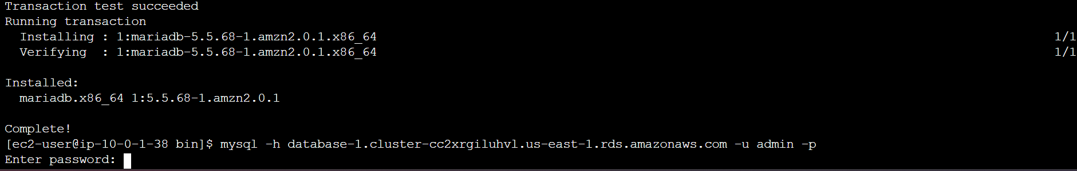
- You will then be prompted to type in your password. Once you input the password and hit enter, you should now be connected to your database.
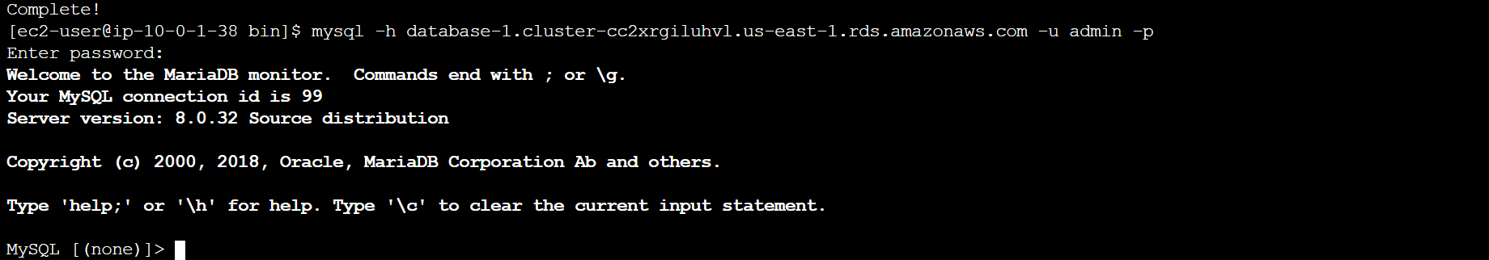

- Create a database called webappdb with the following command
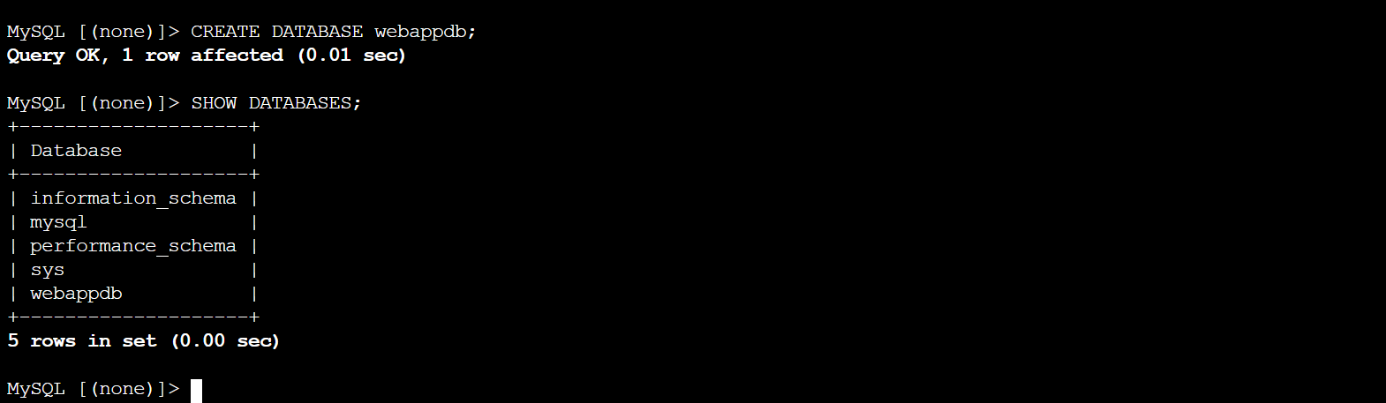
- Create a data table by navigating to the database we just created
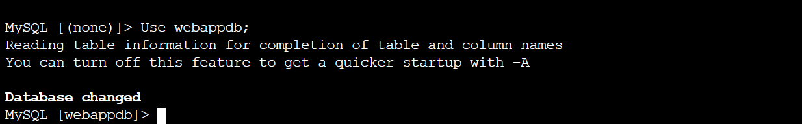
- Create the following transactions table by executing this create table command
- Verify the table was created
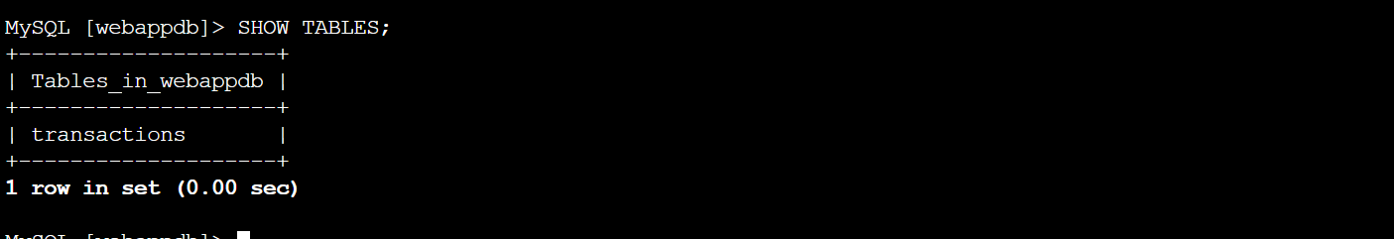
- Insert data into table for use/testing later
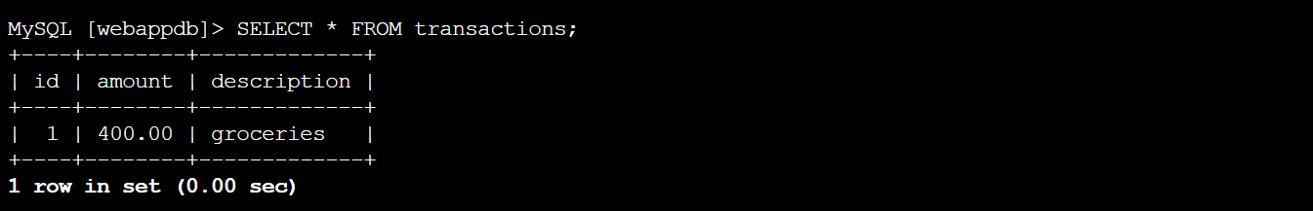
- When finished just type exit and hit enter to exit the MySQL client

- The first thing we will do is update our database credentials for the app tier. To do this, open the application-code/app-tier/DbConfig.js file from the github repo in your favourite text editor on your computer. You’ll see empty strings for the hostname, user, password and database. Fill this in with the credentials you configured for your database, the writer endpoint of your database as the hostname, and webappdb for the database. Save the file

- Upload the files in app-tier folder to the S3 bucket that you created
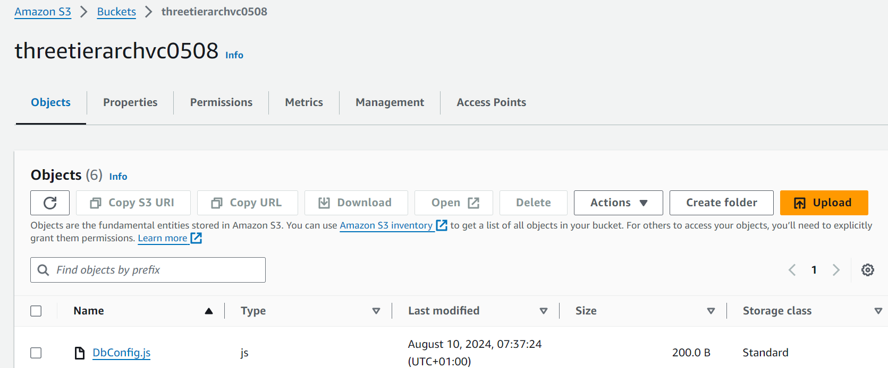
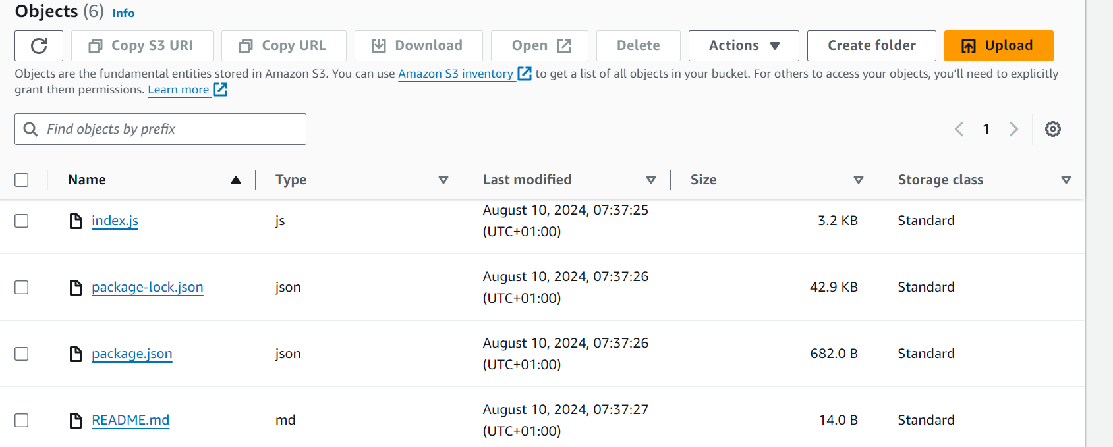
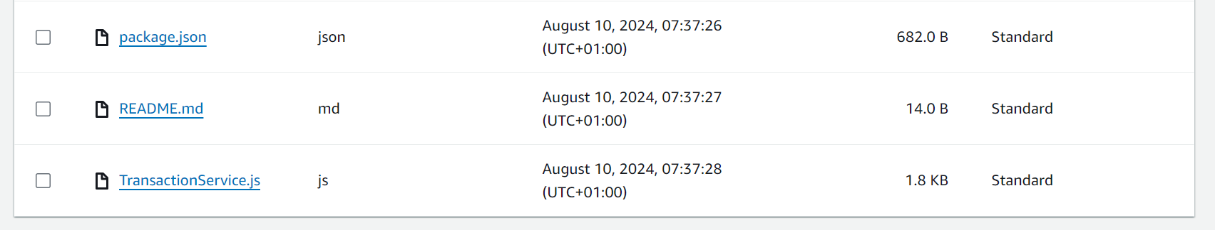

- Now we need to install all of the necessary components to run our backend application. Start by installing NVM (node version manager).
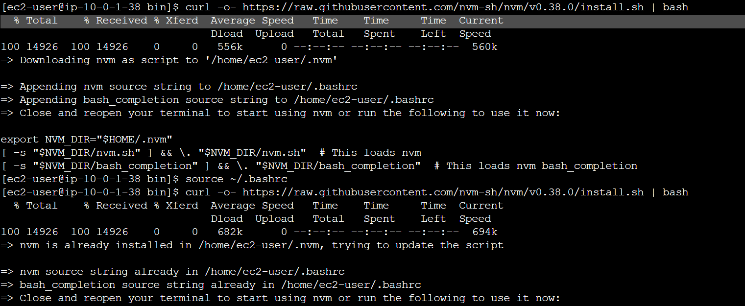
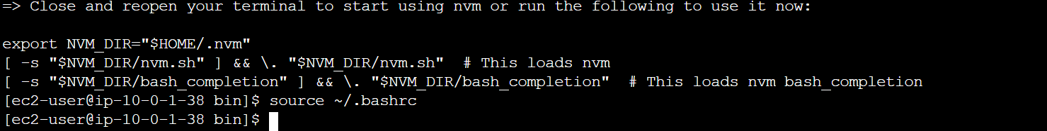

- Install a compatible version of Node.js and make sure it’s being used
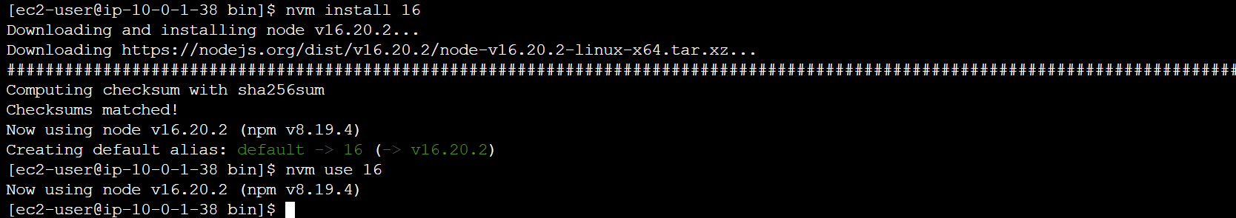
- PM2 is a daemon process manager that will keep our node.js app running when we exit the instance or if it is rebooted. Install that as well.
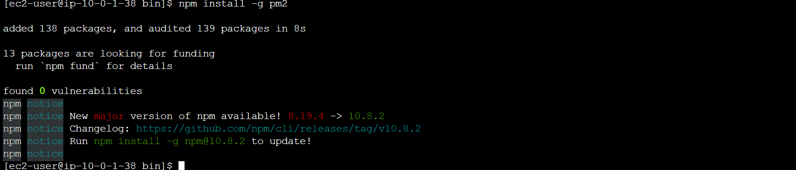
- Now we need to download our code from our s3 buckets onto our instance. In the command below, replace BUCKET_NAME with the name of the bucket you uploaded the app-tier folder to a folder called as ‘new’
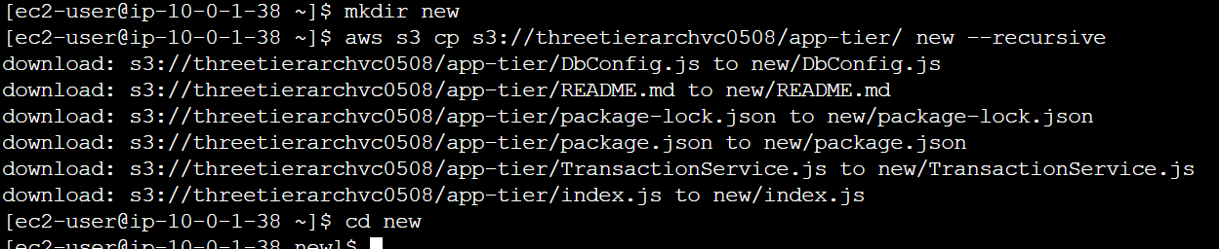

- Navigate to the app_tier directory, install dependencies, and start the app with pm2. Use following two commands
npm install
pm2 start index.js

- To make sure the app is running correctly run the following:
pm2 list

- If you see a status of online, the app is running. Use pm2-logs if status is errored and to find errors. If there are no errors then you can see the application is listening on 4000
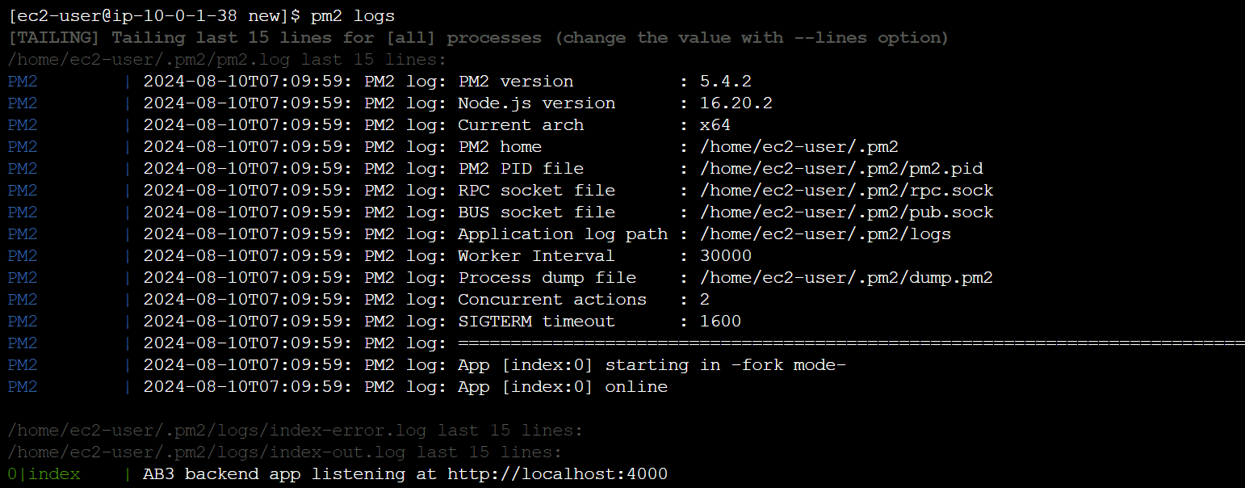

- Right now, pm2 is just making sure our app stays running when we leave the SSM session. However, if the server is interrupted for some reason, we still want the app to start and keep running. This is also important for the AMI we will create:
pm2 startup

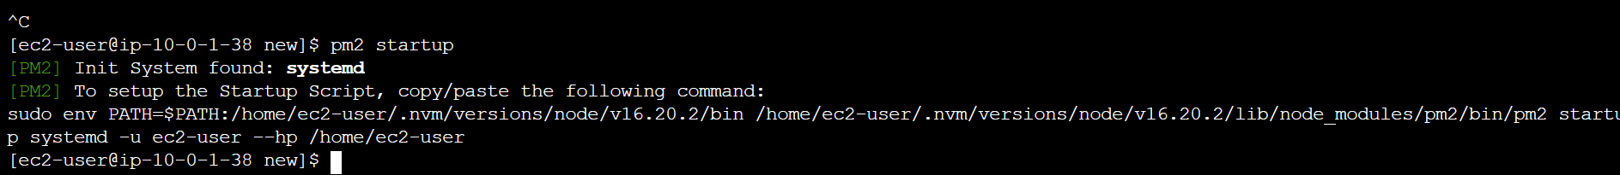

- Run the command shown on the output
sudo env PATH=$PATH:/home/ec2-user/.nvm/versions/node/v16.20.2/bin /home/ec2-user/.nvm/versions/node/v16.20.2/lib/node_modules/pm2/bin/pm2 startup systemd -u ec2-user --hp /home/ec2-user
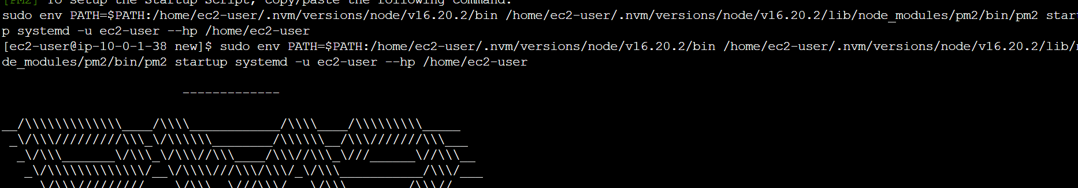
- Run pm2 save to save the configuration
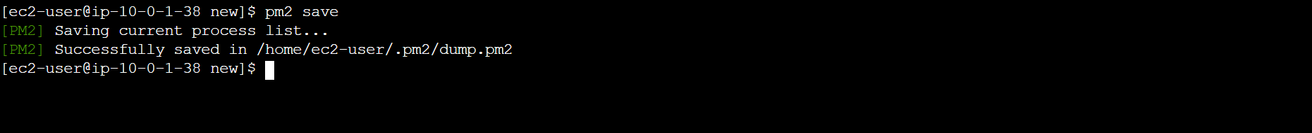
- To check if the app is running fine execute following command
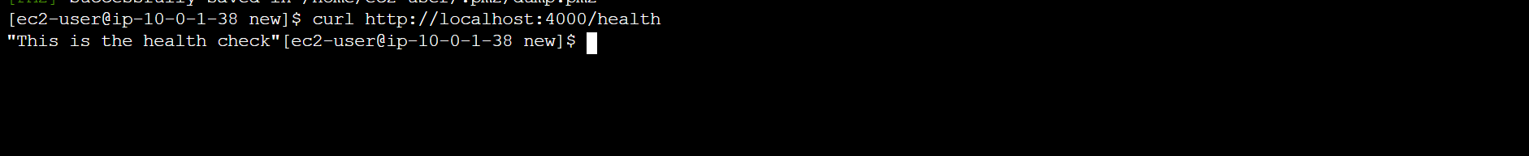
- Check database connection by running following command
- We will deploy an EC2 instance for the Web Tier and make all necessary software configuration for the NGINX web Server and React.js website
- Select the app tier instance we created and under Actions select Image and templates. Click Create Image.
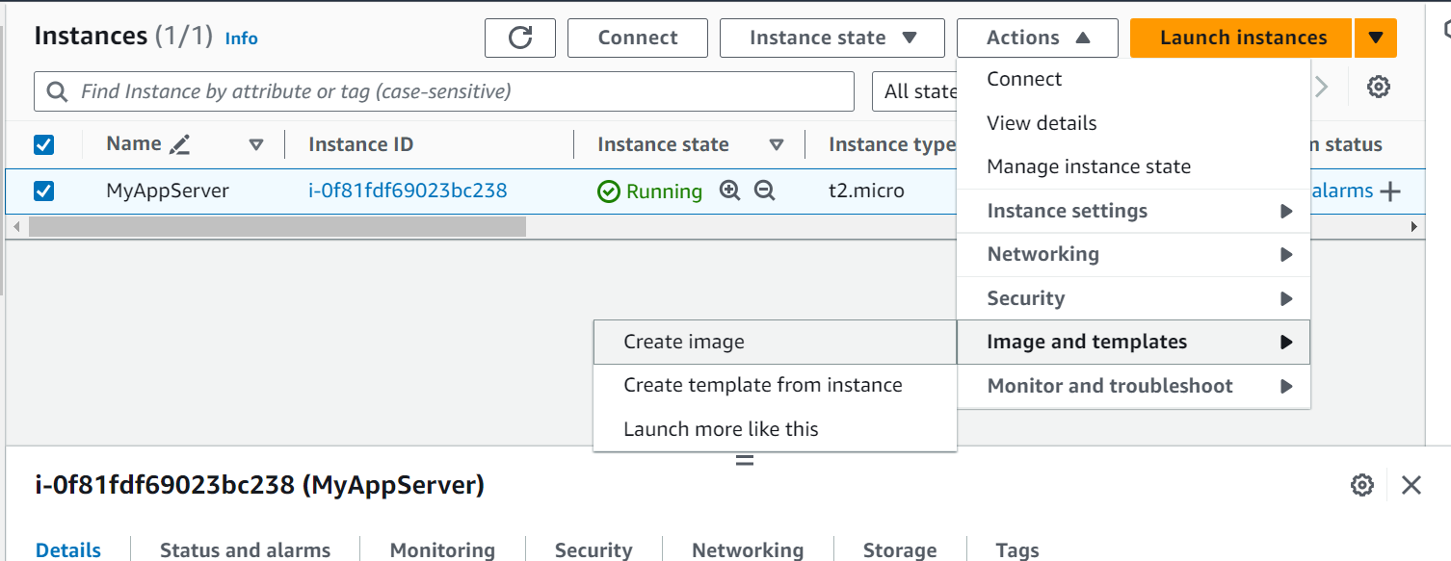

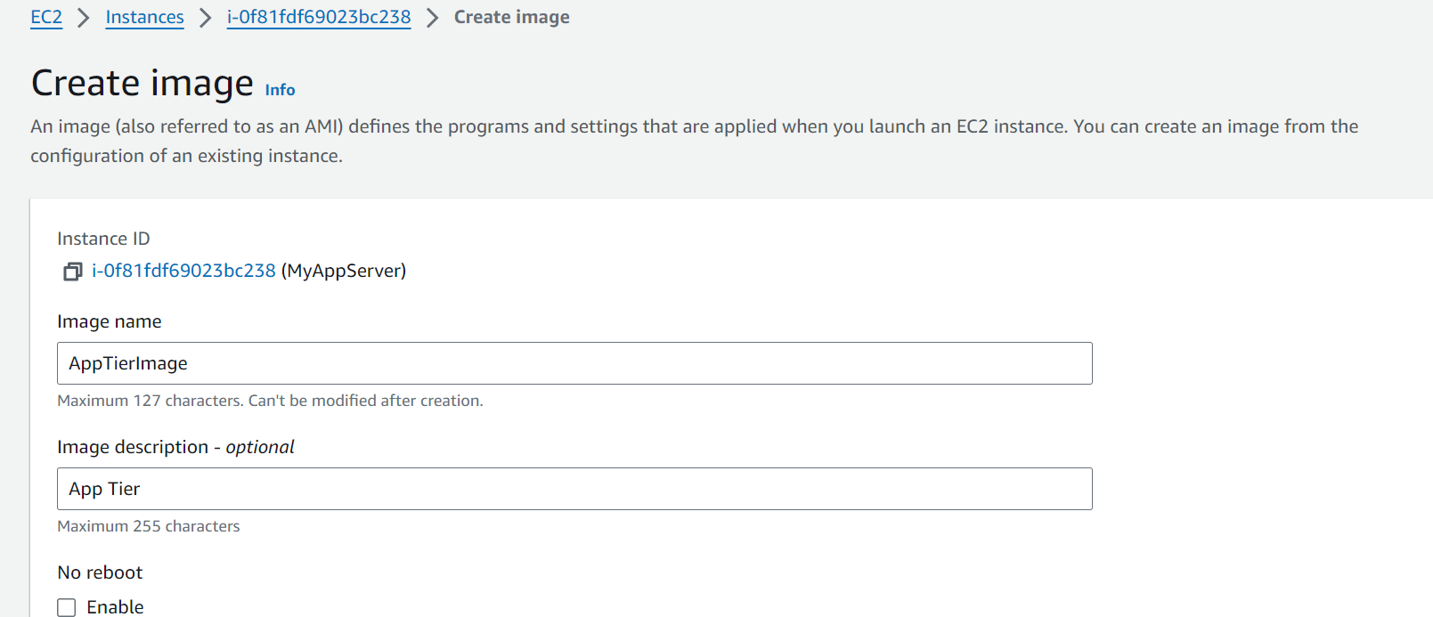
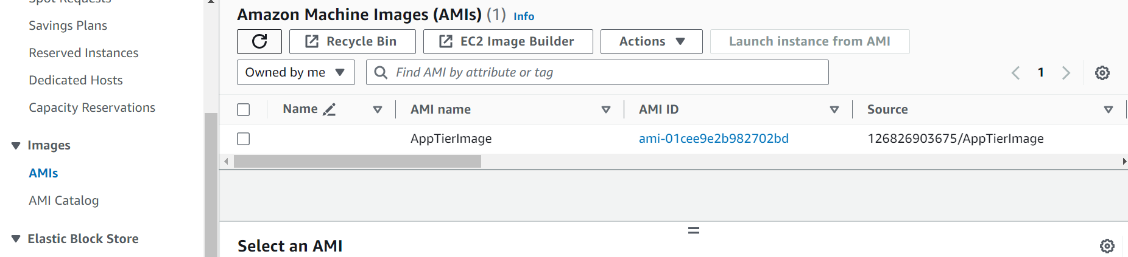

- Create Target group to use with the load balancer. On the EC2 dashboard navigate to Target Groups under Load Balancing on the left-hand side. Click on Create Target Group. Select port as 4000 since this is the port Node.js app is running on. Change the health check path to be /health. This is the health check endpoint of our application. DO not register an Targets.
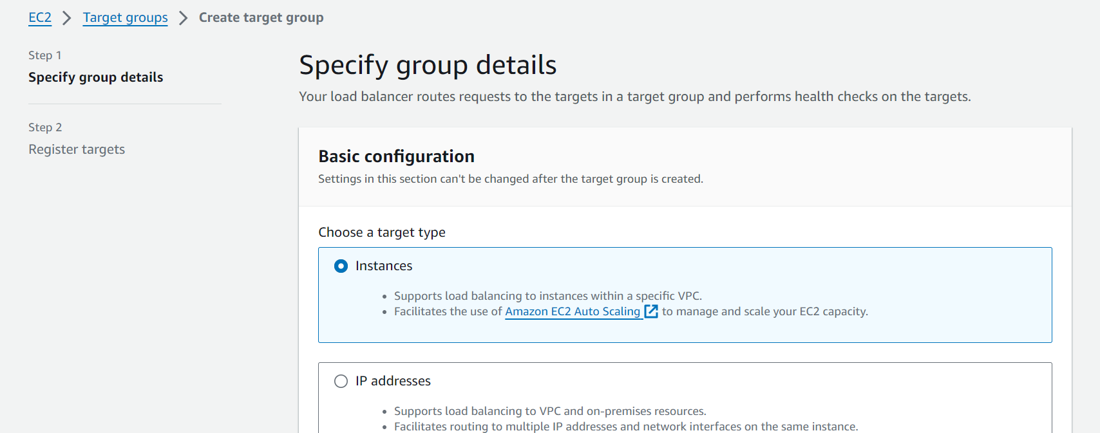

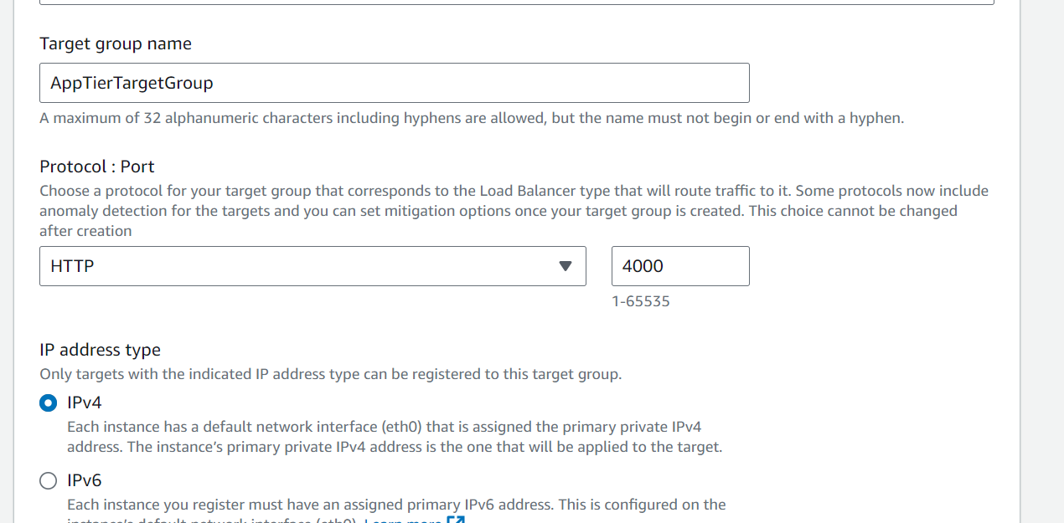
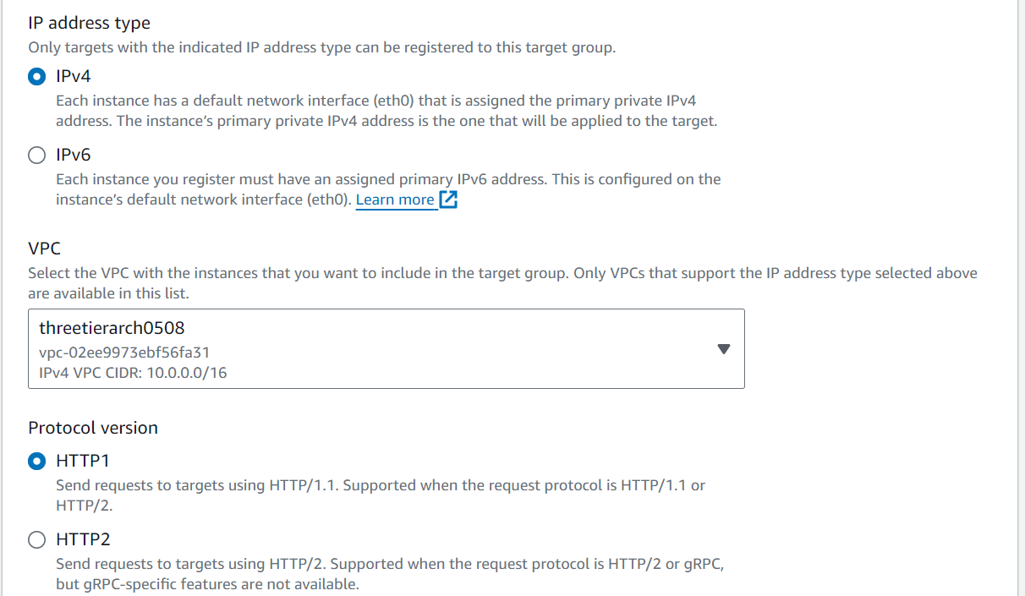
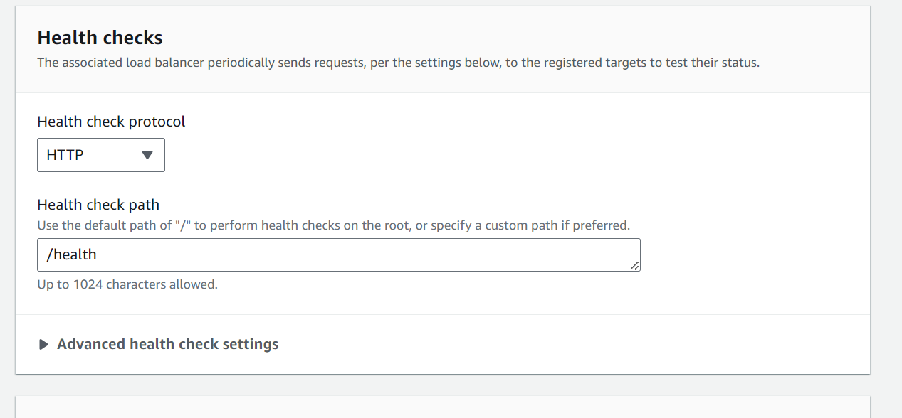
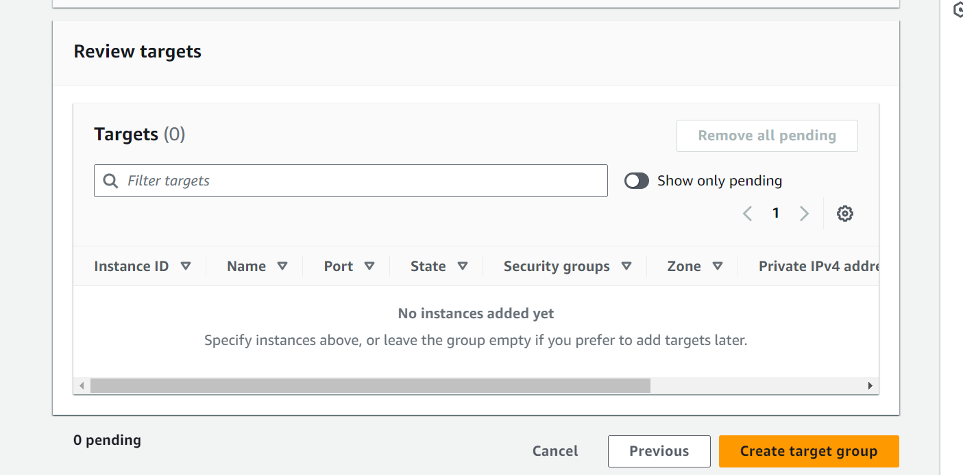

- Create internal Load Balancer. We will be using Application load Balancer
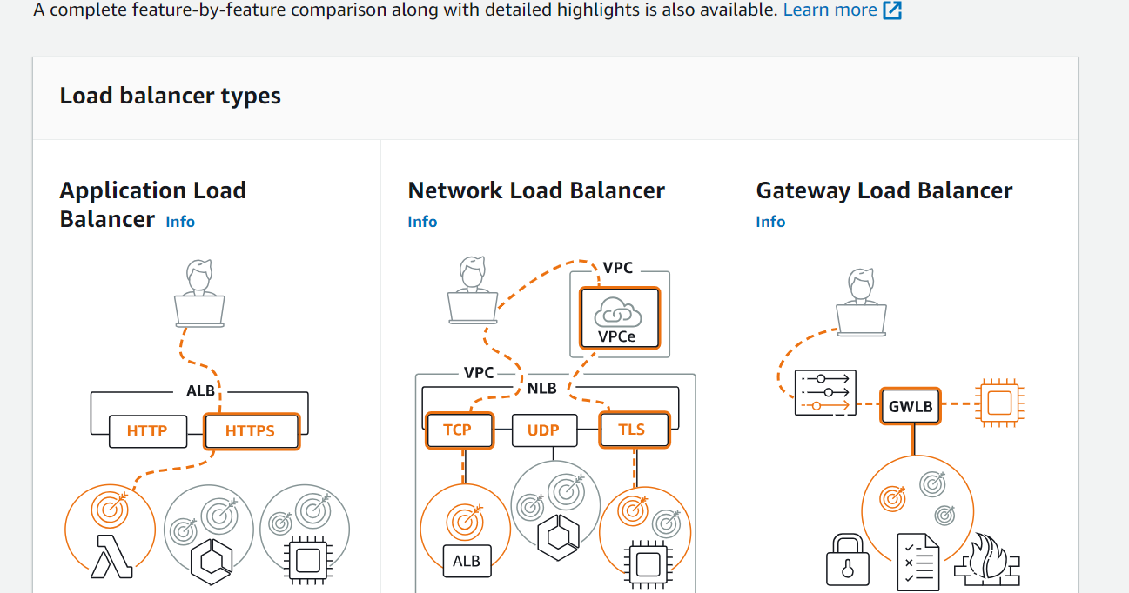
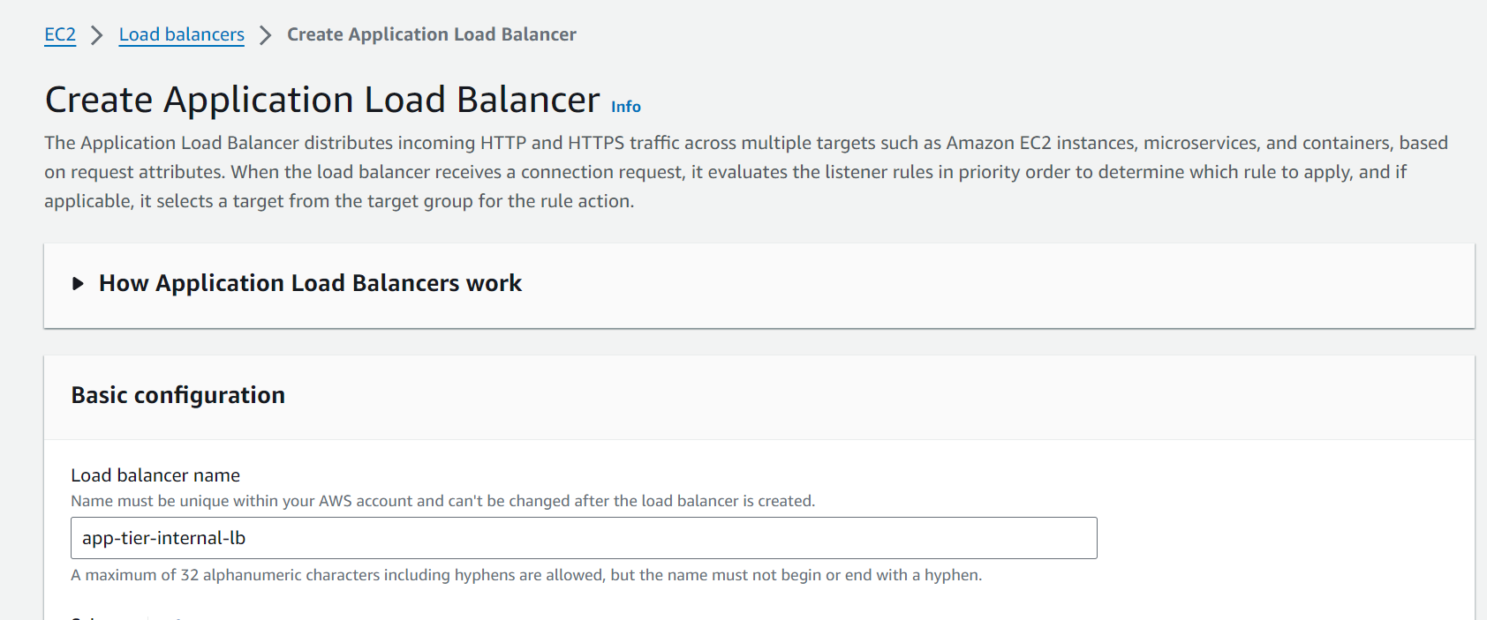
Select Internal since this load balancer will not be public facing and route traffic from web tier to the app tier
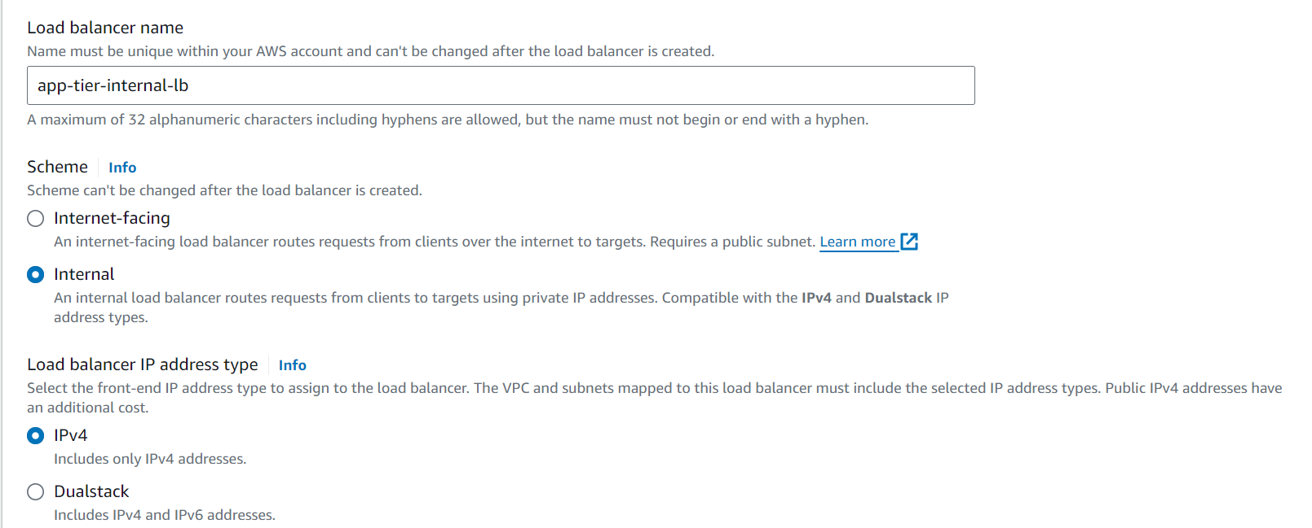

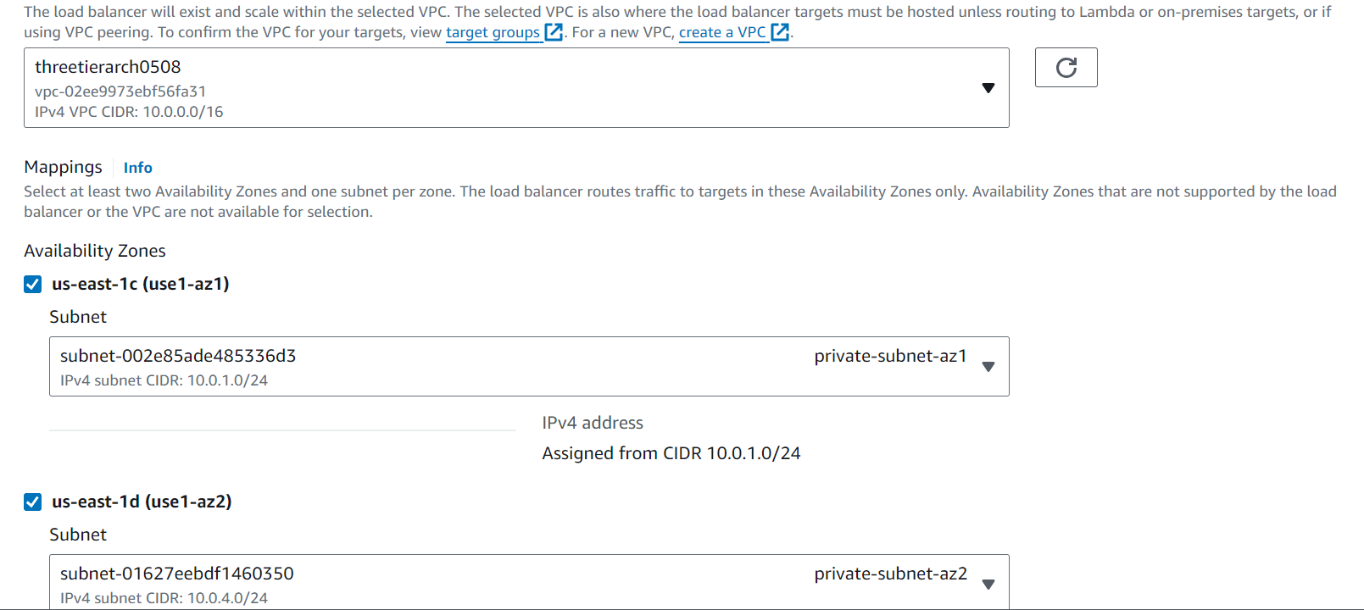
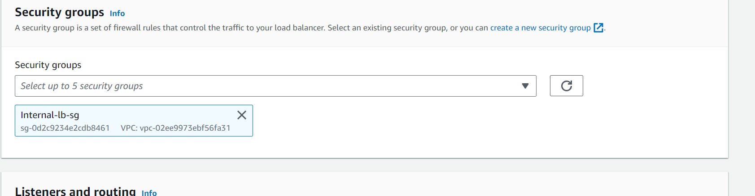

Forward traffic to AppTierTargetGroup. This is the target group we created. This ALB will be listening for HTTP traffic on port 80
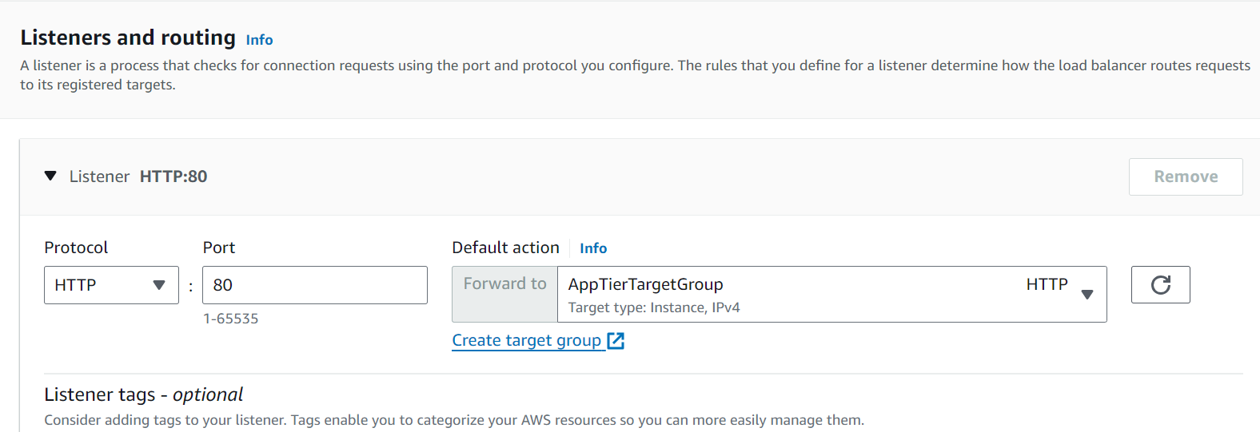

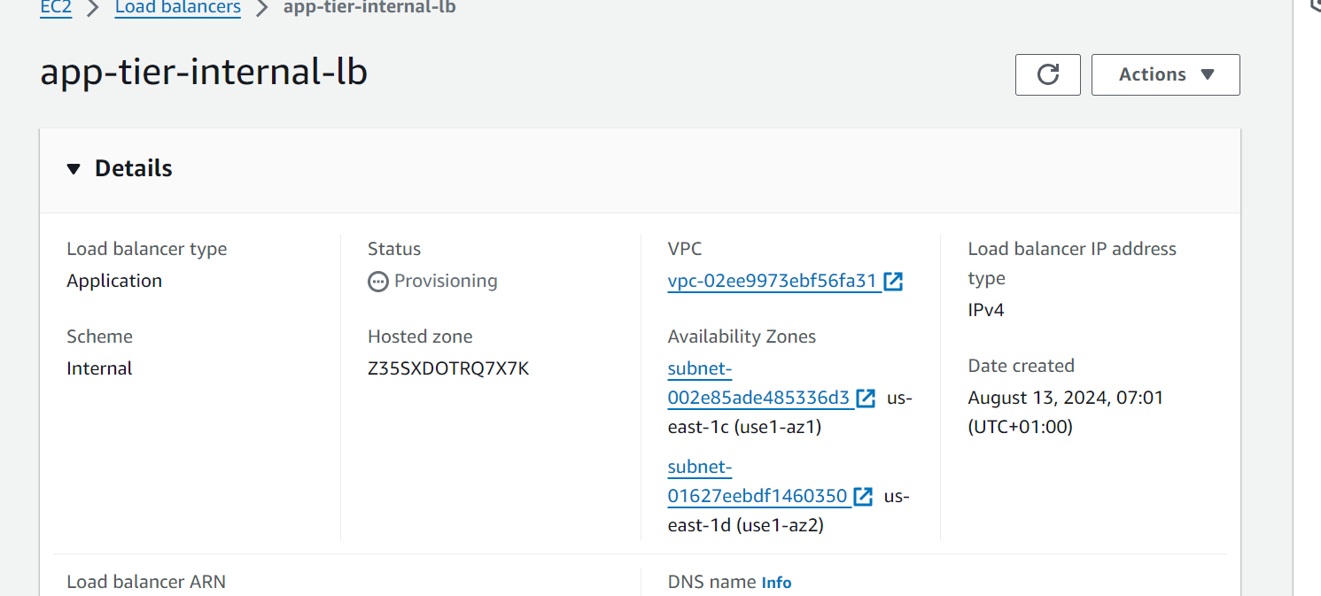

- For Auto Scaling, first create the Launch template with the AMI which has been created
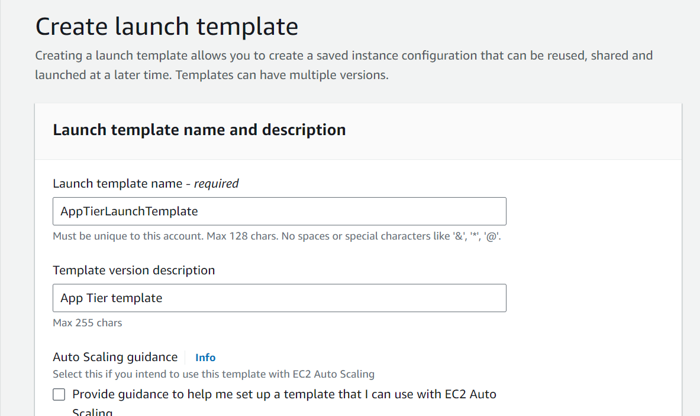

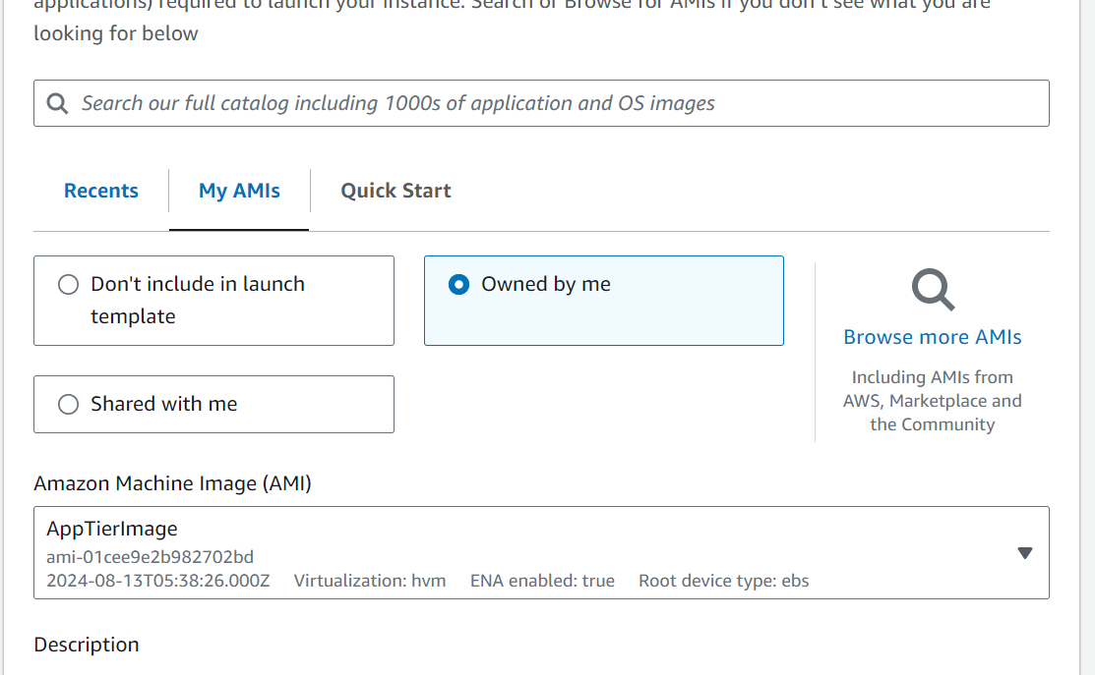

Under Instance Type select t2.micro. For Key pair and Network Settings don't include it in the template. We don't need a key pair to access our instances and we'll be setting the network information in the autoscaling group.
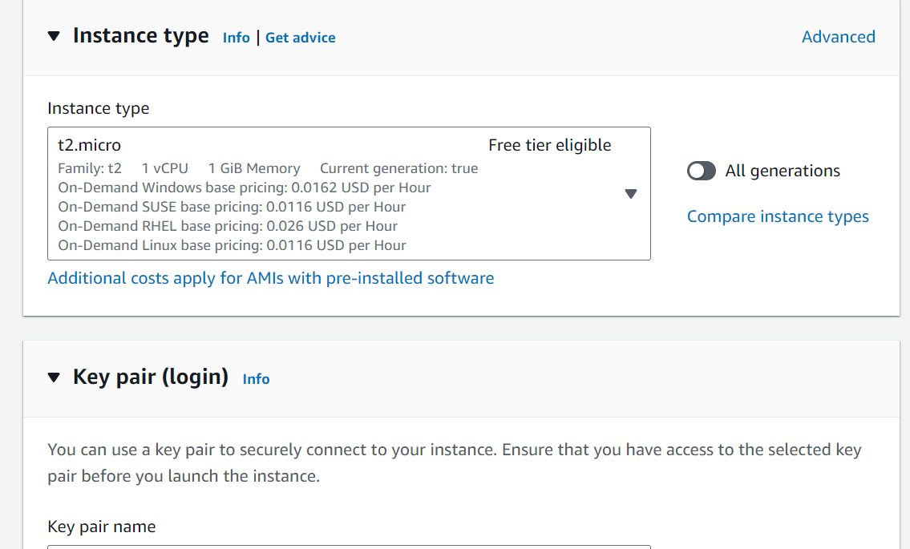

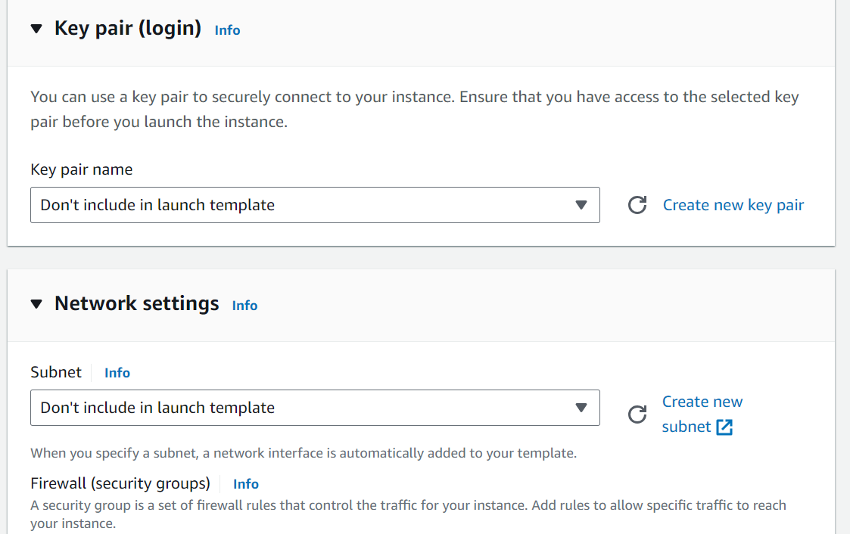

Set the correct security group for our app tier, and then under Advanced details use the same IAM instance profile we have been using for our EC2 instances.

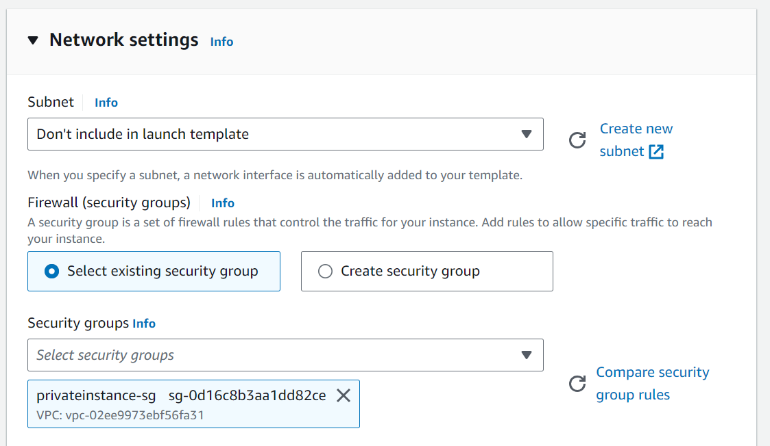

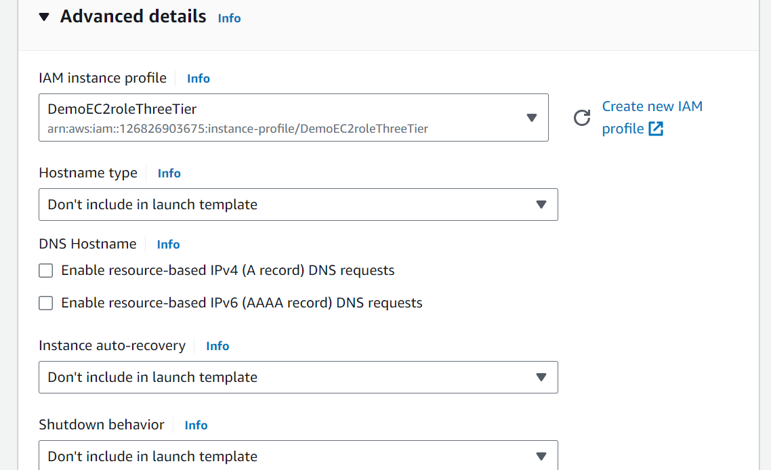

- Create Auto Scaling Group for app instances
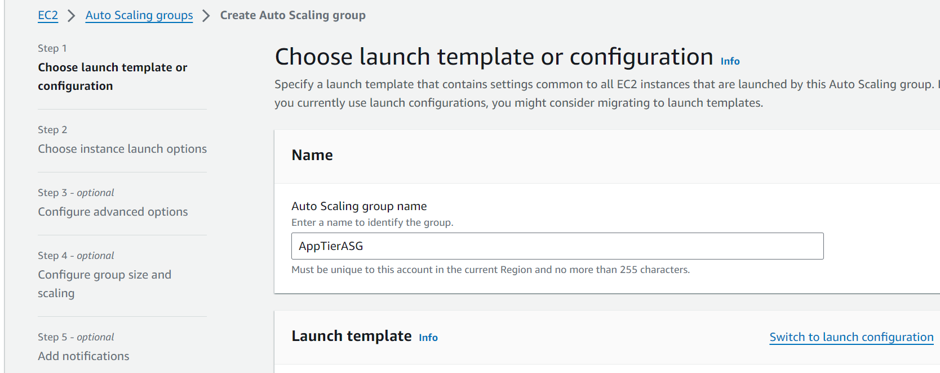
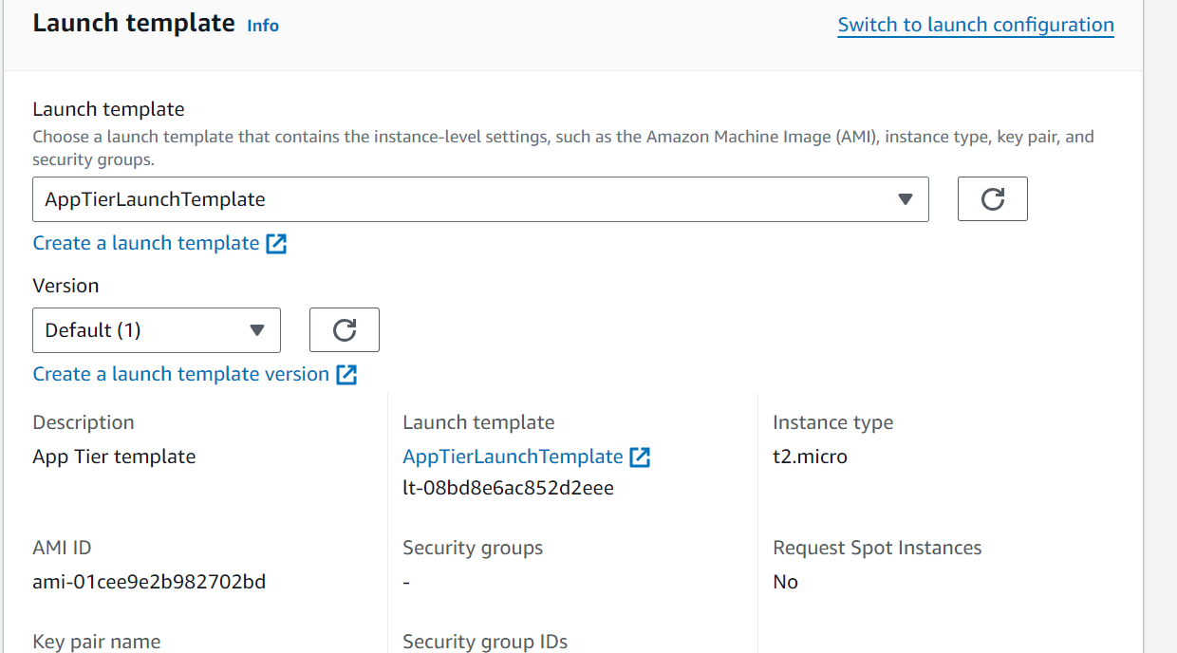
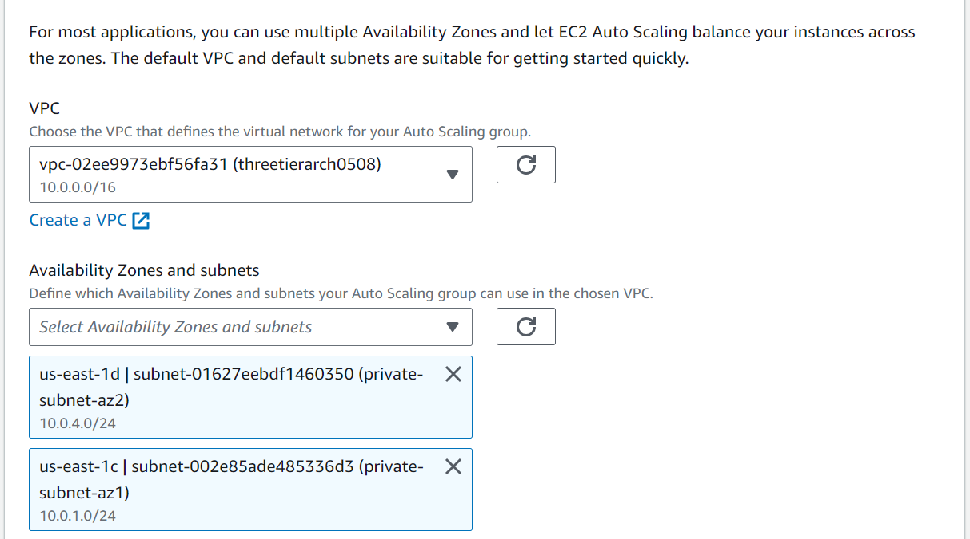

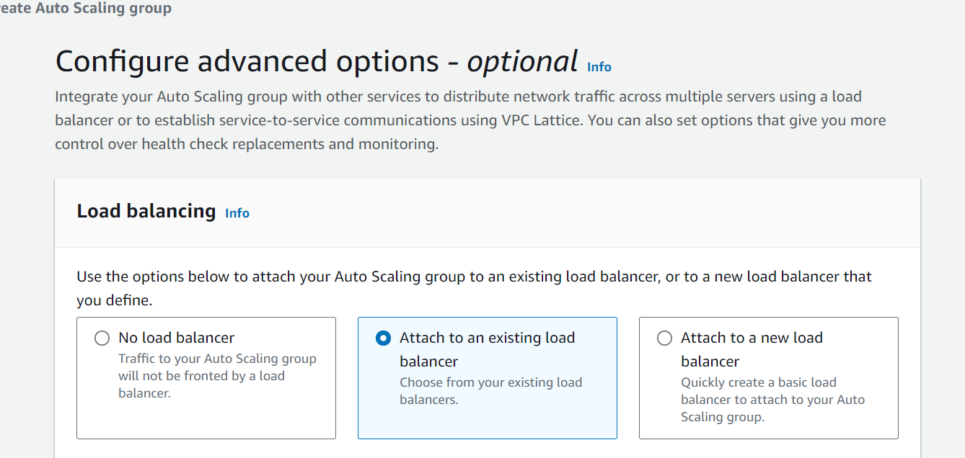
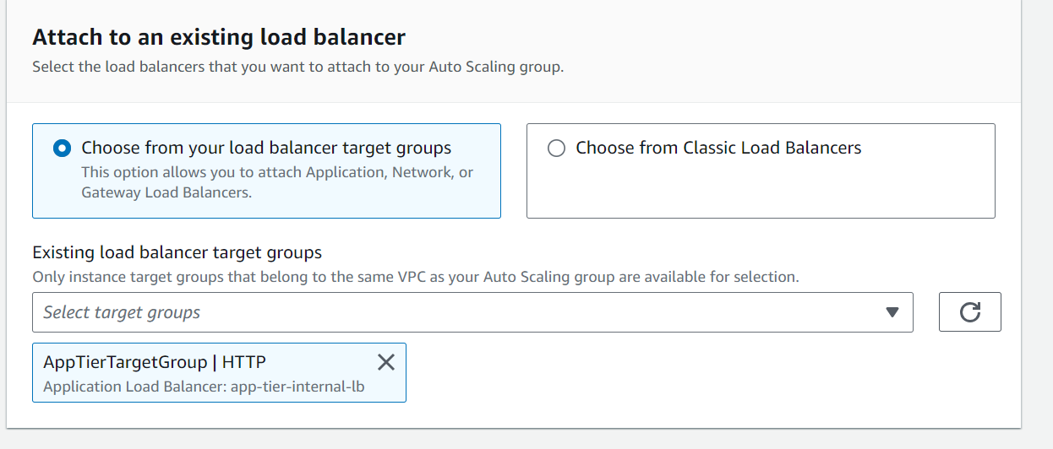
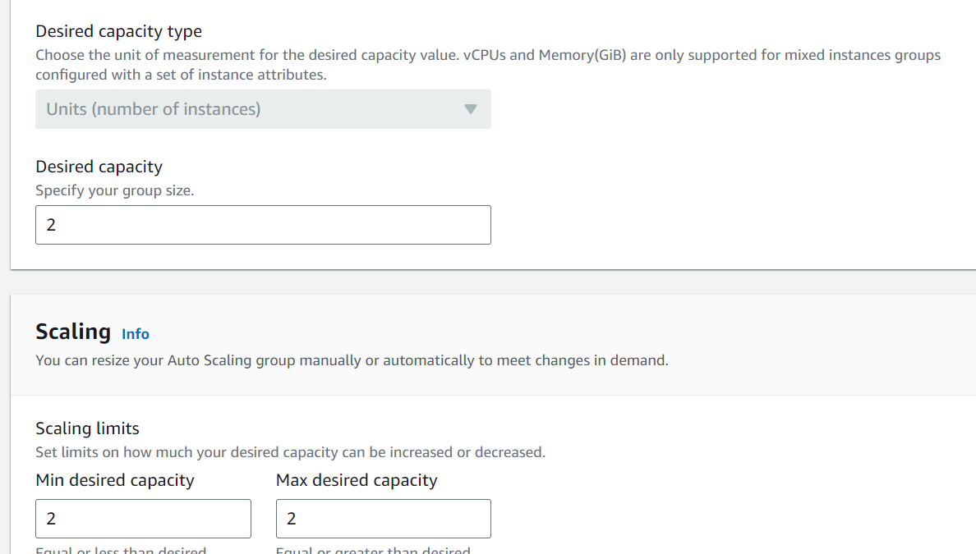
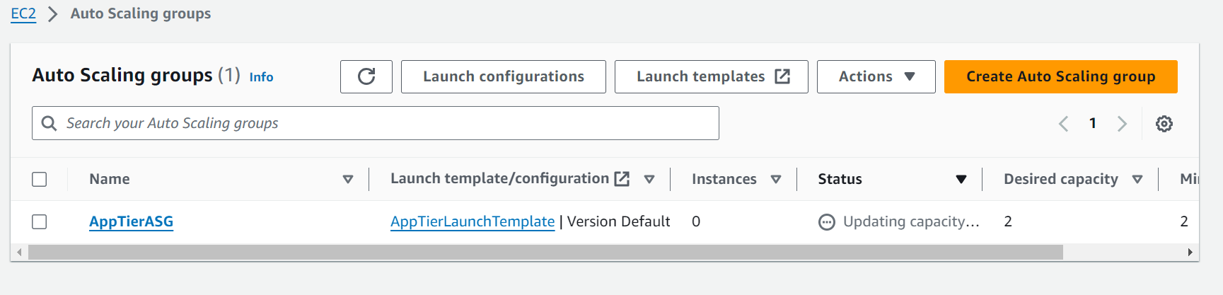
You should now have your internal load balancer and autoscaling group configured correctly. You should see the autoscaling group spinning up 2 new app tier instances. If you wanted to test if this is working correctly, you can delete one of your new instances manually and wait to see if a new instance is booted up to replace it.

- Deploy an EC2 instance for the web tier and make all necessary software configurations for the NGINX web server and React.js website.
- Before we create and configure the web instances, open up the application-code/nginx.conf file from the repo we downloaded. Scroll down to line 58 and replace [INTERNAL-LOADBALANCER-DNS] with your internal load balancer’s DNS entry. You can find this by navigating to your internal load balancer's details page.
- Then, upload this file and the application-code/web-tier folder to the s3 bucket you created for this lab.
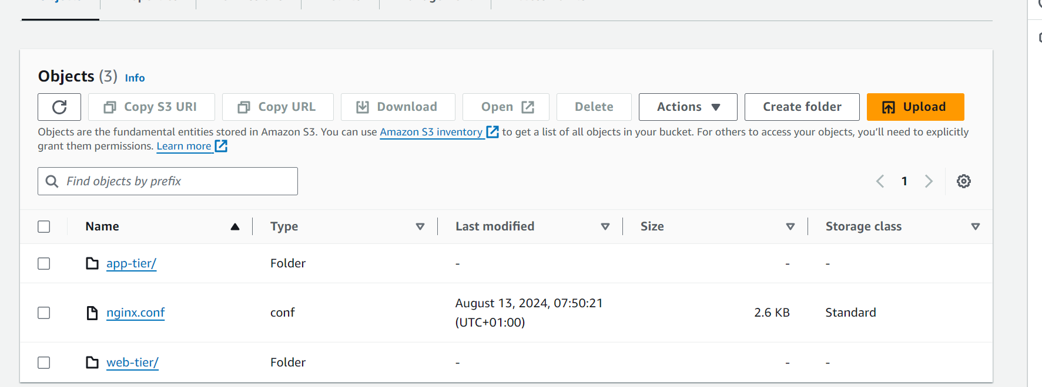

- Deploy a Web instance in a public subnet. Make sure to select the correct network components, security group, and IAM role. This time, auto-assign a public ip on the Configure Instance Details page. Remember to tag the instance with a name so we can identify it more easily.
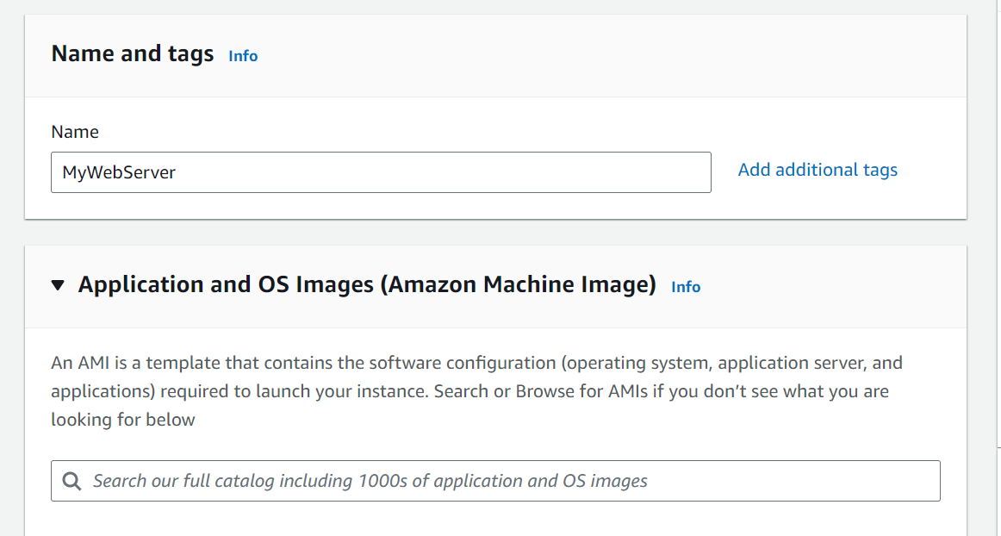
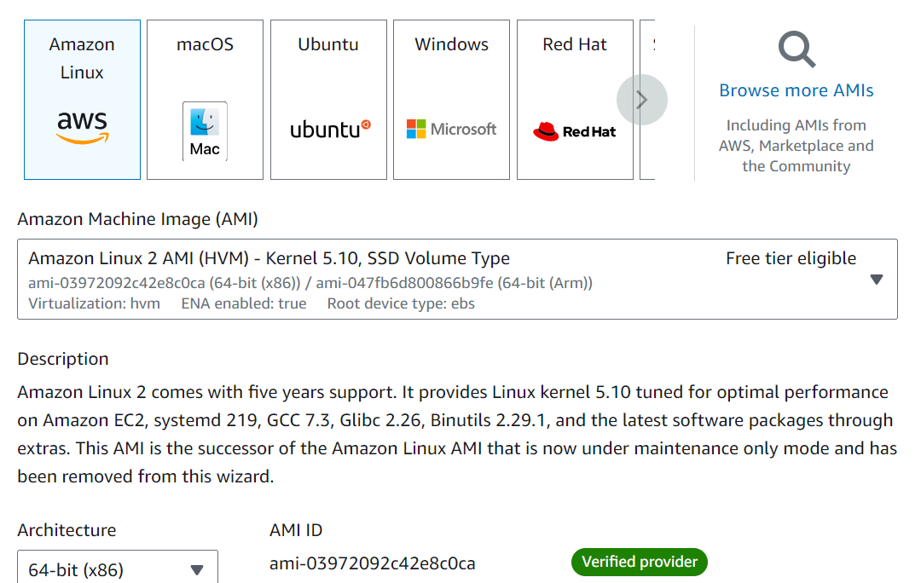
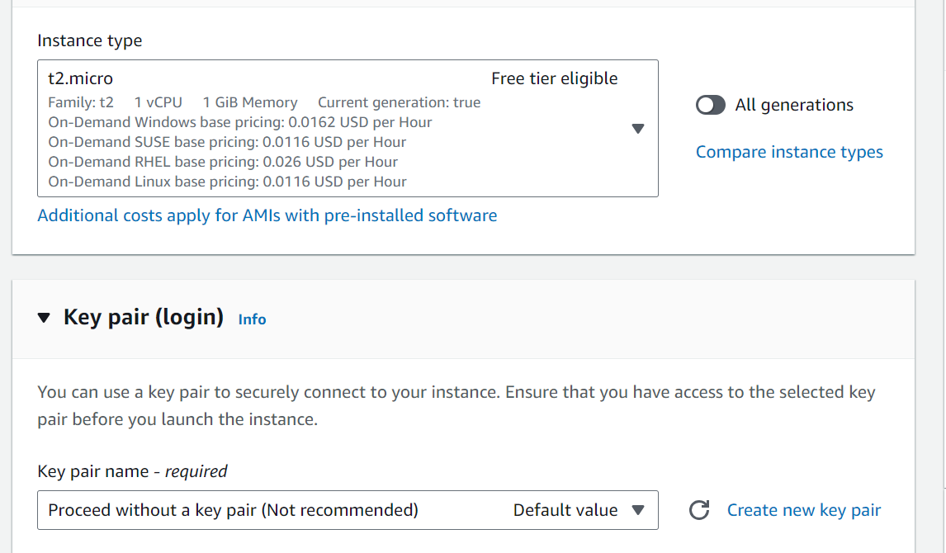
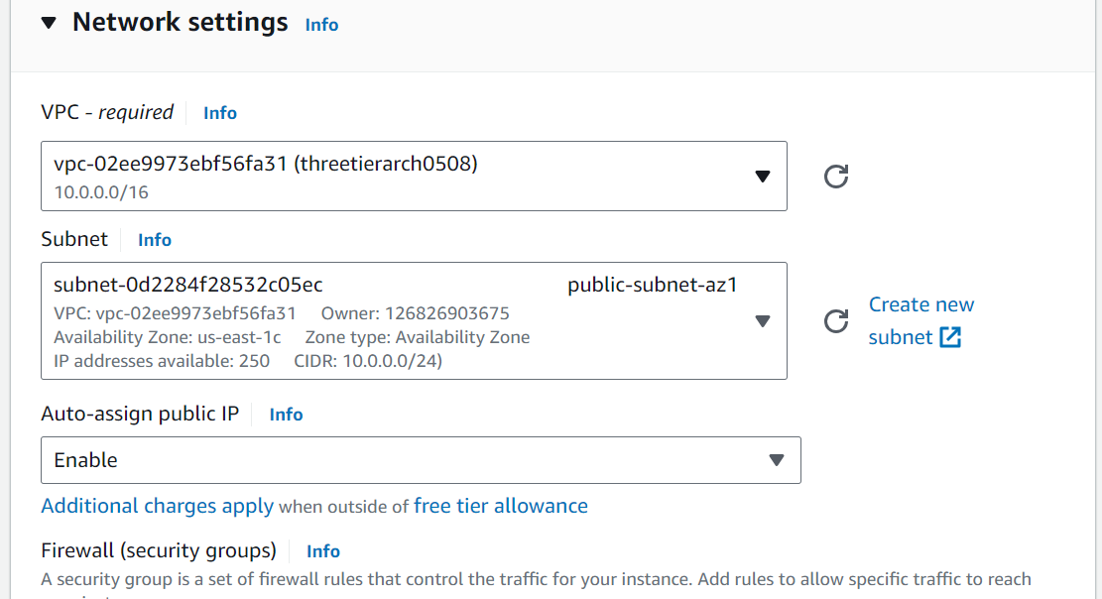
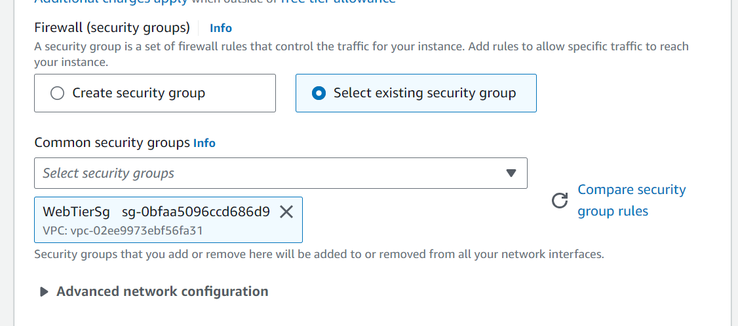
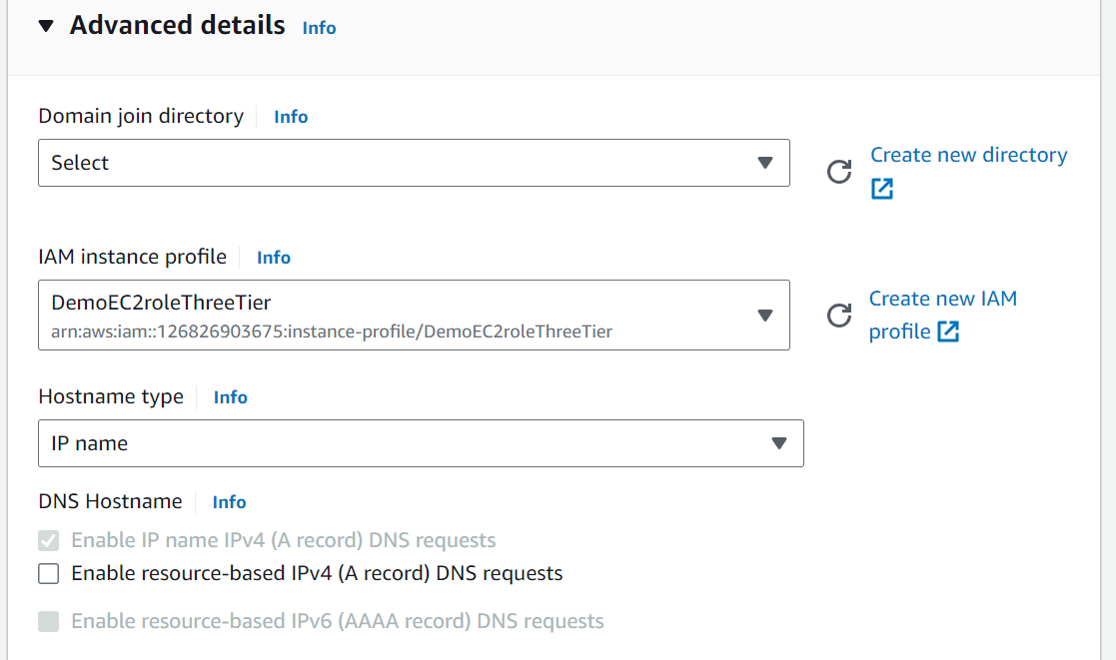

- Connect the instance using Session manager
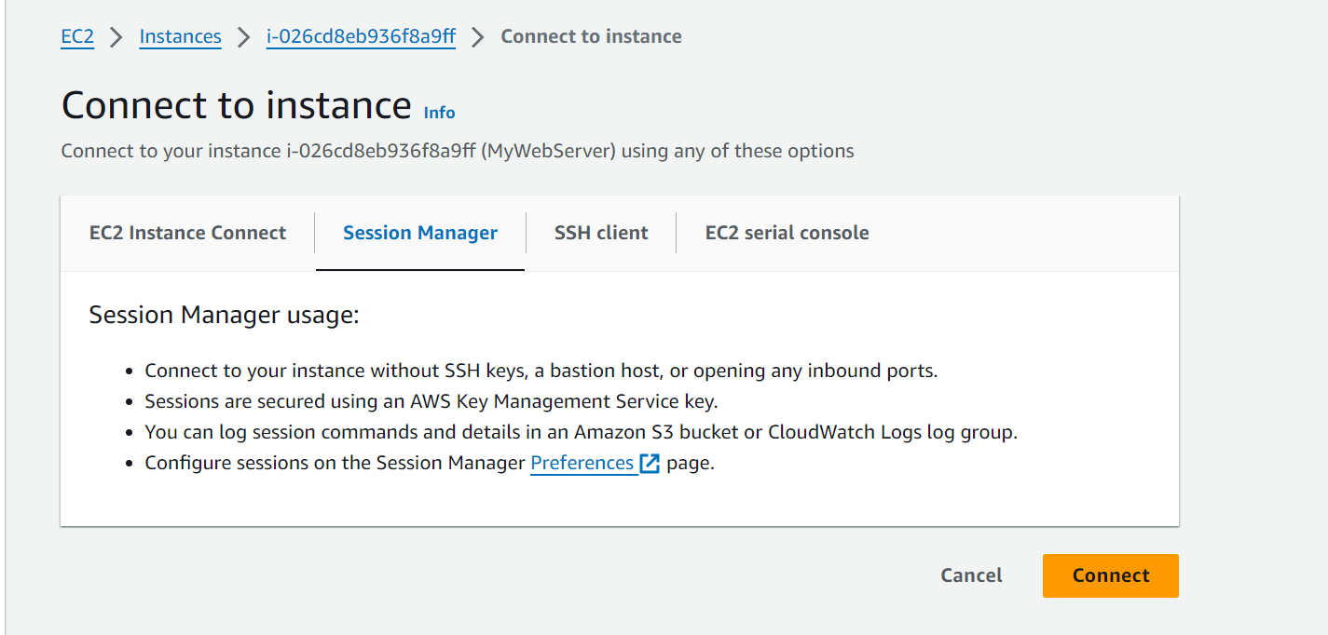

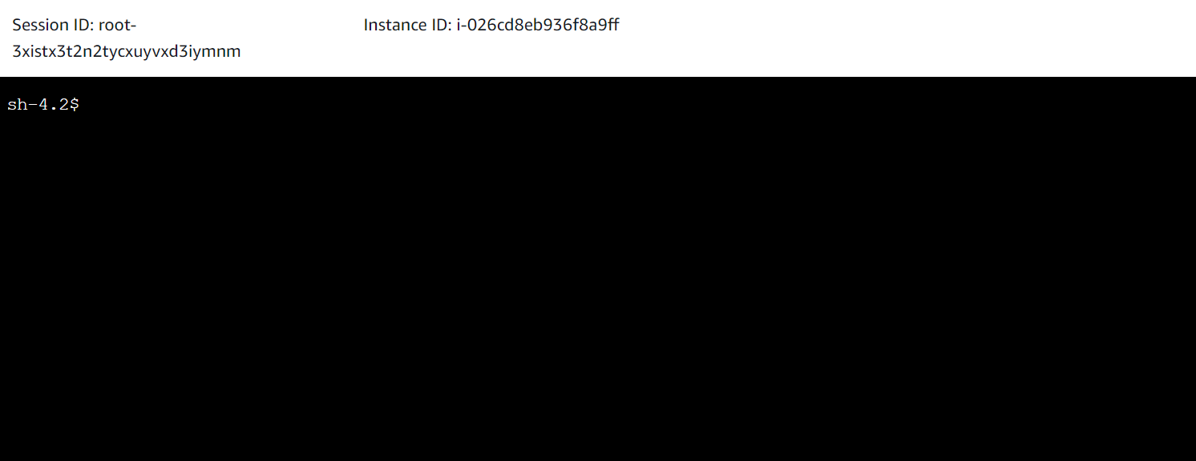
- Follow the same steps you used to connect to the app instance and change the user to ec2-user. Test connectivity here via ping as well since this instance should have internet connectivity:
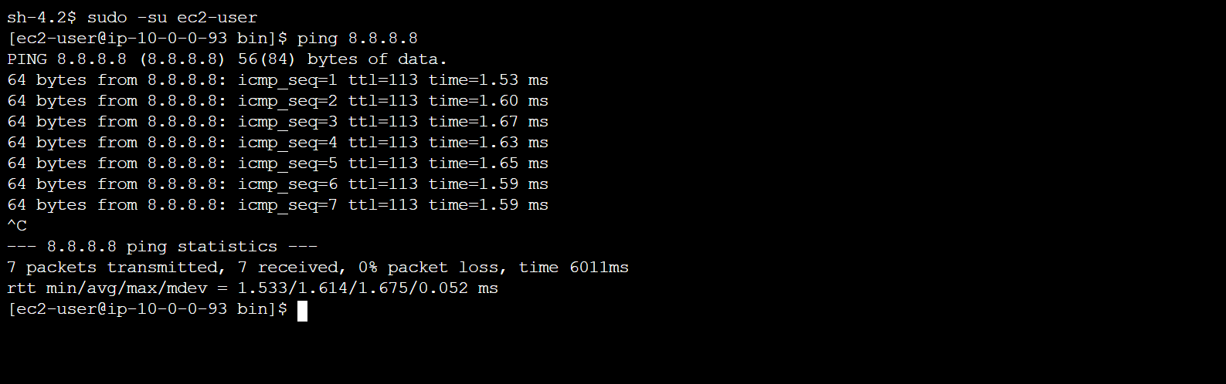

- We now need to install all of the necessary components needed to run our front-end application. Again, start by installing NVM and node
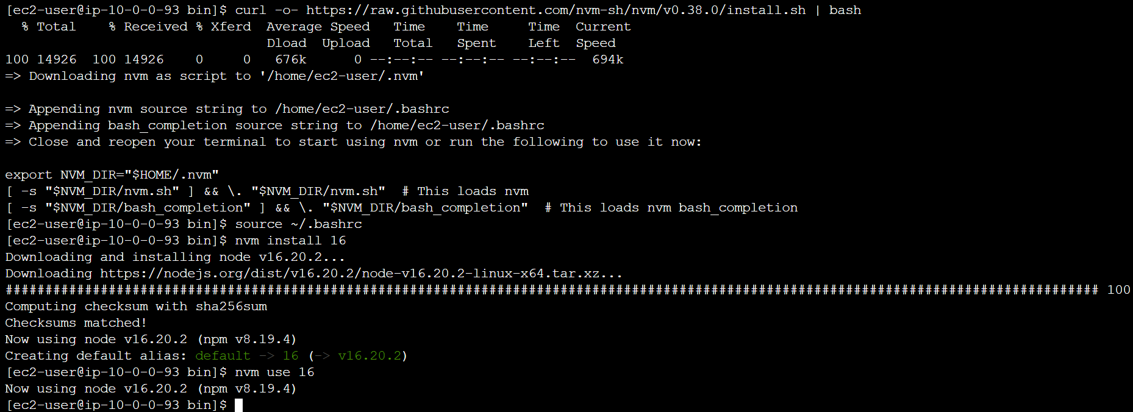

- Download our web tier code from our s3 bucket
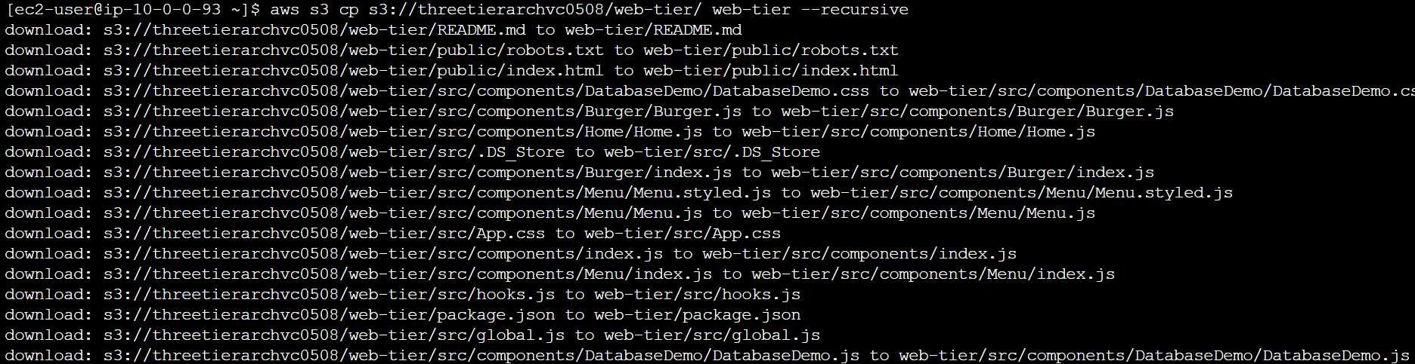
- Navigate to the web-layer folder and create the build folder for the react app so we can serve our code
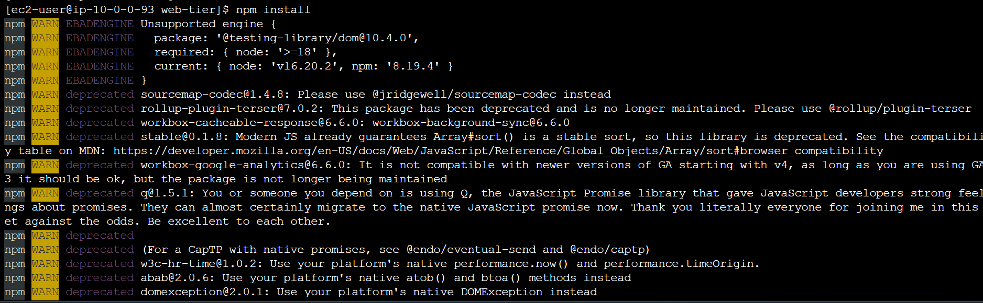
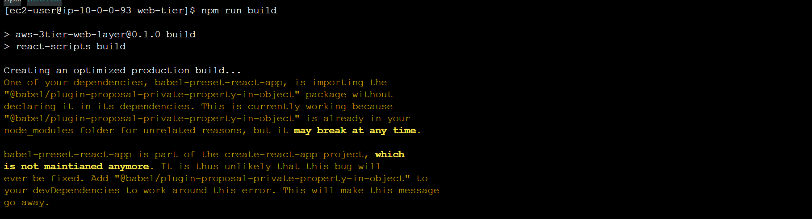

- NGINX can be used for different use cases like load balancing, content caching etc, but we will be using it as a web server that we will configure to serve our application on port 80, as well as help direct our API calls to the internal load balancer
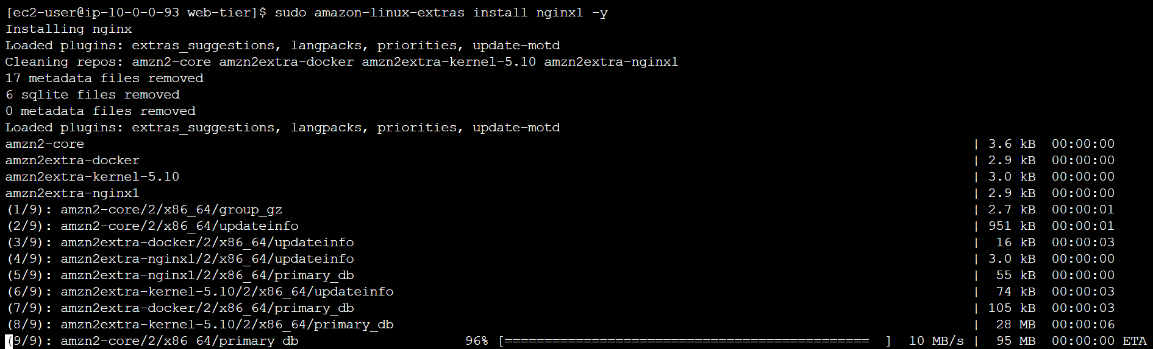
- We will now have to configure NGINX. Navigate to the Nginx configuration file with the following commands and list the files in the directory
- We’re going to delete nginx.conf file and use the one we uploaded to s3. Replace the bucket name in the command below with the one you created for this workshop
- Then, restart Nginx with the following command
- To make sure Nginx has permission to access our files execute this command
- To make sure the service starts on boot, run this command
- Use following command to curl on the local host
- Create AMI for the Web tier, Launch template, Auto Scaling and external load balancer
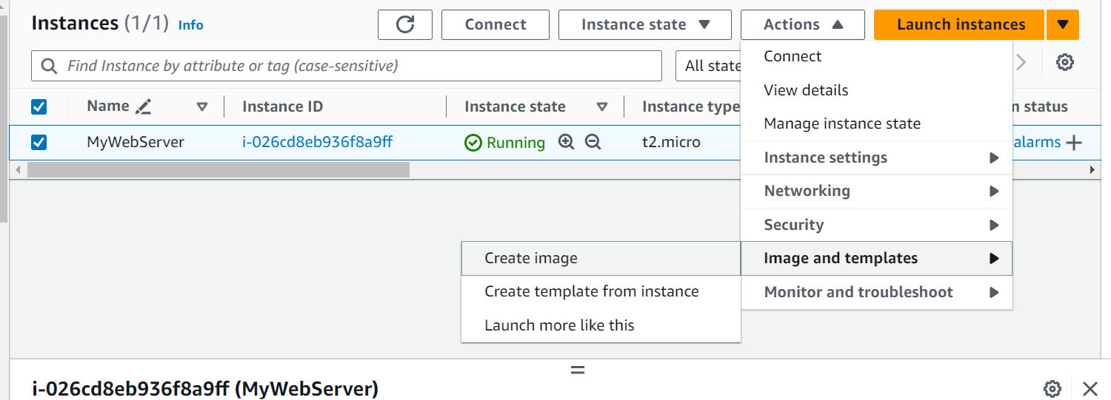
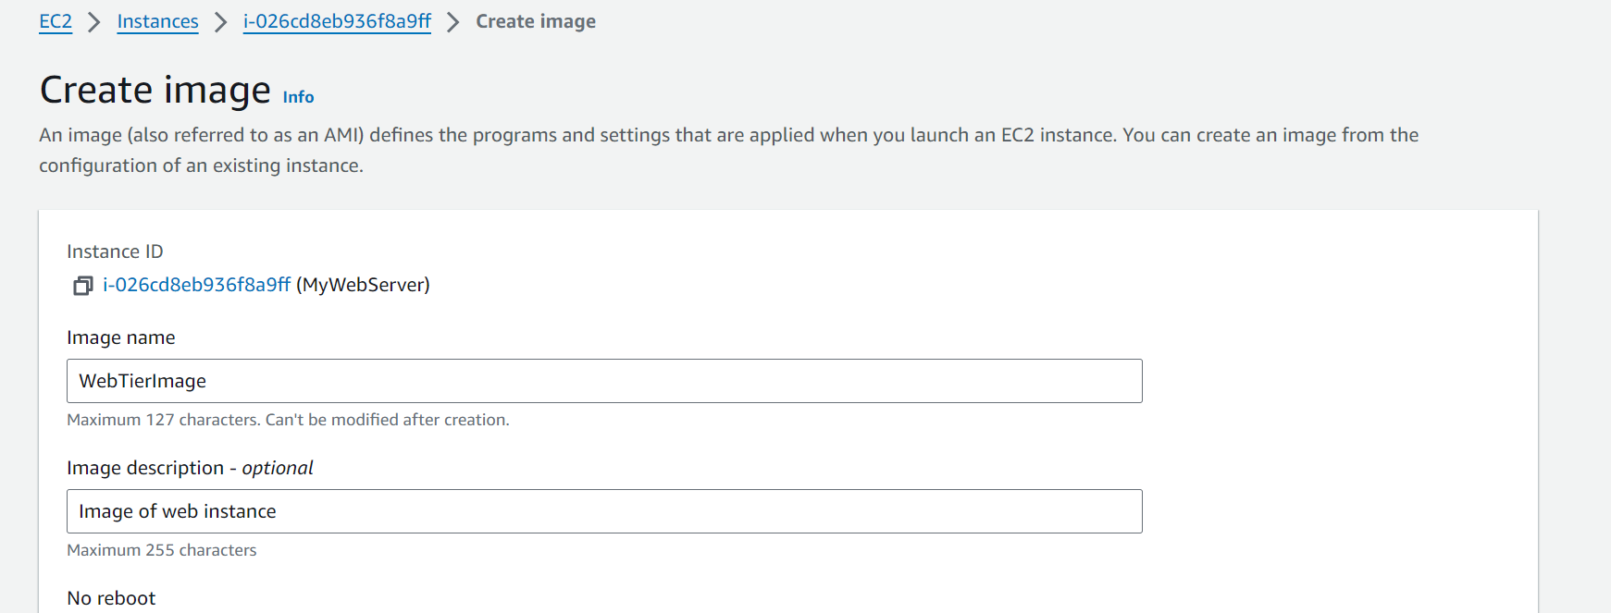
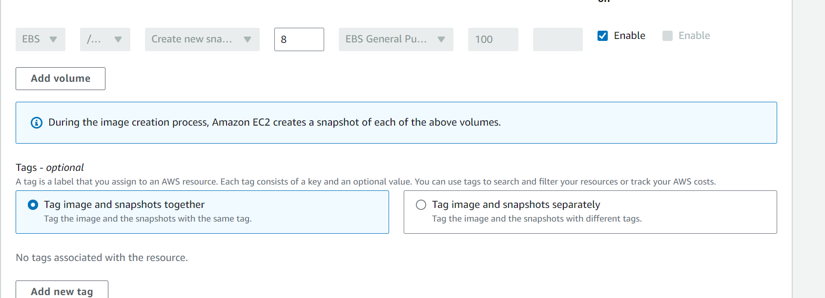
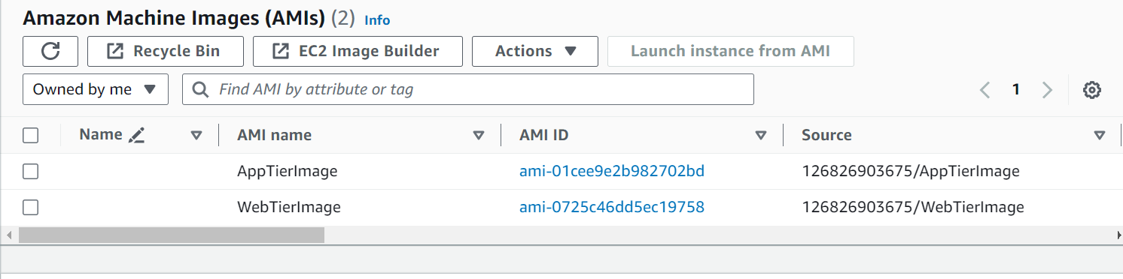
- Create our target group to use with the load balancer. On the EC2 dashboard navigate to Target Groups under Load Balancing on the left hand side. Click on Create Target Group.
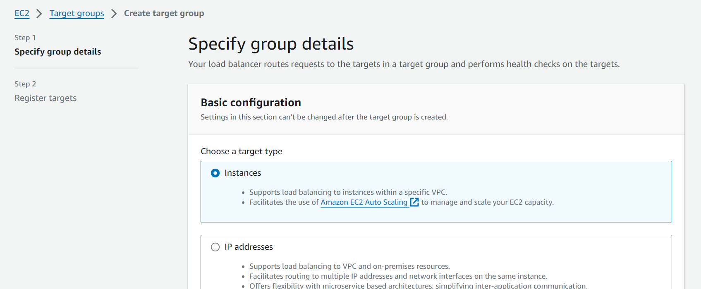
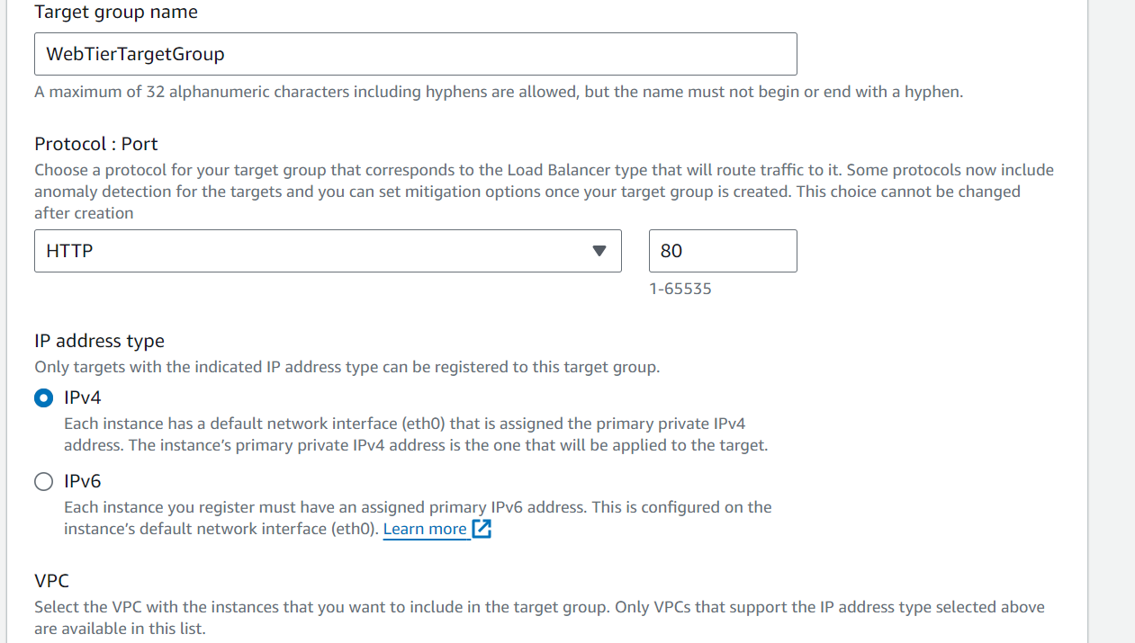
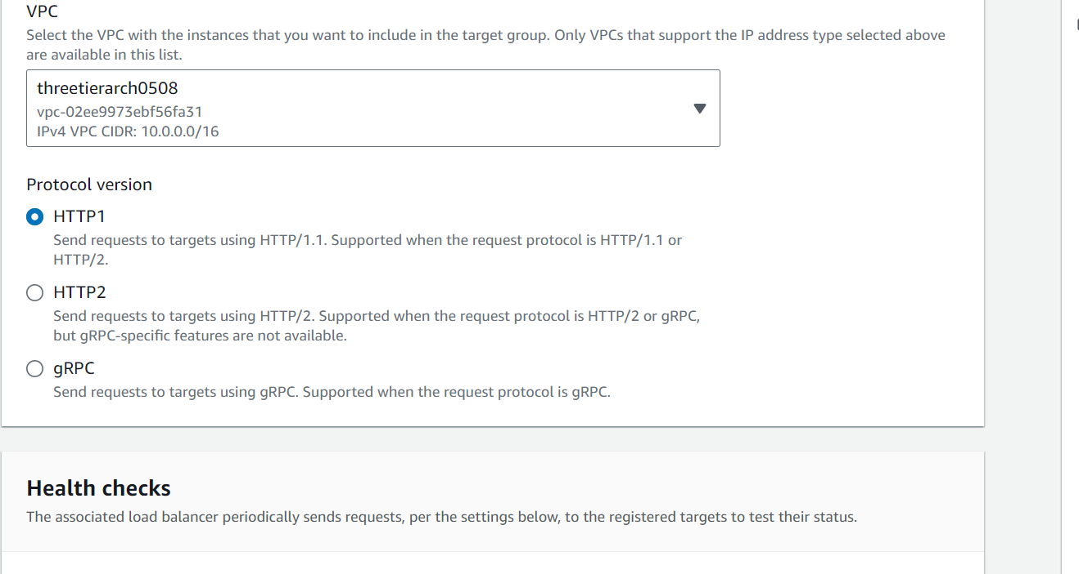
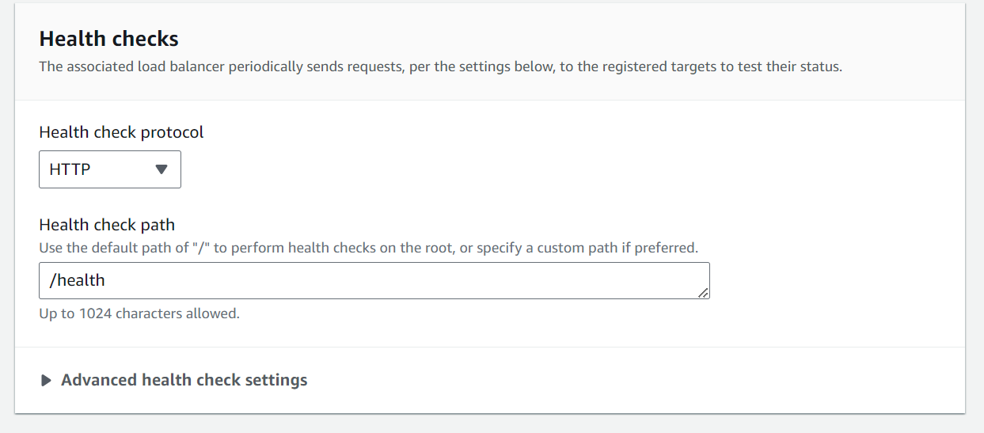
Do not register any targets
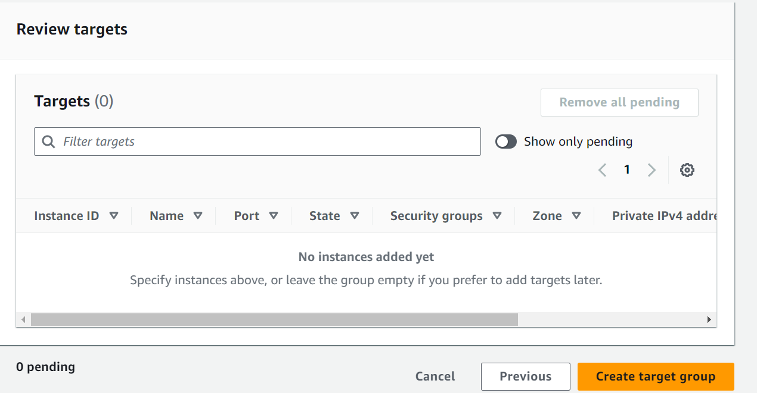
- Create Internet facing load balancer
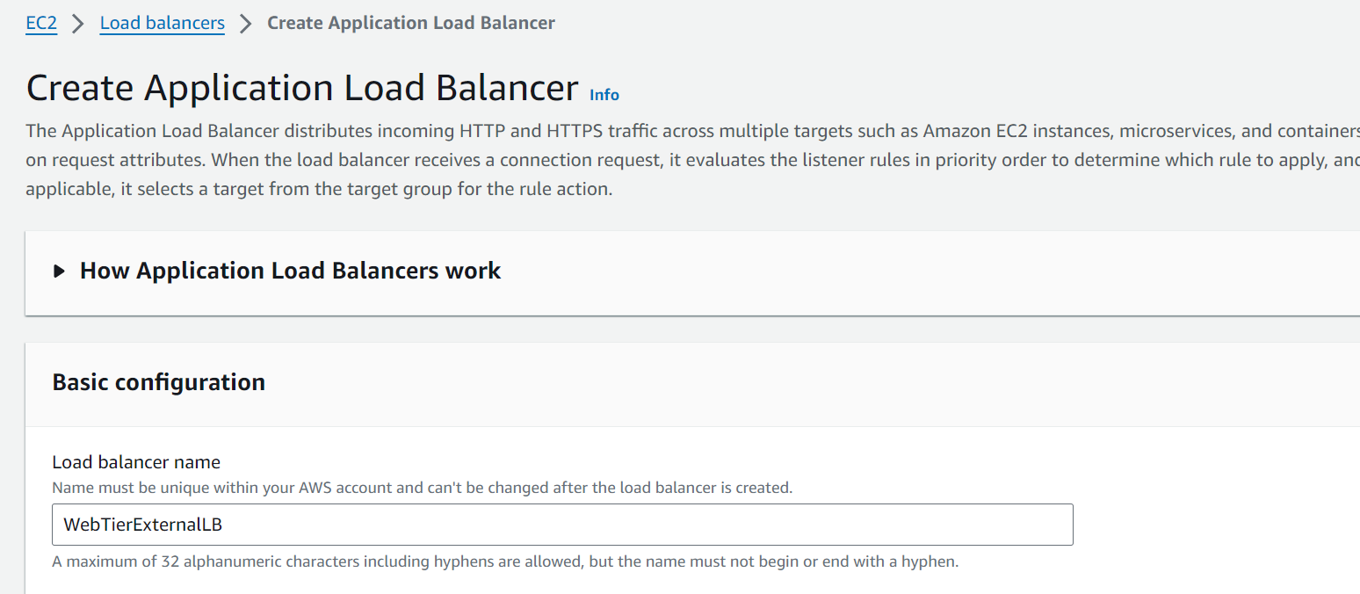
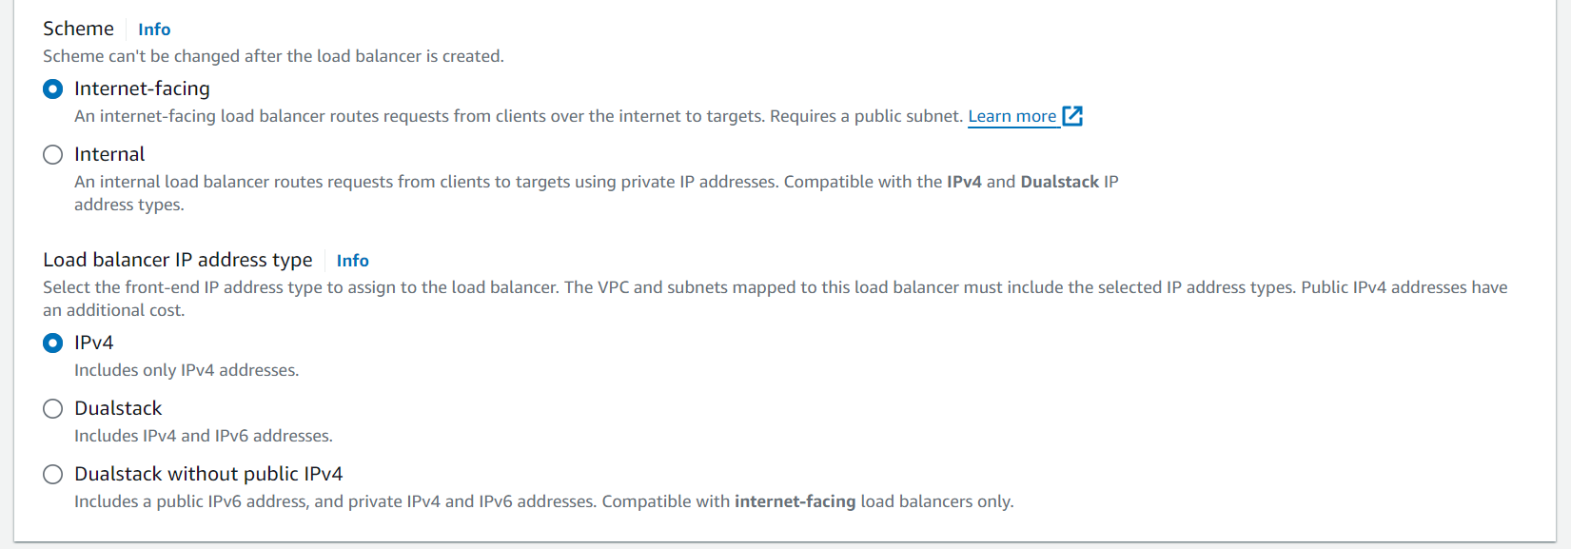
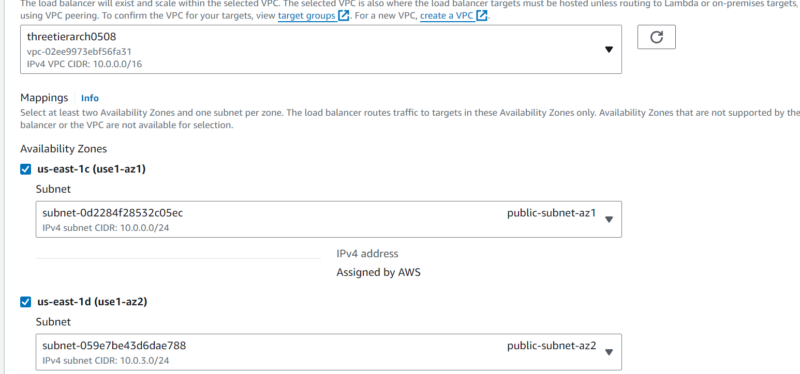
- Select the security group we created for this internal ALB. Now, this ALB will be listening for HTTP traffic on port 80. It will be forwarding the traffic to our target group that we just created, so select it from the dropdown, and create the load balancer.
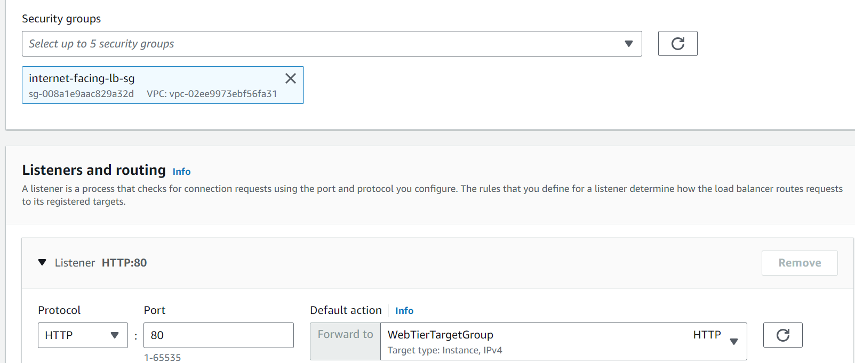
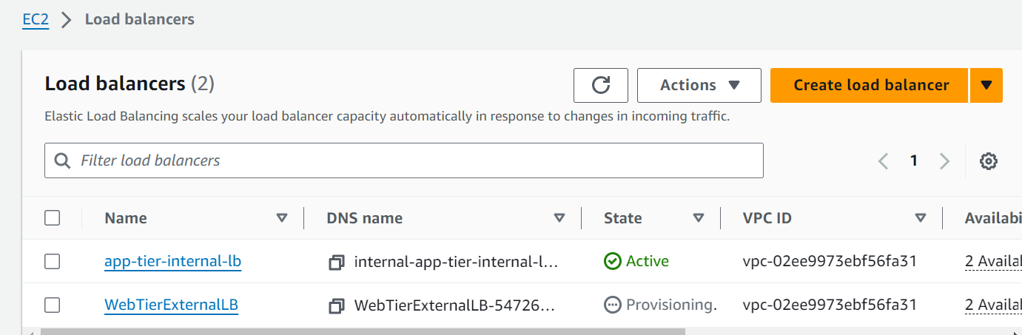

- Configure Launch Template for the Target Group
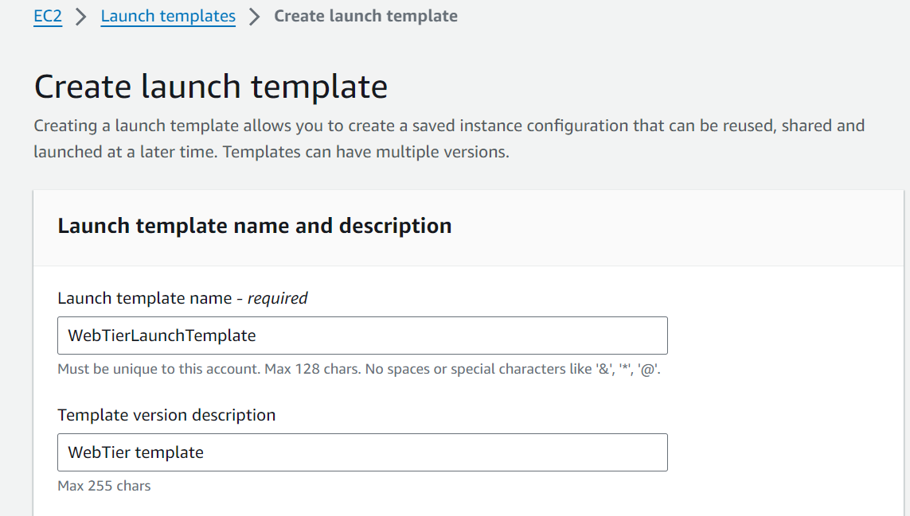
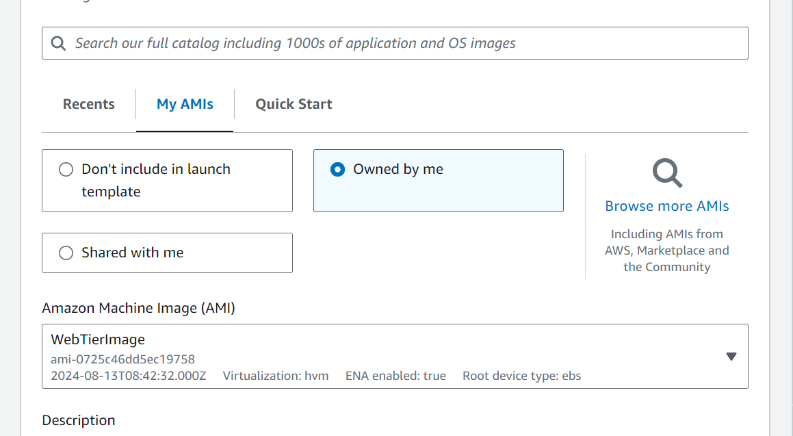
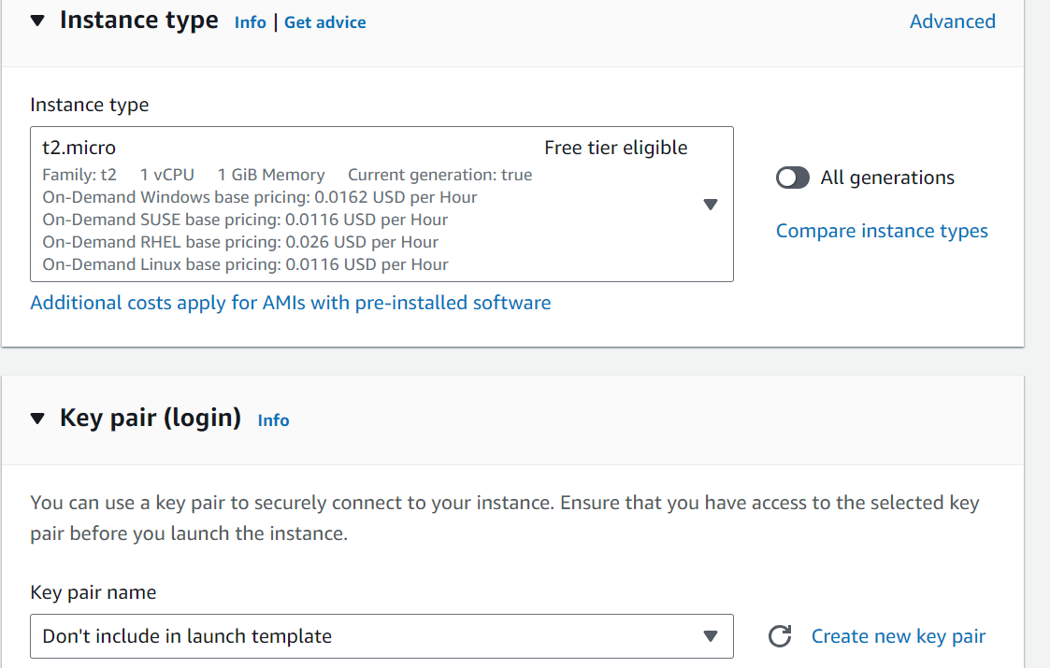
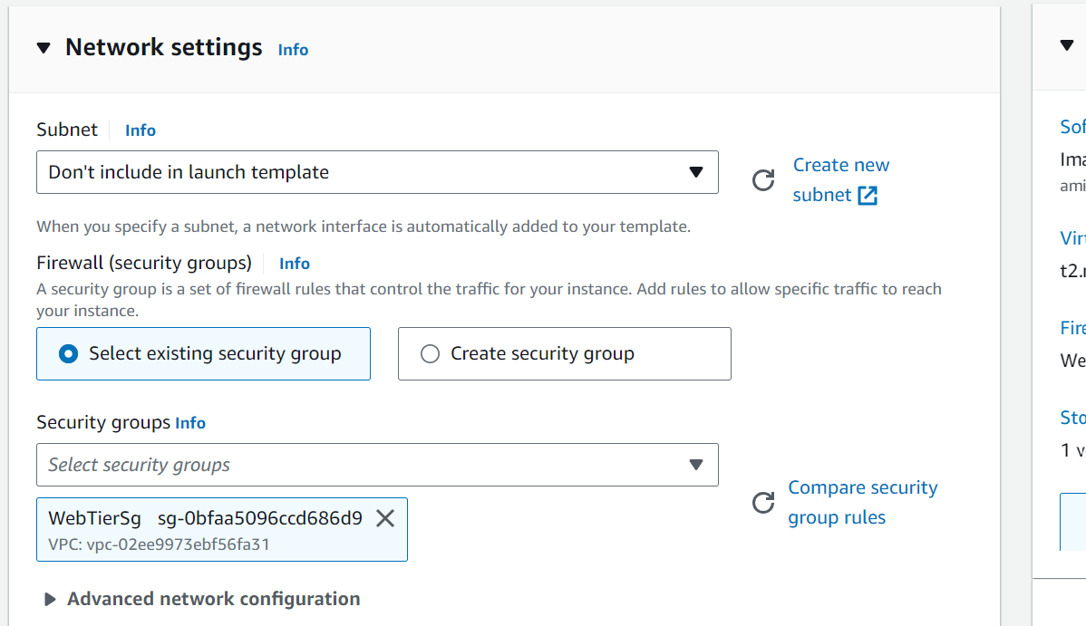
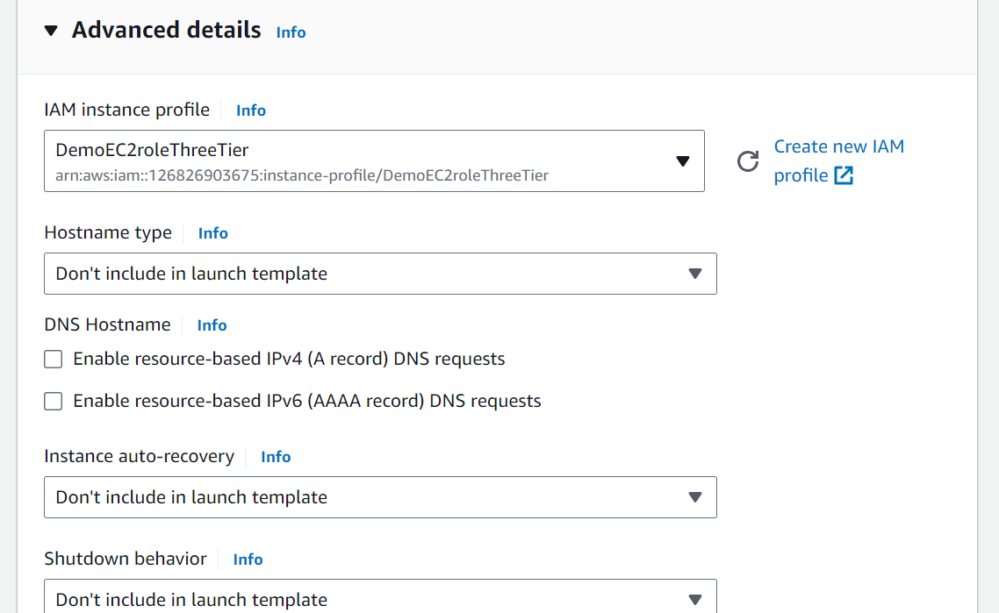
- Create the Auto Scaling Group for our web instances. On the left side of the EC2 dashboard navigate to Auto Scaling Groups under Auto Scaling and click Create Auto Scaling group.
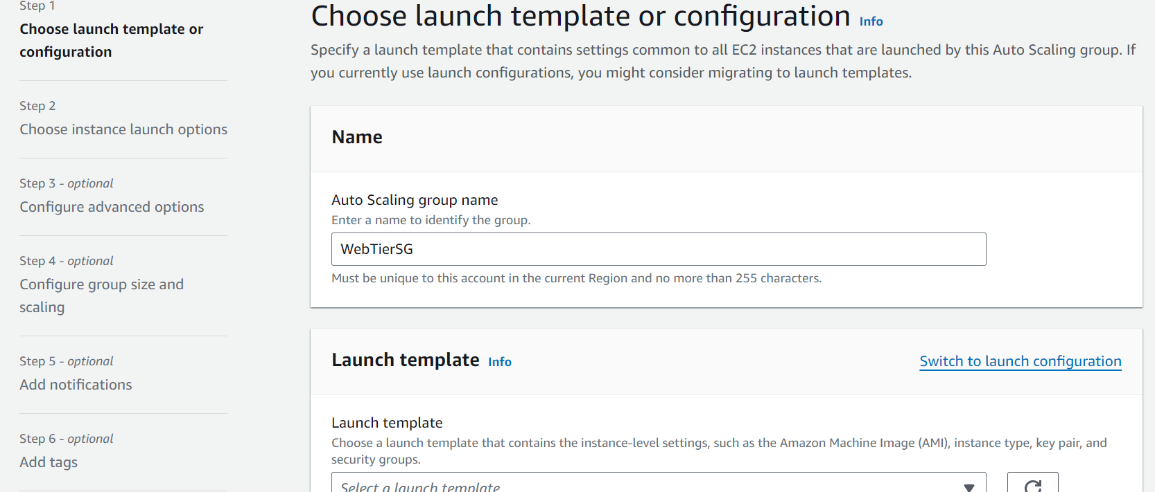
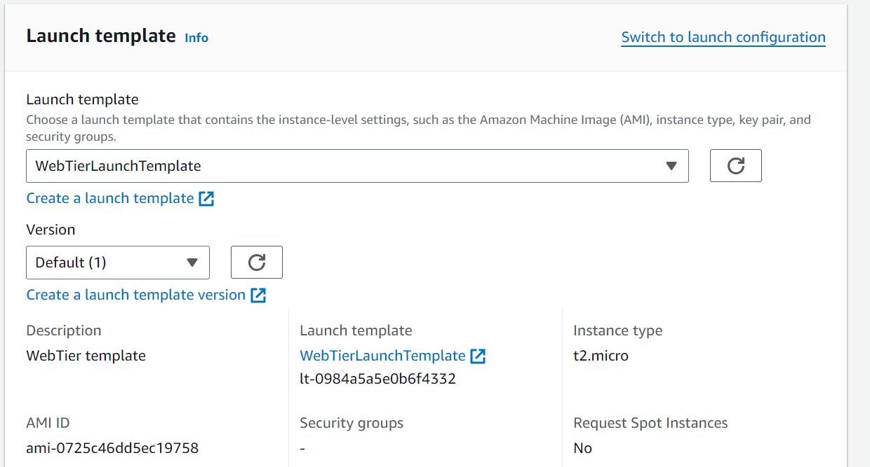
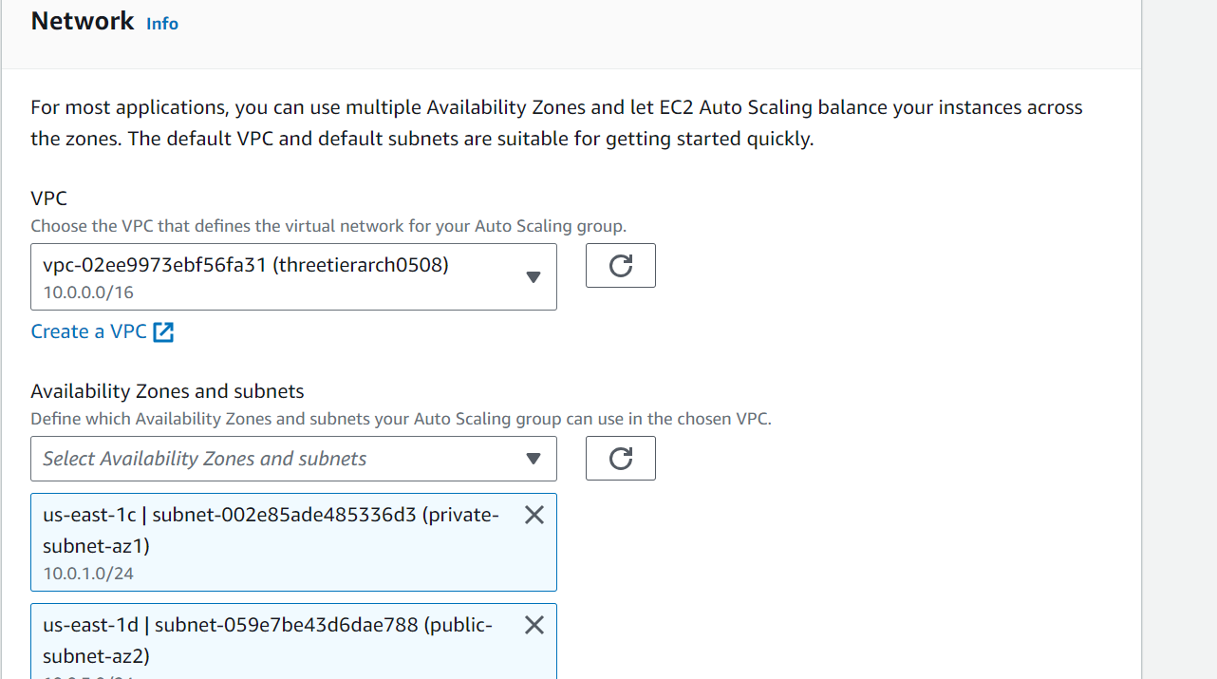
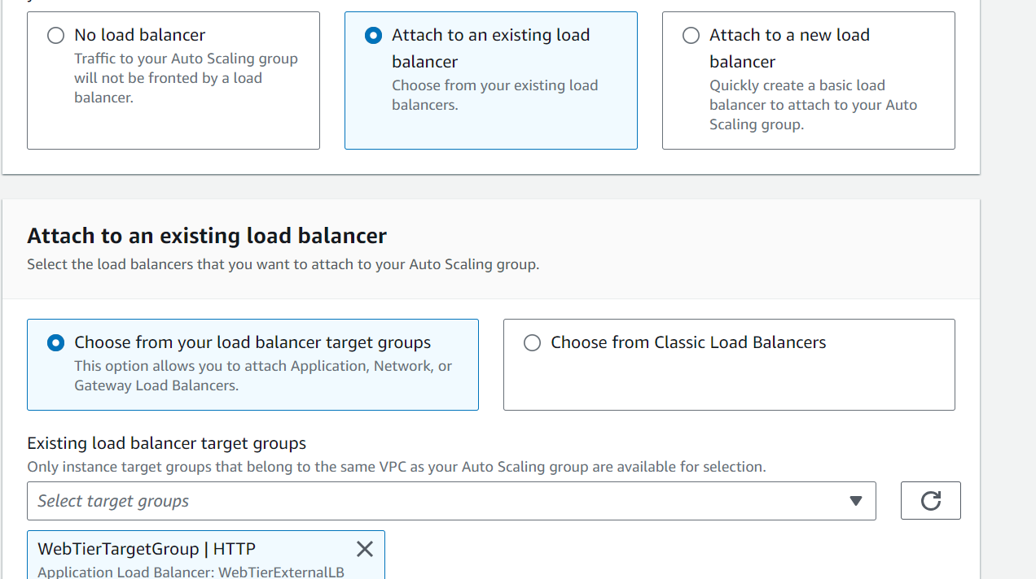
- You should now have your external load balancer and autoscaling group configured correctly. You should see the autoscaling group spinning up 2 new web tier instances. If you wanted to test if this is working correctly, you can delete one of your new instances manually and wait to see if a new instance is booted up to replace it. To test if your entire architecture is working, navigate to your external facing loadbalancer, and plug in the DNS name into your browser.
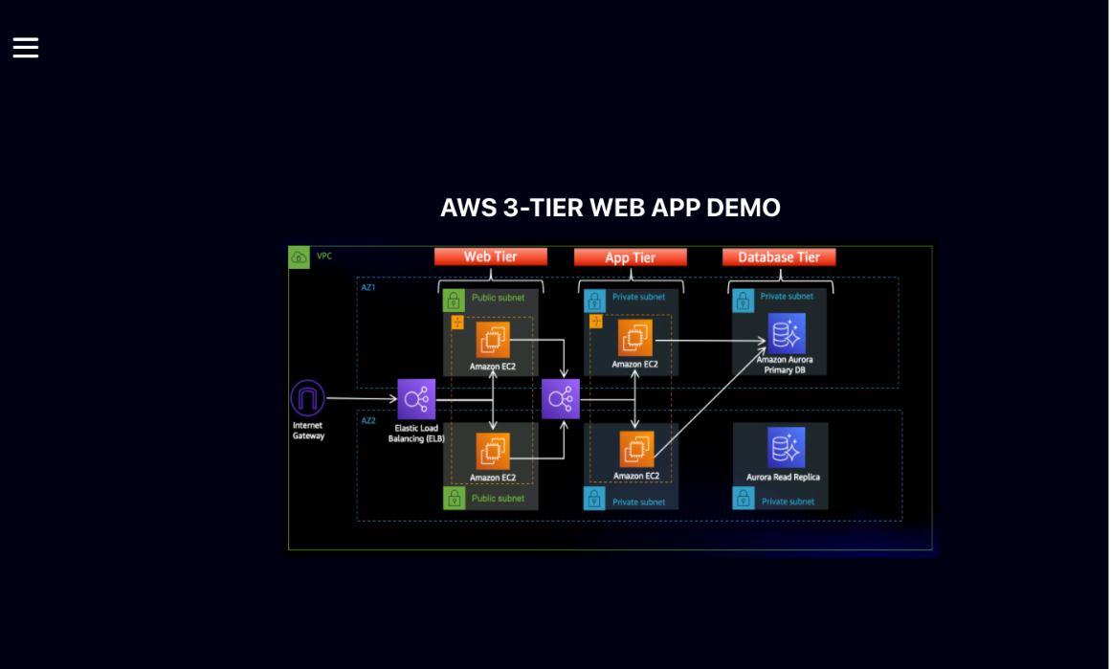
We can see that the application is running and we have deployed a three tier Web architecture
- Appendix is available at the following location.
https://catalog.us-east-1.prod.workshops.aws/workshops/85cd2bb2-7f79-4e96-bdee-8078e469752a/en-US/appendix

- Delete all the AWS resources in the AWS account. Please refer following link to delete the resources
https://catalog.us-east-1.prod.workshops.aws/workshops/85cd2bb2-7f79-4e96-bdee-8078e469752a/en-US/cleanup

